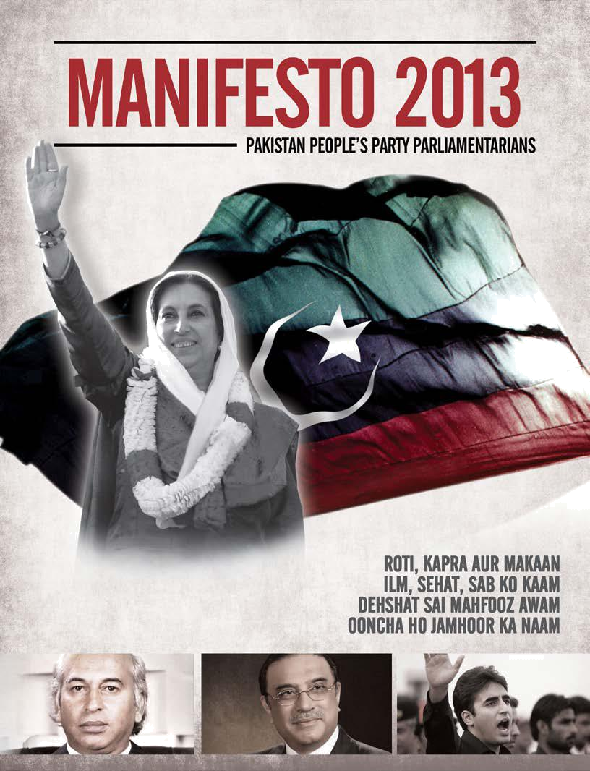
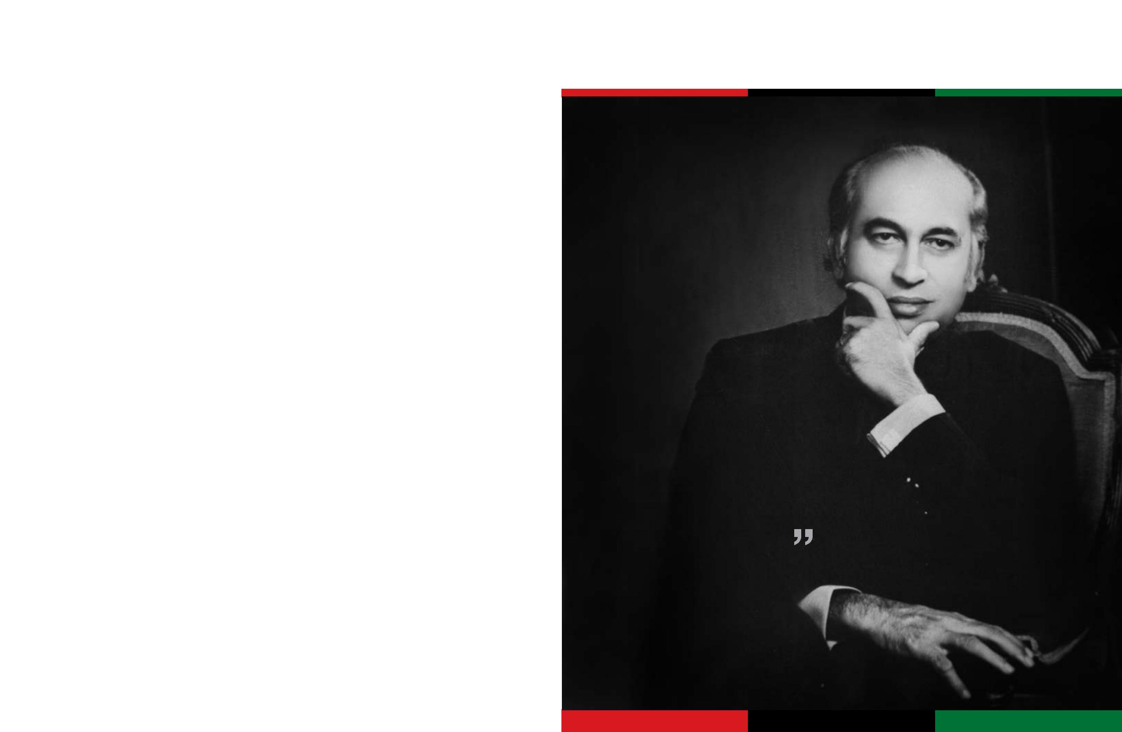
Manifesto
2013

 We badly need to gather our thoughts and clear our

minds. We need a political ceasefire without conceding
ideological territory.
Quaid-e-Awam Shaheed Zulfikar Ali Bhutto,
Founder Chairman of the Pakistan People’s Party,

President and Prime Minister of Pakistan

Pakistan People’s Party Parliamentarians

Contents

Core priorities
Preamble

The mission before us

Living up to our commitments

Our pledge to the people of Pakistan

Basic principles of the Party

Why vote for the PPPP?

Manifesto
2013

2

8

8

9

10

11

12

 |  | Manifesto
 |  | 2013
International human rights instruments and Pakistan |  | 32
Civil society |  | 32
Enforced disappearances and missing persons |  | 32
Strengthening ties with overseas Pakistanis |  | 32
Part III – Inclusive and equitable growth
Executive summary |  | 34
Living up to our commitments |  | 36

Part I – Ensuring basic needs

Executive summary | 14
Living up to our commitments | 15
The way forward | 17
Safety nets: Benazir Income Support Programme | 17
A new beginning: building a system of entitlements | 17
Health for all | 17
Preventive medicine | 18
Curative medicine | 18
Regulation of drugs and medical devices | 19
National health insurance | 19
Reforming medical education | 19
Mother and child: building a strong foundation | 20
Family planning | 20
Access to universal and quality education | 21
Power to workers and farmers | 22
Housing for all | 23
People’s Works Programme | 24

Part II – Empowerment for all

Executive summary | 26
Living up to our commitments | 27
The way forward | 28
Power to women | 28
Mainstreaming and protecting minorities | 29
Power to the youth | 30
The rights of children | 30
Freedom of Expression and the Right to Information | 31

Pakistan People’s Party Parliamentarians

The way forward | 37
Poverty alleviation: the Benazir Income Support Programme | 40
People’s employment | 40
The right to employment | 41
Modernizing agriculture and enhancing production | 41
Expansion and consolidation of agricultural facilities | 41
People’s Agriculture Programme | 42
Livestock and fisheries | 43
Investment policy | 43
Small and medium enterprise | 43
Special economic zones | 43
Banking | 43
Trade | 44
Textiles | 44
Part IV – Infrastructure for the future
Executive summary | 46
Living up to our commitments | 47
The way forward | 48
Sustainable and renewable energy | 48
Information and communications, science and technology | 49
Urban planning | 49
Water security and flood management | 50
Protecting natural resources, wildlife and the environment | 51
Enlarging cultural space | 51
Tourism and travel | 52
Protecting heritage and culture | 52
Sports and community development | 52

Pakistan People’s Party Parliamentarians

Manifesto
2013

Part V – Towards a new social contract

Executive summary | 54
Living up to our commitments | 55
The way forward | 57
Devolving power to local government | 57
Reconciliation, coordination and cooperation | 58
New provinces | 58
Bahawalpur-Junoobi Punjab | 58
Accountability at all levels | 59
Judicial reform | 59
Civil service reform | 59
FATA reforms: a work in progress | 60
Gilgit-Baltistan: self rule and forward | 60
Azad Jammu and Kashmir: rebuilding lives | 60

Part VI – Protecting the people of Pakistan

Executive summary | 62
Living up to our commitments | 63
The way forward | 64
Securing Pakistan | 64
Internal security | 66
Narcotics control | 66
Law enforcement and police reforms | 66
External security | 67
Defence | 68

Part VII – Engaging with the world

Executive summary | 70
Living up to our commitments | 71
The way forward | 73
Peace, prosperity and stability | 73
Regional cooperation and engagement | 73
Strengthening bilateral ties and building new relationships | 74

Pakistan People’s Party Parliamentarians

Manifesto
2013
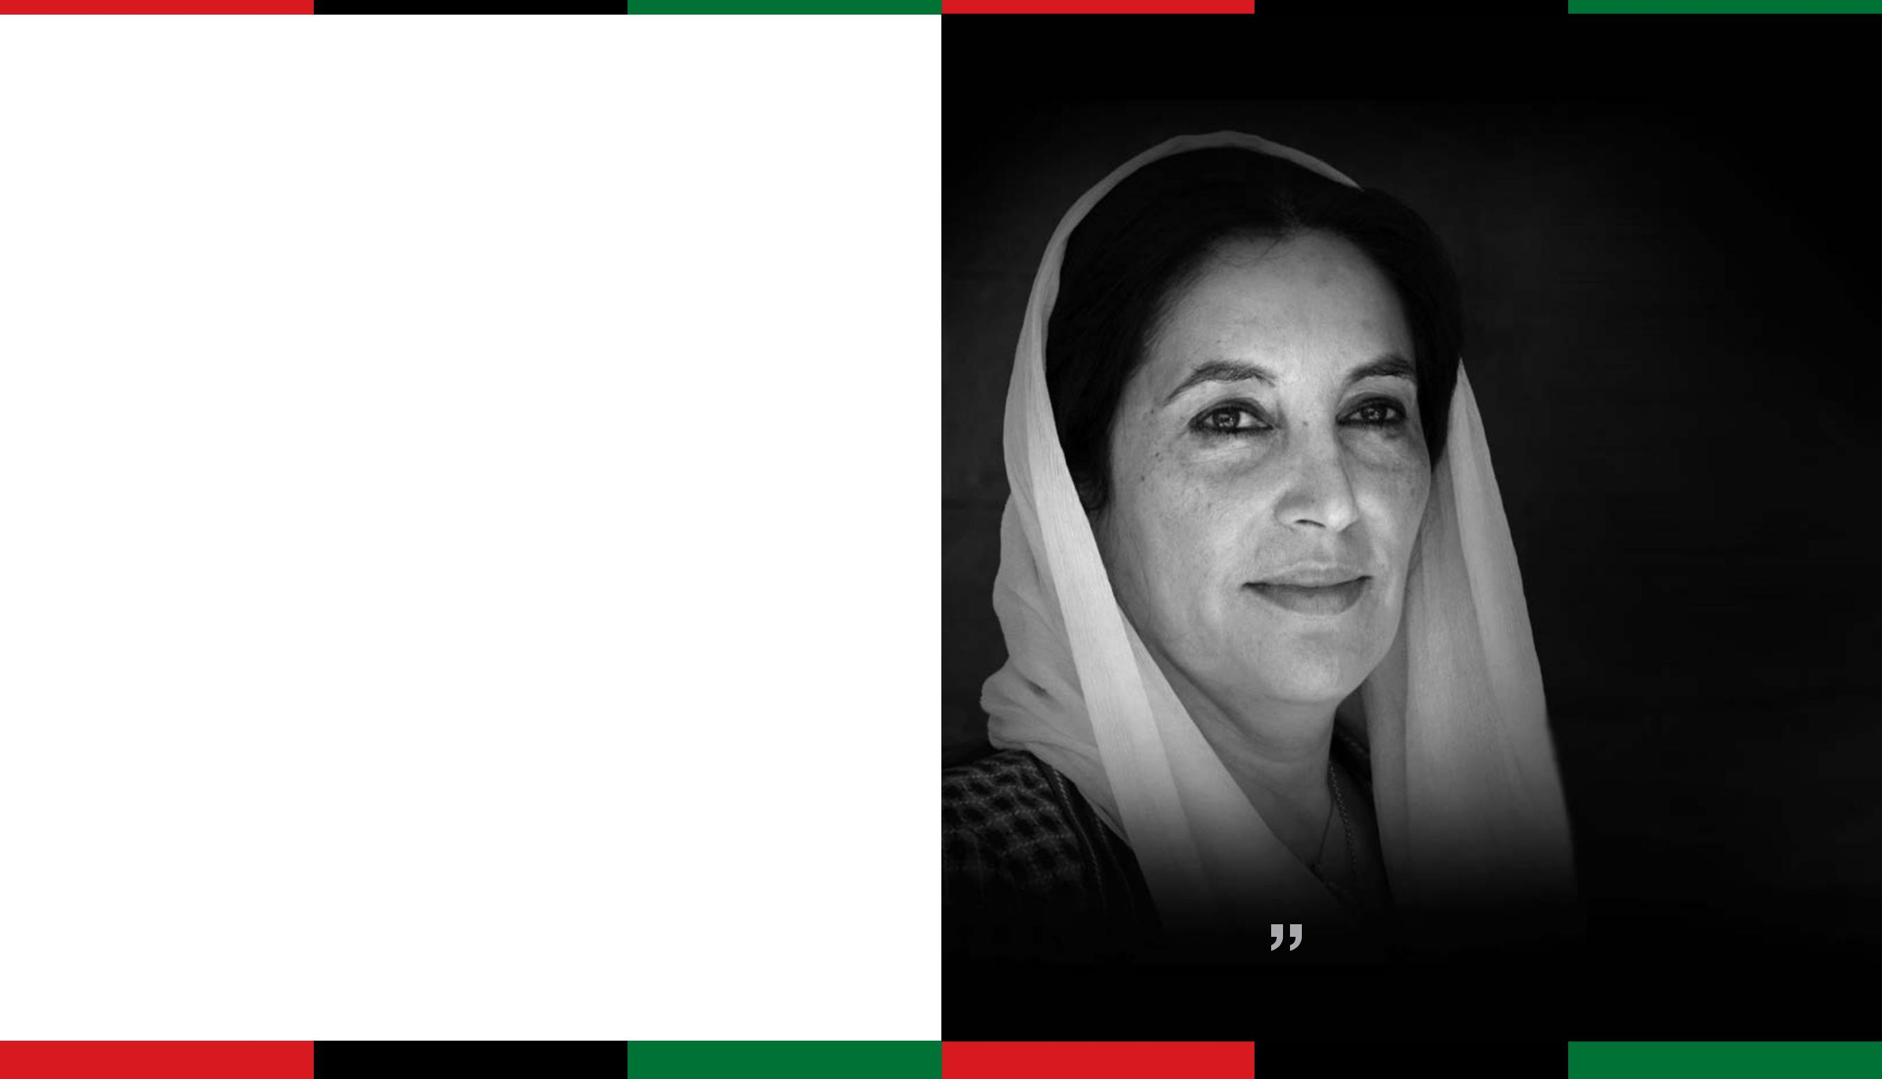

 Leadership is a commitment to an idea, to a dream, and to a vision of what can be. And my dream is for my land and my people to cease fighting and allow our children to reach their full potential regardless of sex, status, or belief.
Shaheed Mohtarma Benazir Bhutto

1

Pakistan People’s Party Parliamentarians


 |  | Manifesto
CORE PRIORITIES |  | 2013

Manifesto
2013

Pakistan People’s Party Parliamentarians: Towards a progressive, just and prosperous Pakistan

Roti, kapra aur makaan

Ilm, sehat sab ko kaam

Dehshat sai mehfooz awam

Ooncha ho jamhur ka naam

The Pakistan People’s Party Parliamentarians have laid the foundations for a sustainable, accountable and robust democracy in Pakistan.

We faced down deep divisions and hazards five years ago, when a terrorist bullet martyred Shaheed Mohtarma Benazir Bhutto. As we shepherd Pakistan into its first constitutional transfer of power through elections, we resolve today that we will continue to make history by using a new elected term in office to take Pakistan into a future based on social justice, peace and prosperity for all.

Our 2008 term was used to preserve and strengthen the federation by building a new social contract for Pakistan and devolving power to the provinces. We deployed consensus and reconciliation to navigate the country through a minefield of dangers when others would have collapsed. We strengthened the democratic system, often at our own expense. We built bridges where fires were burning, in our hearts, in our land, and in conflicts abroad. The President, Asif Ali Zardari, voluntarily gave away his own powers to the head of Parliament, empowering the people and investing in a future where the public good trumps politics. We emptied our jails of all political prisoners, including judges. Instead of pursuing the politics of revenge for the great wrongs done to us, we have pursued democracy.

In the interest of preserving the independence of institutions and to prevent the derailment of a fragile
- transition, we presented ourselves in the courts of

the law without demur, losing the highest elected officials in the land to the wheels of justice. We no longer even remind people of the jail terms and the extra-judicial executions this party has faced; today, the PPPP still stands as the most accountable party and government in the history of Pakistan. We allow history to judge us, never running away from the judgements that strike at us. We have a trail of blood and daily sacrifice leading to our own homes to show for it.

We did all this while giving Pakistan its first non-partisan, non-politicized social safety net for the poor and vulnerable, while protecting labour. The Benazir Income Support Programme (BISP) is now cited as a model anti-poverty programme in international development forums. As a strategic priority, we initiated a large-scale programme for the empowerment of women at the bottom and top of the pyramid, making women the centrepiece of our development, anti-poverty and leadership strategy.

We know our people suffer hardships every day as they bravely face losses from terrorism and rising global food prices. We know that 60 per cent of Pakistan is under the age of 30, and that a big proportion of this demographic needs jobs and secure futures. We know that our girl children need to go to better schools, our mothers need more than a health care unit in every district, and our polio vaccinators need protection. Our minorities need to feel secure and proud of being Pakistani.

We faced the hardship of conflict and violence and the full brunt of natural disasters that killed our people, swamped our crop, our homes and our livestock. In the middle of all this we resettled a record number of people, in the millions, stricken by conflict and disaster. We put the agricultural sector back on its feet and made Pakistan a wheat exporter again. From the bubble economy we inherited, based on consumer credit, stock market speculation, property mark-ups, non-transparent

Pakistan People’s Party Parliamentarians

privatization, zero investment in energy security and inflation in double digits, that exposed the people to local and international shocks, we brought down inflation to single digits, built up Pakistan’s exports to unprecedented levels, and attracted the highest flow of remittances in Pakistan’s history. And we will go further.

Our manifesto is based on the bedrock of ground realities. We make no promises for which we cannot find resources, nor do we plan to rebuild Pakistan from the top down through a trickle down of profits. We believe that national security is premised on human security first. Anyone governing Pakistan in the next ten years of a global recession and regional security upheavals will also have to make tough fiscal, economic, security and governance decisions. A nation that is economically insecure at the bottom of the pyramid, capitally uncompetitive and infrastructurally unprepared stands a poor chance of survival in a world that is shifting political and economic gears rapidly.

We have seven core priorities that will protect and empower the people of Pakistan, and we will initiate key programmes in 100 days at the federal and provincial levels. We will urge all partners in democracy to do the same in the cause of the greater national good.

Ensuring Basic Needs of the economically and socially disadvantaged is a crucial foundation for building our new Pakistan, and a core priority for the

- We have always targeted food security, shelter, health care, education, jobs, labour protections and equal opportunity for all. Our focus in providing social entitlements has not been about showy buildings and boom and bust ghost programmes. While we pursue brick and mortar health facilities in every district, our primary health care provision has always been dynamic and globally acknowledged, as in our Lady Health Workers Programme, which still forms the backbone of Pakistan’s primary health

care outreach in the public sector. Going forward
our focus will be on preventive medicine in the
provinces, and we will launch a flagship Mother and
Child Support Programme which will incentivize
the seeking of reproductive health and health care
services through voucher schemes and direct
cash transfers. We commit to polio eradication
as a national priority, integrating it with routine
immunization, and will provide enhanced security to
vaccinators. To date, our flagship poverty alleviation
programme, the BISP, has been focused on reducing
vulnerability for those most at risk, reaching 18
per cent of our population already. It goes forward
to provide health insurance to the poorest, which
has begun rolling out as the Waseela-e-Sehat. We
will also enrol, educate and make employable a
critical mass of young people every year through
the Waseela-e-Rozgar and Waseela-e-Taleem
programmes. While we build on secure entitlements,
we hope that provincial governments will tighten
belts and provide matching grants for education and
health, as these will be principle responsibilities of
the provinces. The PPPP will commit more than 4.5
per cent of GDP on education by the end of our next
term. Curriculum reform will be pursued proactively
in order to purge textbooks of hate speech. Shelters
for children, such as those already provided by
the Baitul Maal, will be replicated by provinces in
order to decrease child labour and pull children into
the schooling net. We will seek to bridge the gap
between private and public schooling by building
a National Education Standards Council for all
provinces to coordinate efforts, and look to target
universal primary enrolment by 2018 as guaranteed
in the Constitution, along with a pool of 10,000
higher education and technical vocation scholarships
every year. Labour too will be given a greater share
in public enterprise through the BESOS programme,
and the minimum wage will go up to 18,000 rupees
per month. Labour representatives will get four seats
in the National Assembly and two seats in each
provincial assembly, through legislation. Housing will
receive renewed impetus and the poor will be given
priority with low-cost housing schemes launched | 3

Pakistan People’s Party Parliamentarians

Manifesto
2013

Manifesto
2013

through a transparent public–private partnership and government mandated 20-year mortgage lending. The PPPP sees the inclusion and Empowerment of All citizens, especially the marginalized and

the vulnerable, the women, the minorities and the young and dispossessed, as fundamental to the rights framework on which our federation is built. We will move forward on mainstreaming women, minorities and the youth of Pakistan by consistently and incrementally securing and enhancing their legal and constitutional rights in an increasingly volatile world. To empower women we will invest in the least included to become agents of change by providing them incomes, computerized identity cards to avail new entitlements, credit lines, opportunities and legal safeguards. Role models will also feminize leadership at the top and bring more women at all levels into decision-making roles. An Equality Commission will be set up to ensure a Fair Pay and Fair Job Policy across the board for women and minorities in consultation with the provinces. The National Commission on Minorities will be given statutory status, with a budget and secretariat, and interfaith dialogue encouraged in mandatory inter-provincial forums. Religious properties will be given protection, and rebuilt and refurbished, as is underway, in cooperation with provincial governments. To mainstream our young people, one of the largest youth cohorts in the world, they must be provided opportunities, vocational training and cultural space for constructive expression of plural identities. As the most vulnerable members of our society, children too must be protected against predatory behaviour, abuse and exploitation. All human rights entitlements and freedoms which the PPPP has already upheld and protected, such as the Right to Information which has been made a fundamental right, will be guaranteed and given stakeholder status in building a vibrant democracy.

We will revive a globally impacted economy and invest in Equitable and Inclusive Growth by

- launching our own stimulus packages through

a mix of job-creating programmes, bringing financial inclusion and extending credit to the small entrepreneur and farmer, launching our youth employment initiative, the Peoples Employment Programme, and building new agriculture and livestock cooperatives powered through women. We will support our farmers by charging flat rates for electricity for tube wells and providing cheaper non-middlemen inputs, while leveraging existing agri-capital by legalizing title deeds. As the People’s government, our war against poverty will continue through an expansion of the Waseela-e-Haq and other poverty alleviation initiatives like the BISP across the board, and every household that has qualified for income transfers will be graduated to an income-earning programme. The BISP monthly cash payments will be increased to 2,000 rupees and pegged to inflation annually. We will provide a safety net for small depositors, expand our banking services, both branchless and commercial, enhance the SME sector through capacity and access to credit, invest in milk processing and extend crop insurance for the agriculture sector. To boost manufacturing and enhance investment we will build Special Economic Zones where capital goods are exempt from duty, establish a ‘Weaving City’ and provide skills development to boost the textile industry, and build on our unprecedented growth in exports by investing in manpower exports supported by training and vocational centres in each major city. We will boost trade and build on creative currency swap agreements like those already executed with China and Turkey, to protect our currency. Our plan to expand the tax net to 5 million by 2014 will be operationalized with the use of the NADRA tax database we built, even if we need to target tax evaders at the top of the pyramid. We have already brought total debt to within 60 per cent of GDP, and we will reduce government borrowing to bring the budget deficit to less than 4 per cent of GDP by 2017.

No nation can prosper without investing in Infrastructure for the Future. Realizing that the

Pakistan People’s Party Parliamentarians

children of Pakistan urgently need inexpensive light to read by, and that our industries need uninterrupted power, our existing power programmes will start kicking in to generate a fuel mix of hydel, coal, gas and renewable energy of 12,000 MW by the end

of our next term, with a reduction in line losses and higher governance benchmarks to reduce the burden of circular debt. Given our resource base, we will invest in public–private partnerships to build a web of city-to-town and farm-to-market roads, linking Pakistan to a web of productive linkages. We have laid down a new grid of motorways connecting Islamabad to Peshawar, Faisalabad to Multan, Gwadar to Ratodero, and further knitting the provinces in one transport chain. Sensitive to the stresses our people and environment face with the onset of global climate change and its impact, triggering natural disaster in our region, and to ensure that our national resources are used sustainably for the future, we will build environmental protections and conservation incentives, including water security, into every national and provincial programme. Given that Pakistan is now the fastest urbanizing country in the region, we will prioritize urban and municipal governance, address zoning challenges, provide local transport, increase land supply, and institute recycled water plants and sewerage as mandatory for new towns and in phased enforcement for existing settlements. We will invest in information technology to develop economic and social capital, create software parks, and deploy the expanded teleco footprint of Pakistan to meet development and financial imperatives for the young and the excluded.

We have devoted our full resources and focus to building a sustainable democratic foundation for the people of Pakistan by spearheading a New Social Contract for the federation, provinces and people of this great nation through parliamentary consensus. Through a series of Constitutional Amendments, including the 18th, we have transferred key powers of taxation and governance to the provinces. We will take this historic process forward by devolving more

power to the people, seeking consensus on local government as the next step. We have made the superior courts and election commission of Pakistan totally independent by giving away our powers to appoint and nominate, privileging our role in posterity in cementing democracy over power. Realizing the critical importance of better governance and higher public sector transparency, we will introduce civil service reforms in consultation with parliamentary partners. We will go further in integrating Balochistan into the national mainstream, giving its due rights on missed entitlements, which has already begun, and by assuaging its legitimate grievances. We have given Gilgit Baltistan a new lease of life and self-rule, and given the province of Khyber Pakhtunkhwa its indigenous identity. We have introduced long-awaited governance reforms in FATA and begun the process of political mainstreaming, which should go forward in the future as a new provincial entity. We will also move to enhance two seats reserved for women candidates from FATA. We have moved forward on our commitment to make a new province in South Punjab in accordance with the wishes of the people to be called the province of Bahawalpur Junoobi Punjab, and we pledge to take all other constitutional measures to make this province a reality. As one of the largest megacities of the world and the country’s port, Karachi will receive a special grant in the NFC Award from the federal divisible pool.

Realizing that there can be no growth, welfare,
fundamental freedoms or quality of life without
security and a guarantee of basic protections,
we will strengthen the rule of law and devise
coordinated, comprehensive strategies to Protect
the People of Pakistan. We will invest in the police,
counterterrorism forces and law enforcement
units for each province, diverting resources and
human agency to internal security. Federal and law
enforcement measures will be given additional teeth
with witness and judges protection programmes,
preventing the resurfacing of banned outfits and
criminals who feed on innocent citizens. Citizens- | 5

Pakistan People’s Party Parliamentarians

Manifesto
2013


Manifesto
2013

Police Liaison Committees will be introduced in every major urban centre. Nationwide campaigns will be launched in order to reduce the space and media oxygen for intolerance, and to reverse the momentum of the extremist mindset. A National Counter-Terrorism Authority will be redesigned and placed in the PM Secretariat, which will serve as a counterterrorism control room for all federal agencies. The provinces will be encouraged to set up their own counterterrorism authorities in coordination with the centre and all security agencies. While we continue to successfully resettle internally displaced persons dislocated by anti-terror programmes, we will use force where needed and initiate peace talks only when combatants accept the laws of the land, the writ of the state and the Constitution of Pakistan. Our brave soldiers and citizens have faced enough trauma. We seek to build consensus like we did for action in Swat. Just as we will disallow terrorists to rip our flag and bomb our schools, hospitals, shrines and mosques, we take clear and unambiguous issue with all encroachments on our air space and land as violations of our sovereignty, including drone attacks conducted by foreign governments.

We will intensify the diplomatic outreach we began so that Pakistan can Engage with the World as a responsible nation state and global player in trade and economic advancement as a strategic priority for the future. There has been a constant focus

on regional peace, security and prosperity as a pivot for Pakistan’s relations with the international community on the same lines, and an aggressive pursuit of regional networking to give the nation an edge in leveraging the trade, energy and communications opportunities emerging today. The

- has also brought about a transformational shift in the country’s foreign policy by basing it on public consent and transparency. By bringing all stakeholders in national security, including public representatives, into the policy-making process in Parliament, the PPPP has initiated a robust and enhanced process of external engagement based on the principles of equality, mutual respect and benefit. Partnerships have been renewed globally at difficult crossroads, such as with the US, and enhanced with old friends such as the People’s Republic of China. We have deepened our engagement with the EU and initiated a policy of sustained dialogue with neighbours such as Afghanistan, India and Iran. We will continue our outreach to the Central Asian Republics, Turkey, Saudi Arabia and other Middle Eastern countries. We will pursue the goal of stability and peace-building in the region as a specific policy priority without sacrificing our diplomatic and moral commitment to the people of Jammu and Kashmir.

The Pakistan we shall endeavour to remake will be at peace with itself, and at peace with the world.

Bhuttoism is an ideology for the
poor. You will cut our hands,
but we will raise our flags. They
will sew our lips, but we will
chant, ‘Long live Bhutto!’ 

Chairman PPPP, Bilawal Bhutto Zardari

Let us, on this day also resolve to
defeat the militant mindset and
make Pakistan a truly welfare driven,

rather than security driven, state.

6

Pakistan People’s Party Parliamentarians

President of Pakistan, and
Co Chair Pakistan People’s Party Parliamentarians Asif Ali Zardari

7

Pakistan People’s Party Parliamentarians

Manifesto
PREAMBLE ²⁰¹³

Manifesto
2013

“We are starting in the days where there is no discrimination, no distinction between one community and another, no discrimination between one caste or creed and another. We are starting with this fundamental principle that we are all citizens and equal citizens of one State.”

Quaid-e-Azam Muhammad Ali Jinnah, Address to Pakistan’s first Constituent Assembly, Karachi, 1947

“If things do not change, there will be nothing left to change. Either power must pass to the people or everything will perish.”

Quaid-e-Awam Shaheed Zulfikar Ali Bhutto, Central Jail, Rawalpindi, Pakistan, 1979

“We are prepared to risk our lives. We’re prepared to risk our liberty. But we’re not prepared to surrender this great nation to militants.”

Shaheed Mohtarma Benazir Bhutto, Karachi, Pakistan, 2007

extremist mindset of those who bring suffering to the tolerant majority.

Today, the people of Pakistan are proud to claim that their elected representatives have completed their term of five years. The sovereign will of the people has prevailed in completing the first constitutional and peaceful transiti on, and this is indeed a great and historic achievement.

At every step we faced hurdles but we successfully averted many conspiracies against the mandate of the people of Pakistan. Our task ahead is strewn with challenges but we remain answerable to the people and the great electorate of Pakistan.

Our Party vowed to restore the people’s rights and we strengthened the democratic system in ways that Pakistan has never witnessed before.

Our Party confronted the divisions in the federation and reunited it constitutionally. We lived up to promises made 30 years ago but our journey to bring good governance to the doorstep of the people has only just begun.

Our Party is laying the foundations for a new Pakistan. By reframing the social contract the people of Pakistan have with each other and with the federation, we have in real terms devolved power closer to the grassroots.

The President of Pakistan has voluntarily given up his powers in order to strengthen and consolidate the parliamentary system.

There is still a long way to go, with the country threatened by agents of terror and ignorance, and by the global challenge of rising food and energy prices, as well as natural disasters triggered by climate change.

Living up to our commitments

With the popular mandate given to the Party in the 2008 general elections, both in the national and provincial legislatures, we were able to form a coalition government by keeping every party on board.

The PPPP contested elections in challenging conditions and difficult times. We had just lost our great leader, Shaheed Mohtarma Benazir Bhutto, who was leading the struggle for democracy. The people voted for our policies, our struggles and what we stand for, and we emerged as the single largest party.

Our reconciliation policy helped us get the leader of the House elected unanimously, while the Speaker and the President were elected with a two-thirds majority.

Through our Party nominees, office-bearers and workers, our government strove unceasingly to rid the country of structural and deep-rooted problems that had grown during the decade of dictatorship. Under the guidance of our Party leadership,
the government was able to make great strides in fulfilling the promises made to the people of Pakistan.

The mission before us

This Manifesto is our sacred pledge to the people of Pakistan and, most importantly, to our women, our youth, our children and our minorities.

Quaid-e-Azam Mohammad Ali Jinnah’s Pakistan is fighting a battle for its survival, a battle waged by its

- enemies within and without.

Quaid-e-Awam Shaheed Zulfikar Ali Bhutto’s Pakistan is fighting with those who perpetuate oligarchy, injustice and insecurity.

Shaheed Mohtarma Benazir Bhutto’s Pakistan is fighting a battle with the forces of darkness and bigotry.

Bilawal Bhutto Zardari’s Pakistan is committed to fighting as long as it takes to win a war against the

Our Party saw its current term as a time to lay strong foundations for democracy and protect the democratic process from derailment. In our next term we will focus on making democracy work through better governance.

Nor did we shirk away from great challenges: our Party confronted militancy, terrorism and extremism, sacrificing our own leader’s life in the process. We now resolve to strengthen our defences so we can fight to the finish.

The party remains committed to protecting the citizens of Pakistan. In our current term, we:

- Strengthened the federation by passing the 18th

Amendment and by negotiating the historic NFC Award.

- Promoted and deepened parliamentary

democracy when the President and Party Co-chairman Asif Ali Zardari gave up his powers to

Parliament. ⁹

Pakistan People’s Party Parliamentarians

Pakistan People’s Party Parliamentarians

Manifesto
2013

Manifesto
2013

- More than 80 per cent of the Charter of

Democracy signed in May 2006 has been implemented. The Party will also implement the remaining articles of the Charter.

- Launched the largest poverty alleviation scheme in the history of the country, the Benazir Income Support Programme.

- Initiated landmark legislation to promote and enhance the rights agenda, transferring power and rights to women and labour.

- Stabilised the economy and brought down inflation to single digits.

- Made Pakistan a wheat exporter again and stabilized the agricultural economy despite repeated and unprecedented natural disasters.

- Diversified our energy policy and initiated renewable energy projects that will come online during the tenure of the next government.

- Introduced an innovative counterterrorism approach that is grounded in the critical components of political engagement and economic development.

- Made progress in the war against militancy and extremism, and united the whole country in eliminating militancy from Swat.

- Encouraged more effective communication between intelligence agencies and key law enforcement personnel.

- Enacted key legislation that seeks to identify, ban and significantly hamper the financing mechanism of militant organizations.

- Sought to protect and rehabilitate disadvantaged citizens who were internally displaced due to action by the armed forces against terrorists seeking to impose their ideology of hate.

- Passed the National Counter-Terrorism Authority

Act 2012.

- Framed independent and multi-dimensional foreign policy, focusing on better relations with

- our neighbours and ending Pakistan’s isolation.

Our pledge to the people of Pakistan

Seeking once again the trust of the people, our Party renews and affirms our commitments to them. For the next five years, our pledges to the people are as follows. We promise to:

- Build a strong Pakistan that is progressive, modern and dynamic.

- Protect the people of Pakistan against terrorism.

- Battle extremism and defeat its message of hate by initiating a strong and unambiguous counter-radicalism policy and promoting a culture of tolerance.

- Strengthen and promote Shaheed Mohtarma

Benazir Bhutto’s policy of reconciliation and inclusion.

- Further strengthen democracy by strengthening political institutions.

- Create conditions for the revival of economic growth and prosperity.

- Renew our commitment to build a hopeful future for those stricken by poverty.

- Strive for a Pakistan where all, rather than some, live in comfort and plenty.

- Work for a Pakistan where everyone is included in the expanding circle of development.

- Foster a just society free from discrimination against women and minorities.

- Give our youth hope and a stake in a forward-looking Pakistan.

- Ensure that our natural resources are used responsibly and sustainably, with the benefits to be shared with the people.

- Develop better systems and procedures for disaster management and climate change mitigation.

- With greater vigour and determination, continue to introduce historic reform and implement policies that secure the basic needs of all citizens.

Pakistan People’s Party Parliamentarians

- Build a responsive, responsible and representative government at all levels.

- Eliminate social and economic inequalities between various classes, between Pakistanis of various religious beliefs and sects, between provinces and within provinces.

- Help to bring about a multicultural, plural and diverse Pakistan where the space for civil society is enlarged and nourished.

- Expand, strengthen and enhance friendship with our neighbours, reach out to other countries, and promote Pakistan’s position in multilateral organizations.

Basic principles of the Party

Islam is our faith, democracy is our politics, social justice is our economy — all power to the people

The founder of the Party, Shaheed Zulfikar Ali Bhutto, built a solid foundation on which the Party stands today, promoting democratic rights and social justice within the context of our own cultural and religious identity.

Islam teaches brotherhood, love and peace. Our faith places a responsibility on each citizen to reach out in a spirit of accommodation and tolerance to all religions and sects, and to treat people of all faiths with respect, enabling them to enjoy religious freedom and equality before the law.

The politics of our Party has always been led by the democratic ideal. In every era, PPPP leaders, office-bearers and party workers have been thrown behind bars, sent into exile, and faced political persecution and torture. They have suffered these indignities to strengthen democracy in the country. The PPPP’s commitment to freedoms and rights can be gauged by the tremendous sacrifices of leaders and workers alike. The judicial murder of Quaid-e-Awam Shaheed Zulfikar Ali Bhutto, the assassination of Shaheed

Mohtarma Benazir Bhutto, and the killing, torture and imprisonment of thousands of Party workers have made us the frontline and foremost defender of the rights of the people.

The Party has led movements for the restoration of democracy, remained in the forefront of efforts to strengthen democracy, and now stands committed to protect democracy from those who would see it undermined.

The PPPP aims to ensure social justice and equal opportunity for all citizens. We are committed to empowering the weak and enriching the poor through the equitable distribution of assets and resources. We are the party that is identified with the underprivileged, the downtrodden, the marginalized and those who are discriminated against. We are the voice of the tillers of the land, the workers who toil in factories and on farms, and the wage earners who construct our roads and bridges. We will continue to speak out for their rights.

While dedicated to improving the lives of the underprivileged, our policies create space for entrepreneurship and business to grow so that opportunities are available to all. We will continue to work for a just social market economy based on equity and opportunity, and on healthy partnerships between the public and private sectors, designed as a synthesis of economic liberalism with a strong social democratic agenda of state responsibility for fulfilling basic needs: the right to education, to health, to food, to shelter.

But in the final analysis, it is the people alone who have the right to determine their destiny and chart the course of their country. We must all answer to the aspirations of the people through their legitimately elected representatives in Parliament and in the provincial assemblies. The Party believes that all power belongs to the people. This is not a gift or endowment to the people; it is their lawful right.

11

Pakistan People’s Party Parliamentarians

Manifesto
2013

Manifesto
2013

Why vote for the PPPP?

The PPPP is the only federal party in the country, with historic and growing roots in all provinces and geographical areas, and among all linguistic groups.

It is the only party that has built bridges and erased boundaries between people. It is the only party that is truly free from any ethnic, linguistic, class or gender biases.

It is the only party that can unite the people of Pakistan as multiple challenges confront us, as it has done in the past.

It is the only party whose leadership has given tremendous sacrifices to save democracy, to combat extremism and to promote the rule of law.

It is the only party that has had a clear and firm stand on terrorism and extremism, and has declared this to be the foremost issue that threatens our internal and external security.

It is the only party that genuinely focuses on social inclusion, safety nets and poverty alleviation. Executive summary

The Party has always identified access to shelter, food security, health care, education and equal opportunity as fundamental rights for all. Poverty

alleviation and the provision of safety nets for the economically vulnerable have been core pledges of the Party. In that spirit, we have focused resources to protect the rights of the working classes, and designed government programmes and social safety nets like the Benazir Income Support Programme in our current term and the Lady Health Workers Programme during our earlier government which have been internationally acknowledged for their outreach, efficacy and scale in adapting to local needs and providing universally benchmarked entitlements.

We believe that the government is responsible for the basic welfare of the people. Our flagship social security programmes address a wide spectrum of issues that are key to meeting fundamental needs. The Benazir Income Support Programme (BISP) addresses the vulnerability and needs of those most at risk, and is designed to service and empower the poor by reaching out to those who are doubly disadvantaged—the key 51 per cent of our population: women.

The scale and nature of the current development challenge are not insignificant. The children of 9 million BISP beneficiaries are unable to attend primary school largely owing to financial constraints. The BISP seeks to address this disability and has, across the provincial and partisan political board, initiated a primary education programme for the enrolment of children aged between 5 and 12 years from BISP beneficiary families. In compliance with the Party’s pledges, the BISP strives to reach the most disenfranchised citizens to upgrade their socio-economic condition.

We realize that the BISP alone cannot hope to meet the huge challenge of social development in the country, and have therefore designed projects that will harness the resources and energy of the private sector to partner creatively in our endeavours. We have invited researchers, experts and academics to enhance and upgrade initiatives to address emerging and immediate needs. Given that the devolution

ministries like health and education, our Party has underscored and redefined the role of the provinces in institutionalizing a culture of social protection through the BISP.
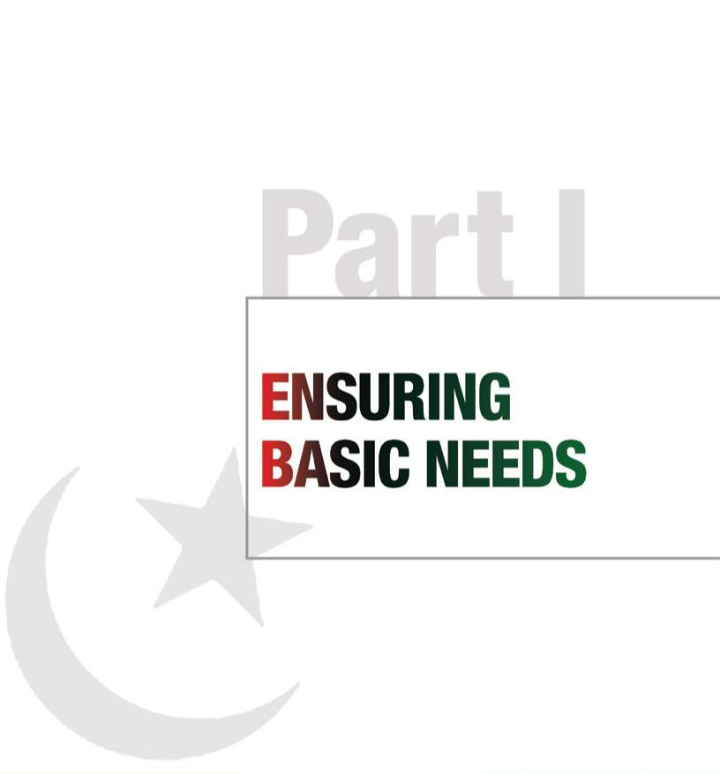

The Party has a clear programme of working collectively to meet the challenge of providing quality health care to all citizens. This involves more than providing the uninsured a working health care option; even those who are insured are not guaranteed quality and convenient access. Too many families face the one-variable issue: the fear that a single episode of illness afflicting one member of the family can throw the entire household into years of struggle and debt. To that end, we have conceptualized programmes to address a wide spectrum of health care issues, reforming health education and certification processes, investing

in preventive medicine, making improvements in curative medicine, improving the regulation of drugs and medical devices, introducing a national health insurance policy, and expanding the Mother and Child Support Programme, a multi-sector initiative that addresses this vital relationship in the homes that it reaches.

We believe that education is the fundamental right of every citizen, and a pathway to opportunity, mobility and the realization of an individual’s full potential. Every child deserves equal access to education, and this challenge needs to be tackled on a priority basis. If we can open the world of schooling and learning to a child, we have forever broadened horizons and planted the seed of hope in a young mind. We believe that education is an essential ingredient for the important virtue of tolerance. The power of education to transform lives is a truth terrorists recognize even as they appropriate it, and so they target our schools and the individuals who seek to promote the value of education. The 18th Amendment declares education to be a fundamental right, and we will work to train educators around Pakistan to create and use assessments that can improve achievement across the country by including the kinds of research, scientific investigation and

12

Pakistan People’s Party Parliamentarians

of power has already taken place in key social

problem-solving techniques that our citizens need to | 13

Pakistan People’s Party Parliamentarians

Part I |  | Manifesto
Ensuring basic needs |  | 2013

Manifesto
2013

“Liberty and freedom depend on social and economic justice... Economic development and political development are surely linked, but both are predicated on guaranteed human rights.”

Shaheed Mohtarma Benazir Bhutto, Indian Wells, California, USA, 2006

learning to a child, we have forever broadened horizons and planted the seed of hope in a young mind. We believe that education is an essential ingredient for the important virtue of tolerance. The power of education to transform lives is a truth

extraordinary economic challenges, the government has remained focused on improving the quality of life of every citizen. Through social security programmes, health initiatives and a renewed focus on education, we have demonstrated our commitment and tenacity

Executive summary

The Party has always identified access to shelter, food security, health care, education and equal opportunity as fundamental rights for all. Poverty alleviation and the provision of safety nets for the economically vulnerable have been core pledges of the Party. In that spirit, we have focused resources to protect the rights of the working classes, and designed government programmes and social safety nets like the Benazir Income Support Programme in our current term and the Lady Health Workers Programme during our earlier government which have been internationally acknowledged for their outreach, efficacy and scale in adapting to local needs and providing universally benchmarked entitlements.

We believe that the government is responsible for the basic welfare of the people. Our flagship social security programmes address a wide spectrum of issues that are key to meeting fundamental needs. The Benazir Income Support Programme (BISP) addresses the vulnerability and needs of those most at risk, and is designed to service and empower the poor by reaching out to those who are doubly disadvantaged—the key 51 per cent of our population: women.

The scale and nature of the current development challenge are not insignificant. The children of 9 million BISP beneficiaries are unable to attend primary school largely owing to financial constraints. The BISP seeks to address this disability and has, across the provincial and partisan political board, initiated a primary education programme for the enrolment of children aged between 5 and 12 years from BISP beneficiary families. In compliance with the Party’s pledges, the BISP strives to reach the

- most disenfranchised citizens to upgrade their socio-economic condition.

We realize that the BISP alone cannot hope to meet the huge challenge of social development in the country, and have therefore designed projects that will harness the resources and energy of the private sector to partner creatively in our endeavours. We have invited researchers, experts and academics to enhance and upgrade initiatives to address emerging and immediate needs. Given that the devolution

of power has already taken place in key social ministries like health and education, our Party has underscored and redefined the role of the provinces in institutionalizing a culture of social protection through the BISP.

The Party has a clear programme of working collectively to meet the challenge of providing quality health care to all citizens. This involves more than providing the uninsured a working health care option; even those who are insured are not guaranteed quality and convenient access. Too many families face the one-variable issue: the fear that a single episode of illness afflicting one member of the family can throw the entire household into years of struggle and debt. To that end, we have conceptualized programmes to address a wide spectrum of health care issues, reforming health education and certification processes, investing

in preventive medicine, making improvements in curative medicine, improving the regulation of drugs and medical devices, introducing a national health insurance policy, and expanding the Mother and Child Support Programme, a multi-sector initiative that addresses this vital relationship in the homes that it reaches.

We believe that education is the fundamental right of every citizen, and a pathway to opportunity, mobility and the realization of an individual’s full potential. Every child deserves equal access to education, and this challenge needs to be tackled on a priority basis. If we can open the world of schooling and

terrorists recognize even as they appropriate it, and so they target our schools and the individuals who seek to promote the value of education. The 18th Amendment declares education to be a fundamental right, and we will work to train educators around Pakistan to create and use assessments that can improve achievement across the country by including the kinds of research, scientific investigation and problem-solving techniques that our citizens need to compete in the 21st century.

The Party champions the rights of the working class. We will continue advocating for and supporting wage earners, factory workers and day labourers. Farmers and workers in the agricultural sector are the backbone of the economy. These citizens must be accorded their due rights and be protected from exploitation. Our public works programmes maintain standards for occupational health and safety, and we will enhance and enforce anti-discrimination legislation. We have abolished special powers to remove employees from service.

The right to housing and shelter is a fundamental right, clearly enunciated in our Party slogan, ‘roti, kapra aur makan’ (‘food, clothing and shelter’). It is our stated goal to provide these rights to every man, woman and child. Housing is essential for personal fulfilment and a better quality of life. Security and shelter are rights essential for a community to live in peace and dignity. The PPPP government has taken a number of important steps to address the housing situation across Pakistan, and we will build on our efforts in the coming years.

Living up to our commitments

Under our Party’s leadership, the government has worked to ensure that the basic needs of all citizens are fulfilled. While facing down the daily threat of terrorism and militancy, and at the same time tackling

in meeting the basic needs of the people.

The Party pioneered the Benazir Income Support Programme (BISP), the first comprehensive social security system in the country, which has drawn unanimous support in the National Assembly and the Senate. Based on its performance, transparency and efficient technology-based systems, the BISP has earned global recognition and donor support and is cited as an example of international best practice. Through the BISP, we conducted a countrywide poverty census, the first such exercise ever carried out in South Asia. We now have poverty scorecards which will ensure that we provide subsidies to deserving segments of society.

Our government provided countrywide counselling, monitoring and training with the Pakistan Poverty Alleviation Fund (PPAF). More than 20 million women have obtained a Computerized National Identity Card (CNIC), and millions of poor people have been brought into the formal financial sector through the introduction of Benazir Smart Cards and Benazir Debit Cards.

Aware of the need to support low-income households, our government expanded the network of low-price Utility Stores across the country, from 560 outlets to 5,700. There are now Utility Stores operating in 34 per cent of the country’s urban centres and 66 per cent of our rural areas, employing close to 15,000 workers. We have completed the groundwork for 2,000 new Utility Stores to start functioning in the near future. Our government also reinstated close to 700 workers who had been dismissed during the previous regime.

Our government established the Prime Minister’s National Health Complex (PMNHC), which aims to house seven upgraded functioning units. The

Drug Regulatory Authority was established with | 15

Pakistan People’s Party Parliamentarians

Pakistan People’s Party Parliamentarians

Manifesto
2013

Manifesto
2013

the mission to ensure the quality and standard of available medicine. Under Shaheed Mohtarma Benazir Bhutto’s leadership, we worked successfully in the past towards eradicating polio. Unfortunately, due to misinformation and propaganda by extremist elements, the disease is on the rise again. Health workers struggling to immunize children are under attack from terrorist organizations. As a result, children as young as 11 months are falling prey to this crippling virus. Despite these challenges, during our current term we have worked with international NGOs and the UN to immunize thousands of children across the country.

Education has been a central pillar of the Party’s policy to take Pakistan into the future. For 2012–13, the government increased the budget for education to 7.845 billion rupees, up 196 per cent from 2011–

- After devolution through the 18th Amendment, strategic priorities and responsibilities for education and health lie with the provinces. This brings services to the grassroots level and improves access for those in need. The federal government is now only responsible for providing health and education services in federally administered areas.

As part of our pro-women policies, we have enhanced women’s representation in top leadership positions in the education system, appointing six women as vice chancellors. The government has enacted several laws aimed at promoting and strengthening our educational institutions including the National Defence University Act 2009, NFC Institute of Engineering and Technology Act 2009, Pakistan Institute of Development Economics Act 2009, National School of Public Policy Act 2010, and Shifa Tameer-e-Millat University Islamabad Act 2011. The Cabinet has also approved the establishment of a Federal Law University.

Under our Party’s leadership, Parliament approved a long-standing demand of the provinces to decentralize the curriculum. Human rights issues were included in the curricula of all provinces except
- Punjab.

The Party’s pro-education policies have enabled over 100,000 young people to receive vocational and technical training. The government established a pilot programme that seeks to develop a number of community centres around the country to impart skills training to women. Under this trade-tested and certified programme, we have to date trained 1,300 workers.

The Party has always remained vigilant and proactive on the issue of workers’ rights. We more than doubled the minimum wage from 4,600 rupees per month to 10,000 rupees and allowed full wages

to be paid even to government workers who were suspended. The government doubled pensions from 1,500 rupees per month to 3,600 rupees. The payment of survivor’s pensions has been extended, covering a disabled child for life and an unmarried daughter until marriage. We also transferred a 12 per cent share in state-owned enterprises to 500,000 employees through the Benazir Employees Stock Option Scheme (BESOS).

Our government extended EOBI coverage to establishments employing five or more workers, besides bringing banking companies and corporate industry under the EOBI scheme and reducing the employer’s contribution from 6 per cent to 5 per cent of the minimum wage to facilitate employers in cutting costs.

Under our government, the Federal Government Employees Housing Foundation (FGEHF) has registered over 20,000 employees to provide them houses. The Pakistan Housing Authority (PHA) has launched seven housing schemes comprising 1,000 residential units across the country, and entered into joint ventures for the construction of a further 2,000 housing units. Pursuant to our Party’s slogan, roti, kapra aur makan, our government announced a plan to construct one million new houses in its current tenure. We initiated work on multiple long- and short-term housing projects in Islamabad, Karachi, Lahore, Peshawar and Quetta. Allotment of plots and houses on a no-profit, no-loss basis is the first phase of the project.

Pakistan People’s Party Parliamentarians

The way forward

Safety nets: Benazir Income Support
Programme

The Party recognizes that society can only be prosperous when social mobility is guaranteed and the working class is empowered as a stakeholder in development. Our government initiated the highly successful Benazir Income Support Programme (BISP), which is now established as one of the largest and most transparent cash transfer programmes in the world. The BISP provides a stipend to women belonging to households that are the poorest of the poor, offering much-needed income support for food, clothing and shelter.

We pledge to further strengthen this programme and expand the social security system to include in its ambit the provision of health, education and livelihoods. Within the BISP are several specific initiatives aimed at addressing various challenges:

- The Waseela-e-Haq programme assists the most vulnerable members of society by providing microcredit to promote entrepreneurship. Successful ventures supported through this initiative transform not just the standard of living of a family but of the local community as a whole.

- The Waseela-e-Rozgar programme aims to provide full vocational and technical training to the poorest Pakistanis, empowering them with the skills they need to find work and earn an honest wage.

- The Waseela-e-Sehat programme underscores the idea that a healthy economy requires a healthy population. It seeks to improve access to quality health services, reduce income loss from catastrophic health shocks and provide a financial cushion in case of the death of a breadwinner.

- The Waseela-e-Taleem programme facilitates families in sending their children to school by linking BISP cash transfers with human capital development. BISP data show that over 71 per

cent of its beneficiaries, aged 5–12, have never attended school. Education is a crucial factor in the development of any society, and we will expand this programme and make it easier for parents to educate their children.

As we continue on our path of empowerment for the deserving segments of society, we will:

- Encourage provincial governments to provide matching grants in order to further expand and strengthen the programme.

- Promote the creation of institutions for special children and children with disabilities, and provide funds for existing schools and facilities for those with special needs.

- Further expand the network of Utility Stores across the country, while re-assessing the system to increase access and improve service delivery.

- Increase BISP monthly cash transfers to 2,000 rupees, pegged to inflation annually.

A new beginning: building a system of entitlements

We believe that the achievement of social policy goals requires not only resources but also effective delivery mechanisms that enable citizens to access their fundamental entitlements. Our efforts have made strides in this direction but there is much more to be done. We hereby renew our pledge to bring a comprehensive, equitable social protection programme to the people of Pakistan.

Health for all

The Party believes that access to quality health services is the right of each and every individual. We will endeavour to achieve our targets for the 2013–18 period through the provincial health ministries by expanding access and enhancing the quality of services, as well as through federal structures for the regulation, standardization and evaluation of the health sector. In our next term we will:

17

Pakistan People’s Party Parliamentarians

Manifesto
2013

Manifesto
2013

- Propose an increase in state spending on health to 5 per cent of consolidated government spending by the end of our next term.

- Seek better governance and transparent utilization of earmarked allocations by the provinces.

- Bring about a revolution in health care by strengthening three of our formative programmes: lady health workers (LHWs), mother and child health, and EPI immunization.

- Cut maternal and infant mortality rates by 60 per cent.

- Tackle through new policy initiatives the issues of socioeconomic disparity and lack of education, which are major impediments to achieving

the health care targets of the Millennium Development Goals.

- Take measures to stem rapid population growth and bring the population growth rate down to 1.6 per cent.

- Increase coverage of LHW services to 100 per cent of rural areas and to urban slums.

Preventive medicine

The main thrust of our health policy on the supply side will be on preventive medicine. To this end, we will:

- Create special departments or units to deal exclusively with preventive health care and medicine.

- Strengthen programmes that deliver on the ground, including the LHW programme.

- Devise strategies to tackle high levels of communicable diseases including gastroenteritis, hepatitis, typhoid, malaria, dengue fever, respiratory disease, tuberculosis and polio.

- Streamline community-level services to create a consolidated programme with adequate organizational, human and budgetary resources to deal with preventive care, primary maternal and child care, immunization, nutrition advice and delivery, and reproductive health.

- • Merge polio eradication, routine vaccination,

LHWs, mother and child care, malaria and hepatitis control, and family planning to create a consolidated and coordinated public health programme, providing security for vaccinators.

- Build on the success of the LHW programme, developing well-resourced community-level interventions to serve as the primary point of contact between service providers and citizens.

- Develop community-level interventions that encompass EPI routine immunization.

- Provide maternal, newborn and child health

(MNCH) services in every basic health unit (BHU) and rural health centre (RHC) in each district.

- Launch behaviour change campaigns in the media, and through community organizations and Party structures, to protect the population from infectious diseases.

- Work on a priority basis to provide clean drinking water and ensure the proper disposal of sewage.

- Introduce nutrition supplements for children, adolescent girls and pregnant women.

- Deploy mobile preventive health care teams to reach universal coverage targets, especially to provide priority coverage to households identified in the poverty survey.

- Ensure that 100 per cent of infants and children under 5 years are vaccinated.

- Procure WHO-certified vaccines at competitive rates.

- Bring equity in service delivery with greater spending for underserved and marginalized areas.

- Eradicate polio by 2015.

Curative medicine

While our efforts in our next tenure will focus on preventive health care and medicine, it is equally important to make strategic improvements in curative medicine. The main approach in this area will be through improvements in tehsil/taluka, district and provincial hospitals, with the upgrading of facilities. We will:

- Establish specialist medical care facilities including trauma centres, and cardiac and nephrology centres at the local level.

Pakistan People’s Party Parliamentarians

- Regulate private hospitals through a systematic evaluation of protocols and medical ethics, and develop insurance plans for health care providers.

- Review the People’s Primary HeathCare Initiative

(PPHI) and develop stronger public–private partnerships for health care delivery systems.

- Improve referral systems for tertiary care, and integrate basic and tertiary care, including data-based linkages between preventive/primary community-level service providers and basic and tertiary care delivery.

- Introduce accountability of health care providers through patient charters and complaint redress systems.

- Decentralize procurement to ensure timely availability of medicines and supplies.

Regulation of drugs and medical devices

The safety and affordability of medicines and medical devices has emerged as a major issue in patient care. Many have lost their lives in tragic incidents involving the use of fake medications. We will take urgent action against spurious and substandard drugs. The Party has already provided for an autonomous and independent monitoring commission to improve exports, implement drug pricing, and assist and enhance our pharmaceutical industry. In our next term we will:

- Develop stronger controls to curb quackery and put an end to the manufacture and sale of spurious and substandard drugs.

- Prepare a formulary of at least 50 essential medications (WHO-recommended) to be manufactured domestically.

- Institute price control mechanisms for life-saving and expensive drugs.

- Ensure the availability of affordable drugs and medications, especially those on the essential list.

National health insurance

The injury or illness of a family member can cause major financial trauma to a low-income household,

often triggering a cycle of debt and hardship. We will introduce a comprehensive national health insurance programme for the underprivileged. Essential health service packages will be developed by the provinces with certain minimum standards of service delivery.

The Party is in the process of formulating a regulatory framework for the micro-insurance health sector. We realize that without meeting the insurance needs of low-income households, the health of our citizens cannot be safeguarded. We anticipate that micro-insurance offerings will help create a transparent and enabling environment for increased health insurance density besides providing affordable health care to low-income groups.

Micro-insurance health units are most often based in the local and social community—village, suburb, katchi abadi (irregular settlement)—and are therefore able to address other important concerns that go beyond primary insurance services, such as training courses on aspects of hygiene and illness. Micro-insurance health units are also important because they increase access to health care services, improve the quality of services, raise awareness of health issues and contribute to community empowerment.

Reforming medical education

We will undertake a strategic review and reform of medical education, with interventions aimed at health professionals including doctors, pharmacists, paramedical staff, technicians and nurses. This reform will be guided by the following objectives:

• Increase the number of educational facilities

for medical personnel such as primary health workers, paramedics and physicians across the board.

• Regulate medical education standards in the

private and public sector.

• Promote degree courses in nursing in the private

and public sector.

• Strengthen community-oriented medical learning

and delivery systems.

• Upgrade the infrastructure of existing medical |  | 19
colleges in the country.
 | Pakistan People’s Party Parliamentarians

Manifesto
2013

Manifesto
2013

Mother and child: building a strong foundation

We recognize the urgency of providing adequate health care to the people, especially mothers and children. The Mother and Child Support Programme (MCSP) is a flagship health care package developed by the Party for implementation in the 2013–18 period. This multi-sector programme is aimed at mothers and children, starting from the time of conception and following through until the child is of school-going age (5 years). Developed following broad-based discussions, the MCSP will focus on providing health care services to a broad range

of stakeholders. This innovative programme will be a demand-side intervention to complement supply-side measures also proposed as part of our manifesto. Through the MCSP, we will:

- Commit to polio eradication as a national priority, integrating it with routine immunization, and provide enhanced security to vaccinators.

- Provide comprehensive support in the areas of maternal, antenatal and postnatal health and care, nutrition, and preschool education.

- Improve maternal and child health, reduce mortality, address malnutrition, and support early learning.

- Reward mothers for pro-health, pro-gender-equality choices, and establish a link between individual mothers and children with health, nutrition and preschool services through an integrated database.

- Provide incentives for an expectant mother to register her pregnancy and to appear for an antenatal consultation at an authorized health care facility. Once a case has been entered into the database, the woman will be provided with a swipe card which will be used to maintain a

record of her and her child’s interactions with health, immunization, nutrition and education services, along with cash or voucher incentives at each critical stage in the 5-year cycle. The mother will receive a cash or voucher incentive for each of three antenatal visits, delivery at an
- authorized health facility, follow-up post-natal

visits, family planning advice, and the entire cycle of immunization for the child, as well as for regular health checks for the child in subsequent years.

- Continue to campaign for responsible family planning, and ensure that women have access to quality health care, family planning services and inexpensive medication.

Family planning

Pakistan’s current population stands at an estimated 180 million, with an annual population growth rate of 2 per cent, the highest in the region. A rapidly growing population adversely affects the well-being of our people by diluting the impact of economic gains, placing a strain on our natural resources and contributing to environmental degradation.

Our Party believes that the well-being of the population is a national priority, and we will ensure sustained commitment to population issues at the highest level. To this end, we will:

- Bring down the population growth rate from the current 2 per cent to 1.6 per cent by 2018.

- Implement an accelerated family planning programme in coordination with initiatives in health, education, nutrition and poverty eradication, using family planning staff and LHWs for a nationwide outreach campaign.

- Promote the idea of family planning services as a right, and enhance, improve and expand access to these services through both the public and private sectors.

- Ensure that all health outlets provide mandatory services to increase current contraceptive prevalence from an estimated 35 per cent to at least 45 per cent by 2018, and 55 per cent by 2020.

- Enhance budgetary commitments to family planning services both at the federal and provincial levels.

- Develop a comprehensive nationwide training programme for public health service providers to enable them to offer family planning services proactively.

Pakistan People’s Party Parliamentarians

- Launch a public awareness campaign targeting and engaging young people.

- Use the incentives-based Mother and Child

Support Programme to reach out to young mothers to promote family planning through birth spacing and delayed first birth.

- Strengthen institutional mechanisms to improve service delivery and enhance coordination.

In order to ensure effective delivery, district coordination officers will monitor and supervise implementation.

- Promote functional integration of health and population departments to ensure efficient service provision.

It is now acknowledged worldwide that focusing on girls’ education and livelihoods for women can be effective in promoting family planning. We are committed fully to promoting girls’ education and to provide women fair and equal access to jobs.

Access to universal and quality education

Honouring the Party’s core commitment to educate each person in Pakistan, we follow in Shaheed Mohtarma Benazir Bhutto’s footsteps to ensure that every child is enrolled in school. The attack on young Malala Yousafzai is proof that there are forces that want to hold Pakistan back from taking our place among the advanced societies of the 21st century, forces that focus their efforts on denying a modern education to our children.

Education reforms are not merely necessary for social development; they lie at the heart of Pakistan’s struggle for an enlightened, modern, progressive future. Our education reforms in the next tenure will be guided by the following policy principles:

- Education for all to eliminate class divides, gender disparities, poverty and unemployment.

- Every citizen should be able to realize their full potential in society through appropriate educational and vocational skills.

- Combat obscurantism and promote a forward-looking national outlook based on our

progressive indigenous traditions and a positive engagement with science, development and universal values.

To implement our education policy, we will:

- Commit 4.5 per cent of GDP to education by the end of our next term.

- Ensure education is treated as a national emergency. This requires effective planning and budgeting as well as a holistic approach to bring about a change in the entire system of education. It requires the development of mechanisms for the exchange of information between different levels of education, and measures to ensure access to schooling for all children.

- Put an end to the abuse of the educational curriculum by removing hate, violence and references to militancy. A comprehensive review of the curriculum will be conducted with the addition of subjects like human rights, ethics, religious tolerance and community work as well as instruction in hygiene, nutrition, reproductive health, environmental protection and sustainability.

- Carry out comprehensive curriculum and academic reform and, for the first time, review and reform language policy with stress on both mother tongue instruction as well as the appropriate introduction of national and international languages.

- Initiate madrassa reforms with the help of madrassa councils to modernize their education systems. No militias will be allowed to seek refuge under the aegis of a madrassa to carry out militant activities.

- Back up constitutional mandates with fiscal allocations that prioritize universal basic education.

- Create a cell within provincial education departments to monitor, coordinate and
overview district-wise utilization of the education

budget. ₂₁

Pakistan People’s Party Parliamentarians

Manifesto
2013

Manifesto
2013

- Carry out a survey of makeshift schools, ‘on-paper’ institutions and degraded facilities in order to upgrade facilities and standardize quality.

- Familiarize teachers at all levels, starting at the province, with the new curriculum and provide training for student performance assessment.

- Promote learning-centred teaching methods and the development of appropriate teaching materials, including through the use of information and communication technology (ICT).

- Put in place appropriate assessment, evaluation and monitoring mechanisms for teachers and students, starting at the provincial level.

- Undertake an in-depth analysis of the size and character of the out-of-school population to ensure their integration into quality schools and other educational and training programmes.

- Strive to first diminish and then remove the qualitative gap between public and private schooling, building a National Education Standards Council for the provinces to coordinate their work.

- Assist the provinces in achieving universal enrolment by 2018.

In our next term, we will:

- Commit 4.5 per cent of GDP to education by the end of our next term.

- Take steps to decentralize decision making for the utilization of funds within the education system.

- Significantly improve the quality of education, ensuring measurable learning outcomes especially in literacy, numeracy and essential life skills.

- Intensify efforts to increase school enrolment and to lower dropout rates.

- Ensure greater transparency and accountability in education at the national, provincial and district levels.

- Eliminate gender disparities in education at the

primary and secondary levels, especially by providing incentives for girls to enrol in school
- and vocational institutions.

- Prepare young people for jobs by providing educational programmes specifically tailored to the job market.

- Significantly improve adult literacy rates and initiate schemes at the district and tehsil levels with the participation of local communities.

- Raise the adult literacy rate from the current 54 per cent to 85 per cent.

- Recognizing that school-going children must be healthy, initiate an extended health care and nutrition programme within the school system.

- Ensure that the learning needs of all young people and adults are met through equitable access to appropriate learning and life skills programmes.

Power to workers and farmers

Historically, the People’s Party has always stood with the working classes and represented their aspirations. We promise that the Party will continue to lead the way in advocating advances for our country’s wage earners, factory workers, farmers and labourers.

We are committed to social justice and we believe the economy cannot flourish unless workers are able to exercise their due rights.

Our government has abolished a number of restrictive labour laws, restored trade unions, devised a new labour policy, promulgated the Industrial Relations Act 2012 and withdrawn special powers to remove employees from service.

Labour representatives will get four seats in the National Assembly, and two seats in each provincial assembly, through legislation.

We raised the minimum wage from 4,600 rupees a month to 10,000 rupees, and allowed full wages to be paid to government workers who were suspended. We doubled pensions from 1,500 rupees a month to 3,600 rupees, and extended the payment of survivor’s pension to cover a disabled child for life and an unmarried daughter until marriage.

The Employees’ Old-Age Benefits Institution (EOBI)

Pakistan People’s Party Parliamentarians

scheme was extended to establishments employing five or more workers, besides bringing banking companies and corporate industry under the EOBI scheme and reducing the employer’s contribution from 6 per cent to 5 per cent of minimum wage to facilitate employers in cutting costs.

We have expanded social security nets and taken

measures to protect the working classes. We now

pledge to move forward on these gains, as follows:

- Through legislation, give labour representatives four seats in the National Assembly, and two seats in each provincial assembly.

- Improve coordination at the federal level to address post-18th Amendment issues and strengthen our position in the ILO, besides ratifying all ILO conventions.

- Pass the Trade Unions Act as an umbrella law to address difficulties and anomalies in industrial relations laws.

- Constitute a powerful and meaningful commission to ensure the implementation of labour laws, labour policy and ILO conventions already ratified. We will repeal all laws in contravention of ILO conventions.

- Construct a labour housing complex in

Islamabad and in the provincial capitals, and set up labour committees at the district level to resolve labour difficulties and disputes.

- Enhance shares up to 25 per cent under the

Benazir Employees Stock Option Scheme (BESOS) and legislate for the removal of section 27B of the Banking Companies Ordinance 1962.

- Promote the registration of workers, including agriculture and general workers, in trade unions and improve the functioning of the Workers Welfare Fund for agricultural and general workers with the issuance of labour cards. Home-based workers, domestic workers, farm workers and peasants will be allowed to register for social security after the appropriate legal mechanisms are devised. All wage earners in a unit will be treated as bona fide workers of that unit.

- Expand the scope of labour laws to cover FATA,

PATA, Gilgit-Baltistan, and Azad Jammu and Kashmir.

- Frame laws to safeguard employment and service conditions, enforce occupational health and safety measures, and promote human resource development.

- Further enhance the minimum wage to 18,000 rupees per month, with the wage rate to be adjusted for inflation.

- Strengthen social security, the EOBI and the Workers Welfare Fund, and ensure that workers are registered in these institutions. The Committee on Labour in the provincial assemblies will oversee the working of these institutions and will have the power to decide on complaints and petitions it receives.

- Enact special laws for home-based and domestic workers to establish trade unions, provide social security and a decent wage, and to end the exploitation of workers by middlemen and employers. We will ensure that the rights of domestic and home-based workers are at par with other members of the workforce.

- Set up special fair-price cooperative shops within the premises of large industrial units and in industrial areas, where bona fide workers will be able to buy monthly rations and items of everyday use up to a limit not exceeding their monthly wages.

- Make maximum resources available for the education and health of workers’ children.

- Promote public–private partnership-based labour colonies to provide workers with housing units and community facilities.

- Provide special incentives, including land free of cost and bank credit, to private-sector units for the construction of housing colonies for their workers. No new unit employing more than 50 workers will be sanctioned unless a housing colony for workers is included in the project proposal.

Housing for all

The housing sector supports economic growth, boosting the local construction and manufacturing industry and creating employment. It provides the best social security and forms the core of our Party’s commitment to the people. In our next term we will:

23

Pakistan People’s Party Parliamentarians

Manifesto
2013

Manifesto
2013

- Pay special attention to housing for the poor, and develop schemes through which more than 500,000 houses will be constructed for the homeless poor in urban and rural areas.

- Provide every government official with a house on mortgage, paying market rates that include interest to cover escalating costs.

- Engage the private and not-for-profit sectors as partners in the development of housing schemes.

- Address the issues of land scarcity and the proliferation of katchi abadis.

- Through reforms in the law, work to ensure that urban areas are revitalized and redeveloped to meet the challenges of housing a growing population.

- Confront the country’s enormous housing deficit by promoting the development of housing in the private sector and ensuring the availability of properly serviced housing sites.

- Improve access to housing finance and building technologies, promoting high-density and mixed land use housing and relaxing taxation and rent restrictions.

Shelter is a fundamental human entitlement that has remained in the forefront of our Party’s investment in the people. Many needs have been identified and met in the past but in order to address the growing housing needs of both urban and rural Pakistan, the Party pledges to strive for affordable, sustainable and environmentally friendly housing for all. To meet this goal, we will work to:

- Provide housing for the poor through special public–private partnership schemes that will build up to 500,000 houses for the homeless poor.

- Construct low-cost housing developments on government land with a 20-year mortgage facility to enable low-income households to shift from rental to owner-occupied dwellings.

- Assist the underprivileged with payment plans, establishing a government-mandated mortgage bank to enable banks and house finance companies to provide long-term mortgages.

- Provide a tax credit to those low-cost housing schemes that use alternative energy as a primary source of power.
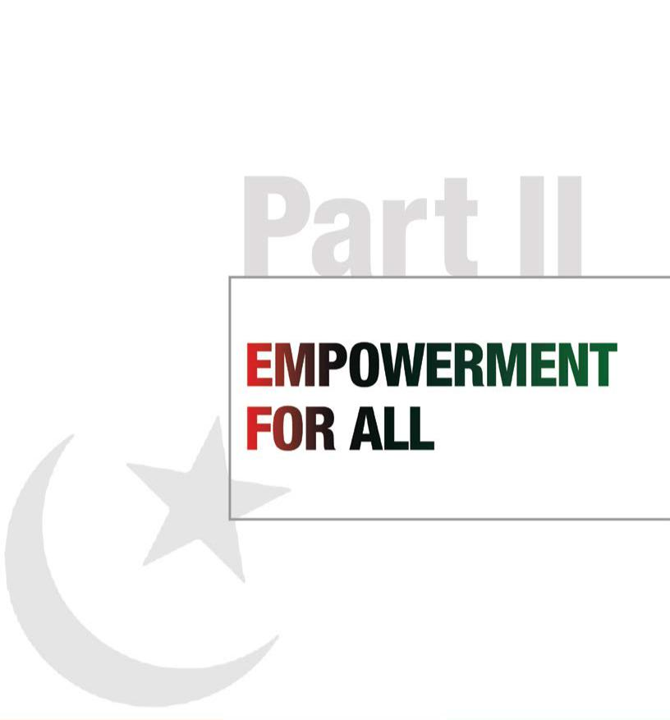

People’s Works Programme

The Party will undertake projects that promote growth and meet the criterion of financial viability over the medium and long term, with high impact in terms of employment and income generation. We will:

- Facilitate labour law reform through technical and financial support for legislation on industrial relations, improved occupational health and safety, and improved employment conditions and services.

- Increase women’s participation in the workplace and secure their rights by enforcing anti-discrimination and anti-harassment legislation.

- Support institutional efforts to prevent child labour and rehabilitate child labourers, and put in place mechanisms to ensure the elimination of child labour practices.

- Promote initiatives to check bonded labour practices and the incidence of internal and external human trafficking, and strengthen law enforcement responses.

- Strengthen institutional mechanisms for inspections as a means to ensure the enforcement of labour laws and practices.

- Enhance the representation and voice of workers through trade union membership.

- Prioritize large-scale infrastructure programmes to modernize and expand roads, bridges, canals and dams.

24

Pakistan People’s Party Parliamentarians

25

Pakistan People’s Party Parliamentarians

  Part II |  | Manifesto
Empowerment for all |  | 2013

Manifesto
2013

“Empowerment is not only a right to have political freedom. Empowerment is the right to be independent; to be educated; to have choices in life.”

Shaheed Mohtarma Benazir Bhutto, Beijing, China, 1995

The Party values the contribution of overseas Pakistanis as an undeniable asset to our nation. In order to build better bridges with this vast and loyal diaspora, we are committed to enabling all Pakistani expatriates in the exercise of their right to franchise

(GRAP), and by distributing land to which women hold the title deeds.

Pakistan’s religious minorities have been under attack since extremists challenged our inclusive

Executive summary

True equality is the legal recognition, soundly expressed in institutions, that the same rights, entitlements and opportunities are due to all human beings. The empowerment of all citizens is one of the central commitments of the Party, and forms the fundamental basis of our vision for an egalitarian, just, inclusive and democratic Pakistan where every individual is able to realize his or her full potential in society without prejudice.

Our founding principles draw upon a rights-based framework. From its inception in 1967, the Party has championed the rights of the vulnerable and stood for the empowerment of the dispossessed. Realizing our responsibility and our sacred pledge to the people of Pakistan, and cognizant of the fact that the path ahead is strewn with challenges and dangers to the vulnerable and disadvantaged, we renew our core commitments to the women, the minorities, the children, the weak, the marginalized, the poor and the homeless of this nation: we will stand by them in their hour of need and work to empower them as equal citizens under the law.

In compliance with our pledge to uphold the rights of all citizens, we have joined voice with workers, peasants, civil society and others to work on enlarging the space for the fundamental freedoms of association, access to information and other rights that were snatched from the people by dictators. We were the first to repeal the black laws against media and civil freedoms, and have further protected the right to information as a fundamental constitutional right via the 18th Amendment.

In our fourth tenure, we have honoured many of our pledges to strengthen and empower women to be part of the economic, social and political mainstream. Our government has targeted women as the beneficiaries of all poverty alleviation and social programmes, and has feminized women’s leadership as an act of political priority. With women in key decision-making positions throughout the

- Party and in government, and as key stakeholders

in social sector programmes like the BISP, we have invested in women as the vehicle of change in their homes, in the fields, in factories, offices and in public life. To further protect and empower women, we will focus on female literacy as the mainstay of our social reform initiatives. We will continue

to spearhead and support all legislative efforts to ensure women’s rights to life and liberty.

Recognizing the extreme pressures and dangers that our religious minorities face as a result of growing extremism and the fallout from the battle against militancy, the Party will build on its commitment to protect and empower minority communities. We honour the sacrifices of Shaheed Salman Taseer and Shaheed Shahbaz Bhatti, men who refused to allow hatred to divide our people. We stand on the shoulders of giants like Shaheed Mohtarma Benazir Bhutto, who paid the ultimate price to keep our country united. We will vigorously strive for equal protection and equal opportunity until we achieve this goal.

Our Party aspires to leverage the youth of Pakistan as key partners in all agendas for a progressive, prosperous and peaceful nation. As one of the largest youth cohorts in the world, our young people need programmes that educate, include and empower them for employment and entrepreneurship. We will provide that to the best of our ability.

We have always invested in the politics of hope. We have made singular commitments to lift the children of this nation out of vulnerability and to battle the poverty and illiteracy that deprive them of opportunity. We will remain proactive in our focus on nutrition, health and basic schooling for all children. The National Commission on Child Welfare and Development (NCCWD) will be strengthened via legislation in order for it to continue its work of providing child welfare and protection frameworks. We will build on our flagship social sector success, the Benazir Income Support Programme (BISP), by establishing complementary programmes centred around children to address delivery and resource gaps in health and schooling, and to protect children and prevent child labour.

as a constitutional prerogative. We have introduced numerous programmes for overseas Pakistanis to invest in their homeland, not just financially but intellectually, socially and culturally as well.

Living up to our commitments

Women form the core of our Party’s empowerment and inclusion project as we rebuild Pakistan after years of dictatorship and grassroots exclusion.

This government and Parliament have enacted more laws in favour of women than all previous governments in Pakistan put together. We have passed landmark legislation defining and criminalizing sexual harassment, protecting women in the workplace, putting an end to harassment against women in the workplace, criminalizing acid and burn attacks, and developing a formal mechanism to support women in distress.

We have begun a process of mainstreaming women’s participation in all walks of life. We have made the National Commission for the Status of Women autonomous of government, and given it full institutional support to advance the cause of women for gender equality, empowerment, political participation, representation, the elimination of discrimination, the promotion of women’s interests, and for maintaining a dialogue with non-governmental organizations, experts and civil society.

We have created a Parliamentary Women’s Caucus to focus on the facilitation and acceleration of legislation in support of women. Our government appointed the first female Foreign Minister and Speaker of the National Assembly, and the first female parliamentary secretaries. We have placed women in prominent positions in the field of education with appointments to university Vice Chancellorships and other leadership positions in academic institutions.

We have launched programmes that aim to make

women economically important to the household

through the Benazir Income Support Programme

(BISP) and the Gender Reform Action Programme

way of life. We have lost great leaders, Shaheed
Salman Taseer and Shaheed Shahbaz Bhatti, who
spoke up for the rights of minorities to be treated in
a just manner and paid the ultimate price for their
principled stand. We will continue to protect, include
and empower the minority communities of Pakistan
and we pledge to do more.
Pakistan’s Constitution, drafted and promulgated
under the leadership of Shaheed Zulfikar Ali Bhutto,
guarantees the rights and fundamental freedoms
of all citizens. It prohibits discrimination against
any citizen on the basis of race, religion, caste,
sex, place of residence or place of birth. We have
always sought to honour the Constitution to the
best of our ability. Under our Party’s leadership,
the system of separate electorates for minorities
was abolished in favour of universal adult suffrage,
fulfilling a long-standing demand of our minorities.
We have confirmed a quota of 5 per cent for
minority representation in the federal government,
and reserved four seats in the Senate. In order to
increase the physical space for religious rituals
and to ensure that this is institutionalized, we have
started by constructing prayer rooms for minorities
in prisons and supporting remission in the sentences
of minority prisoners involved in minor crimes. To
bring minorities into the mainstream, the government
has officially recognized 10 non-Muslim religious
festivals. Similarly, 24 Interfaith Harmony Committees
have been constituted at the district level throughout
the country to create better understanding among
various religious communities.
Under our Party’s leadership, the government has
declared 11th August as Minorities Day to promote
interfaith harmony and understanding in society.
We will continue to use affirmative action as a
tool, enshrined in the Constitution, to support and
increase the representation of religious minorities.
We want to leave to our youth a country where all
citizens enjoy equal rights and protections.
Young people form the backbone of the Party and
have always been in the frontline of the struggle
for the restoration of democracy. Our government | 27
has sought to mainstream this large, dynamic | 27

Pakistan People’s Party Parliamentarians

Pakistan People’s Party Parliamentarians

demographic by fast-tracking growth in employment options. We have set up National Youth Councils to empower young voices and to promote their participation in policy making and civic processes. Our Party will build on the success of this outreach and set up a Youth Parliament at the national and provincial levels. We seek to provide legal cover to the National Internship Programme (NIP), opening up new avenues of opportunity and career advancement in the private and public sectors.

The Party recognizes that we have an uphill battle to fight for the rights of our children, too many of whom remain without access to proper nutrition, are denied education and work lengthy hours in unsafe conditions. We know the future lies in the talents of our children and we will remain vigilant in offering legal protection and the legal enforcement necessary for their success. Pakistan’s prosperity depends on our ability to meet these goals. Under our leadership, the National Commission for Child Welfare and Development (NCCWD) has developed a National Plan of Action and a comprehensive National Child Protection Policy. The Party is committed to abolishing child labour and achieving the Millennium Development Goals.

To protect some of the most vulnerable children in society, the Baitul Maal has established a network of orphanages across the country. We set up some 100 of these ‘Sweet Home’ orphanages, with assistance from philanthropists, to provide shelter to nearly 3,000 children.

Our Party, itself so often denied access to information and the right of association, has worked unremittingly to secure these fundamental rights for the people of Pakistan. Democracy cannot function without an informed public free to express opinions and assemble without fear of reprisal. These are civil rights due to each citizen, and in that spirit we dismantled the laws prohibiting press freedoms and opened the public space for civil society to take its rightful place in the civic process.

We acknowledge the significant contribution of overseas Pakistanis. Their love for and commitment to the motherland is a great source of pride, and their successes demonstrate the potential that lies in our people. Our government has introduced the Foreign Remittance Card and the Pakistan Remittance

- Initiative to allow overseas Pakistanis to be involved with their homeland. We remain committed to our

Manifesto
2013

engagement with Pakistanis abroad, and in today’s globalized world we will maintain their relationship with our culture and economy.

The way forward

Power to women

In its spirit and philosophy, from the very first PPPP government of Shaheed Zulfikar Ali Bhutto, and especially through Shaheed Mohtarma Benazir Bhutto’s terms in office, the Party has promoted
a clear agenda and stood for the rights of the disadvantaged and vulnerable segments of society. Taking forward this agenda, we pledge to:

- Further strengthen the Benazir Income Support

Programme by expanding education, vocational training and health services in coordination with federal agencies, the provinces and line departments.

- Institute quotas in political parties to increase the participation of women. We will propose a law for political parties to commit to an additional 10 per cent quota for women while selecting candidates on general seats.

- Announce a Fair Pay and Fair Job Policy for women, and put in place an Equality Commission which will work to ensure fair pay for women and minorities. It will also seek to ensure that there is no discrimination on the basis of sex, religion or class.

- Increase the job quota for women to 20 per cent, backed by mechanisms for implementation.

- Ensure the mandatory representation of women in all private- and public-sector boards.

- Engage the National Commission for Human

Development to target one million women for literacy and education programmes.

- Frame progressive legislation and ensure its implementation at all levels to secure women’s rights to life, dignity, access to resources, employment, inheritance and justice.

- Frame a dedicated law on the prevention of acid crimes to safeguard women, and on the rights of home-based women workers. Legislation against domestic violence will be extended to all of Pakistan.

- Ensure the provision of credit for women entrepreneurs and rural women farmers by

Pakistan People’s Party Parliamentarians

encouraging commercial banks to develop their SME portfolio and training women entrepreneurs to set up or expand SME businesses.

- Encourage every district to establish cottage and craft industries, with marketing initiatives through public–private partnerships.

- Encourage all social welfare programmes to take special measures to offer social protection to single women not under the care of parents and families, as well as widows and women with special needs.

- Design a special programme to ensure that every woman giving birth is provided safe medical support and every child born is entitled to protection, nutrition and vaccination until the age of 5 years.

- Promote the participation of women in all fields of work, and provide opportunities and services to facilitate this trend. The Party has a strong record of appointing women in high-level decision making positions. It will continue to do so, and to open up opportunities for working women at all levels.

- Through Parliament, ensure that a quota for women judges is put in place so that women are integral to the judicial process at all levels.

- Take concrete steps to ensure the protection of women by initiating reforms in law enforcement agencies and banning illegal alternative justice systems which legitimize crimes against women.

Mainstreaming and protecting minorities

The Party has always stood for an inclusive society where the rights of minorities are protected. The Party has itself made tremendous sacrifices to combat extremism that often targets minorities. Shaheed Mohtarma Benazir Bhutto is in the vanguard of such proud martyrs to the cause. We also recall here the martyrdom of Shaheed Salman Taseer and Shaheed Shahbaz Bhatti who put their lives on the line for a more tolerant Pakistan, honouring the white stripe in our national flag.

The Party’s vision is to build a Pakistan where the distinction between minorities and majorities will be erased, and where equality, interfaith tolerance and plural values will be promoted. We are committed to preventing the misuse of laws to target minorities.

We are working hard to foster religious harmony and tolerance and to prevent incitement to violence on the basis of religion. Recognizing that Pakistan

Manifesto
2013

owes a great debt of healing and protection to its minorities, the Party pledges to strive to:

- Create equal opportunities through progressive legislation and policy reform.

- Build consensus for special procedures in the law to prevent forced conversions.

- Incorporate into the primary and high school curriculum the 11th August 1947 speech of Quaid-e-Azam Mohammad Ali Jinnah, which provided a roadmap for religious harmony in the country.

- Further strengthen interfaith harmony and promote dialogue by involving the best religious scholars of the country.

- Protect religious properties and places of worship with effective security, and refurbish, expand and rebuild them where necessary.

- Acknowledging that violence which takes lives and destroys property can never be fully compensated, make reparations for lost assets, incomes and opportunities.

- Ensure that the Equality Commission monitors the implementation of job quotas for minorities, people with disabilities and other communities facing discrimination.

- Add one more seat in Parliament for minorities to represent the Islamabad Capital Territory (ICT).

- Revive and reconstitute the National

Commission on Minorities as a statutory body with terms of reference that make regular meetings mandatory, provide a budget and establish a secretariat. Its members will include representatives of minority and vulnerable communities.

- Seek Parliament’s advice through its two standing committees on minorities to review the effects of constitutional clauses that discriminate on the basis of religion.

- Ensure that all educational institutions, including primary and secondary schools, higher education institutes, colleges and universities, protect their students from discrimination on the grounds of religion by implementing effective mechanisms for redress and accountability.

- Work to ensure that a more inclusive curriculum is taught at the primary and secondary

school level by producing and disseminating
educational materials and textbooks that
promote equality and respect for diversity. | 29
Pakistan People’s Party Parliamentarians

Manifesto
2013

Manifesto
2013

- Encourage religious tolerance within society through public information campaigns and by sending a clear, unequivocal message to the institutions of the state that state institutions and actors engaging in bigotry, intolerance, discrimination and abuse will be held accountable.

- Urge media houses to set up mechanisms for monitoring and accountability that discourage irresponsible and inaccurate reporting while taking note of public incitement to violence and hate speech against any segment of society, particularly religious minorities.

- Conduct awareness-raising exercises to train the media on reporting on minority issues.

Power to the youth

Throughout the history of the Party, young people have played a vital role as agents of change at the forefront of movements to restore democracy. With more than 60 per cent of our population now under the age of 30, Pakistan is faced with the challenge of bringing millions of young people into the economy. We intend to transform this youth ‘bulge’ into an invaluable human capital dividend that will benefit Pakistan’s future generations.

By lowering the voting age to 18, we have confirmed our commitment to the youth of this nation. The Party recognizes the long road ahead in providing opportunities to our young women and men to realize their potential individually and collectively, and to effectively mainstream them as agents of change for development and transformation.

The low level of skill among Pakistani youth is of great concern, while the current infrastructure for skill development and training remains inadequate. The Party will seek to correct this imbalance by increasing the employability of young people and moving the country towards a knowledge-based economy.

To successfully mainstream young people in development and enhance opportunity, the Party makes the following pledges to the youth of Pakistan. In our next term we will:

- Set up Youth Councils to promote youth participation in policy making, with

representatives from ministries, youth organizations and provincial youth nominees.

- The Youth Council will be a statutory body and

will be formed at the national, provincial and

district levels.

- Establish a Youth Parliament at the national and provincial levels, set up by the respective Youth Councils and with regular funding from the government.

- Emphasize skill development, training and workforce development by strengthening and enhancing the National Vocational and Technical Training Commission (NAVTTC) and its provincial counterparts.

- Provide legal cover to the National Internship

Programme, which will be made autonomous with its own board comprising private-sector, industry and media representatives, so

that youth internships are not restricted to government organizations.

- Expand the Benazir Bhutto Shaheed Youth

Development Programme, a training and apprenticeship scheme based in Sindh, to operate in other provinces through the Benazir Income Support Programme.

- To encourage young people to develop IT skills, undertake a public–private initiative to set up specialized software training centres. NADRA will be further mandated to include training and capacity building in all its registration centres in the districts.

- Motivate our youth to contribute to the national economy by encouraging them to set up small businesses. Banks will be given the mandate to introduce special schemes to reach out to young people establishing SMEs.

- Create a National Scholarship Programme to allow youth from various provinces, especially less-developed areas, to be integrated into the national mainstream. Provide 10,000 scholarships for higher education and specialized technical education for students in FATA and Balochistan.

- Continue to promote the active citizenship of the young by strengthening the National Volunteer Movement set up by Shaheed Zulfikar Ali Bhutto. Through a structured programme of civic engagement and community service, volunteers will be recruited and placed to assist the government in disaster management, education, health and social welfare activities.

The rights of children

The future of Pakistan is its children. The fulfilment of national goals and the welfare and happiness of

Pakistan People’s Party Parliamentarians

the people depend on the opportunities available to them. We are working towards breaking the shackles of the generational poverty that has shuttered Pakistan’s growth.

Under our Party’s leadership, the government has made progress towards achieving key metrics of the Millennium Development Goals (MDGs), particularly those relating to the gross enrolment rate (GER) and infant mortality. A report of the Department of Labour notes that Pakistan has taken a number of steps to abolish child labour.

The NCCWD has prepared a National Plan of Action for Children which provides concrete measures for the protection of children from all forms of neglect, abuse and exploitation. Provincial and district-level stakeholders have been sensitized through a series of consultations.

The NCCWD and the Ministry of Social Welfare and Special Education, in consultation with all relevant stakeholders, have prepared a comprehensive National Child Protection Policy. This policy provides for the adoption of legislative and regulatory measures to protect children from all forms of abuse and exploitation, and for enhancing administrative and institutional capacities at the national, provincial and district levels to effectively address these issues.

We will use the lessons learned from the BISP to create a child-centred system of social programmes across three sectors: nutrition, primary and maternal health, and basic schooling. At the same time, legal mechanisms will be put in place to ensure that children’s rights are emphasized and protected. We pledge to:

- Bring all laws and rules in conformity with our national and international commitments.

- Strengthen the NCCWD through legislation by providing it with an independent and autonomous status. As the subject of child protection is spread across several departments of the provincial government, the NCCWD will play the role of coordination and reportage at the national level. Child Protection Authorities and Bureaus that coordinate child welfare
and protection at the provincial level will be consolidated.

- Amend the Pakistan Penal Code to raise the minimum age of criminal responsibility from

7 to 12 years, in accordance with Pakistan’s commitment to international covenants.

- Amend the Juvenile Justice System Ordinance

2002 to allow for the creation of children’s courts, and assess other means to strengthen the juvenile justice system.

- Make rules and put in place enforcement mechanisms to ban the employment of children under the age of 14, and regulate employment between the ages of 14 and 18.

- Provide training programmes and opportunities for children between the ages of 14 and 18 as a supplement to their secondary education.

- Amend the Prevention and Control of Human

Trafficking Ordinance 2002 to include internal trafficking, drug trafficking, the organ trade and forced marriages.

- Parallel to and in correspondence with the

BISP, establish a cross-sectoral child-centred programme operating at the appropriate tiers of government. Areas and sectors that are the domain of provincial governments will be responsible for provincial interventions, and those at the federal level will work with national interventions. Child nutrition and development will be the main objectives of this programme, which will be framed primarily around three existing hubs of intervention: schools, health centres and LHWs.

Freedom of Expression and the Right to
Information
The Party believes in the fundamental right of access
to information for all citizens. Within the first 100
days of its current term in office, our government
successfully dismantled the black laws inhibiting
press and media freedoms.
In our next term, we will enact an effective
Freedom of Information law, in consultation with all
stakeholders. We believe in the rights of all workers,
and will endeavour to implement the Wage Board
Award for newspaper employees.
During our tenure, a Press Commission has been
established, which will be strengthened and made
more effective, in consultation with all stakeholders.
We will work with private media companies to
provide security and safeguards for working
journalists. We pledge to set up a media city and | 31
university in Islamabad to train and educate media | 31
Pakistan People’s Party Parliamentarians

Manifesto
2013

Manifesto
2013

professionals in the highest journalistic standards. We will work towards reforming Pakistan Press Council legislation to strengthen this important forum for media accountability.

International human rights instruments and Pakistan

Under the Party’s leadership, Pakistan has ratified the International Covenant on Civil and Political Rights (ICCPR), the Convention against Torture and other Cruel, Inhuman or Degrading Treatment or Punishment (CAT), the Convention on the Rights of Persons with Disabilities, and the Optional Protocol to the Convention on the Rights of the Child on the sale of children, child prostitution and child pornography. With these ratifications, Pakistan has become a party to all core human rights instruments. We are now focusing our efforts on implementing these conventions and treaties.

Pakistan now also serves on the UN Human Rights Council. The government, under our Party’s leadership, attaches great importance to constructive engagement with special mechanisms of the Human Rights Council. Our government has demonstrated its cooperation with the UN’s human rights machinery by extending invitations to the UN High Commissioner for Human Rights and three special mechanisms, namely, the Special Rapporteur on Independence of Judges and Lawyers, the Special Rapporteur on Freedom of Opinion and Expression, and the Working Group on Enforced or Involuntary Disappearances.

In our next term, we will continue to work with international human rights organizations to ensure the fundamental rights of Pakistani citizens are safeguarded. We will uphold and work towards further implementation of all international covenants and treaties to which Pakistan is a signatory, and will fulfil our obligations to promote and protect fundamental human rights.

Civil society

As Pakistan goes through a period of transition while battling forces of extremism, the need of the hour is to counter and resist extremist elements through a vibrant and robust civil society. The Party has worked with civil society and leading human

- rights organizations in drafting and implementing key

legislation to safeguard human rights, especially the rights of women. While keeping in mind the law and order situation, our government has strived to protect civil society’s right of association, and we will ensure this right is safeguarded in our next tenure. Aware of its role as a vital stakeholder, the Party will continue to work with and seek inputs from civil society on issues of national importance, legislative measures and the implementation of human rights.

Enforced disappearances and missing persons

The Party is committed to resolving cases of enforced disappearances and missing persons. A Commission of Inquiry on Enforced Disappearances is working on this issue and has been successful in the resolution of a large number of cases. The Party supports all efforts to bring to justice those involved in wrongdoing, and to provide relief to the affected families. Pakistan is also cooperating with the UN Working Group on Enforced or Involuntary Disappearances and a number of cases have been cleared.

Strengthening ties with overseas Pakistanis

The Party is proud of Pakistanis living abroad who have helped advance the cause of Pakistan through hard work and entrepreneurship wherever they have settled. Shaheed Mohtarma Benazir Bhutto’s policies to export labour have allowed millions of Pakistanis now settled abroad to send remittances home, thereby helping to bolster the local and national economy. The Party has introduced the Foreign Remittance Card and the Pakistan Remittance Initiative, which have raised the number of cash transfers to Pakistan. In our next term we will:

- Continue our engagement with Pakistanis abroad, facilitate their travel and strengthen their ties with the national economy by increasing and improving their access to investment at home.

- Encourage expatriate Pakistanis to invest in social-sector programmes including education and health.

- Build consensus and the necessary infrastructure to allow Pakistanis abroad, including those with dual nationality, to exercise their right to vote.

Pakistan People’s Party Parliamentarians

33

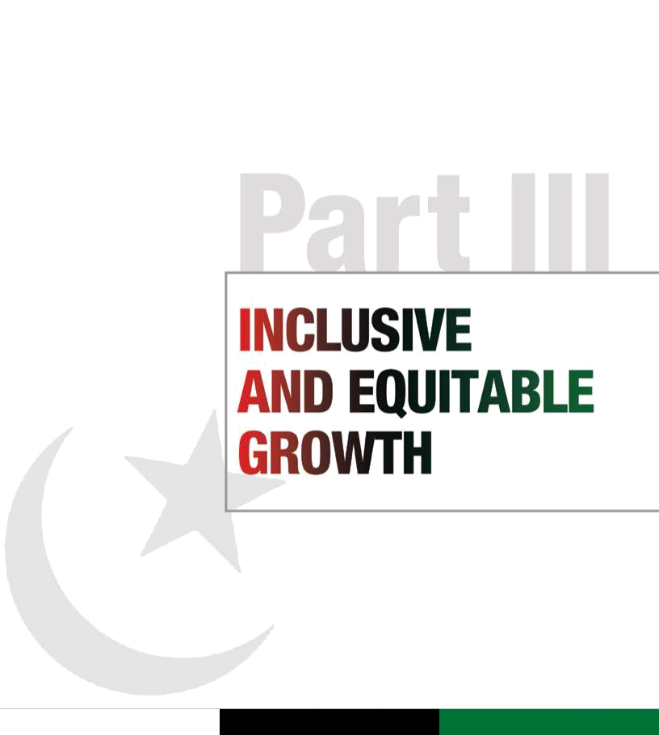

Pakistan People’s Party Parliamentarians

Part III |  | Manifesto
Inclusive and equitable growth |  | 2013

Manifesto
2013

“The People’s Party is a party of the industrial workers, the agricultural labourers and the small man. The interests of these people will continue to have the first call on our resources. We are determined to have an egalitarian society.”

Shaheed Zulfikar Ali Bhutto, Karachi, Pakistan, 1972

employs 60 per cent of our workforce. In order to maximize gains from this big employer we will create clusters or cooperatives of farmers covering up to 500 acres. Facilities and inputs such as tractors, laser levellers, fertilizer, seeds and pesticides will be accessible through collective credit, or ‘group loans’. Agriculture markets at the tehsil/taluka level will be set up with dry and cold storage facilities, using storage as fast-track collateral for financial institutions, thereby unlocking new potential. To

an unprecedented new layer documentation. Life

and health insurance will be added to its delivery

priorities.

Pakistan’s banking sector has shown great resilience, emerging virtually unscathed from the global financial meltdown of 2008. The sector is fairly mature in terms of supply and product ranges including Shariah-compliant products. Although we have made progress in electronic payments, the

Executive summary

Since the days of the first PPPP government, when Shaheed Zulfikar Ali Bhutto took his message of change to the country, the Party has stood on the frontlines of shaping imaginative and equitable policy responses to the core needs of Pakistan’s people. The provision of credit and jobs in rural and urban sectors, the protection of labour, and the creation of capital to spur growth and investment in social and human development remain at the heart of our pro-poor economic policy.

In the last five years we have guided the national economy through choppy global economic waters, with rising food and oil prices, natural disasters that left livelihoods, homes and fields in tatters, virtually no investment in energy, and a battle against militancy and terror that slowed down investment as well as job creation. We inherited a bubble economy based perilously on consumer credit, stock market speculation, property mark-ups, non-transparent privatization and foreign aid. Inflation stood at 25 per cent, stripping the middle classes of mobility, making the poor dangerously vulnerable to local and international shocks.

Our government moved immediately to stabilize the fragile economy and cut budget deficits by sharply reducing government expenditure, correcting the artificial exchange rate for the rupee, extending the tax net, boosting exports, and protecting the poorest by making the first social transfers based on poverty in the history of this nation. Continuing with our promise to bring equity to labour, we pioneered the concept of industrial workers owning a share in the public-sector company in which they work.

We lowered inflation to single digits, and reduced and restructured subsidies for the public sector
- without damaging labour’s needs. In fact, despite the

fiscal squeeze resulting from external pressures and global recession, our prudent management attracted record overseas remittances and cut the fiscal deficit from 7.6 per cent of GDP in 2008 to 6.6 per cent in 2013, a record that compares favourably with many bigger economies. Despite the challenges that came our way from disastrous flooding and terrorism’s impact on the investment and job climate, we kept public borrowing under 60 per cent of GDP so we could maintain our threshold for meeting external liabilities. Our prudent policies allowed us to turn a current account deficit of 14 billion US dollars in 2008 to a surplus of 62 billion US dollars in 2013.

Under our leadership, investor confidence grew. The Karachi Stock Exchange (KSE) index, which stood at 4,800 points in 2008, crossed 18,000 points in 2013.

Going forward with capitalizing on the country’s untapped geographical and natural resources, our aim is to increase the GDP growth rate to 6 per cent by 2016, and 8 per cent by 2018. Our economic policy will focus on agriculture, access to finance, equitable taxation, responsible borrowing, and building on our social safety programmes.

During our current term we raised the support price of wheat, bringing relief to farmers across Pakistan. As a result, wheat yields were increased and we were able once again to export the surplus.

We encouraged mechanized farming, distributing agricultural equipment and farm implements at subsidized rates, and provided seed and fertilizer free of cost to farmers affected by the devastating floods of 2010 and 2011. Our government also provided 16 billion rupees in subsidies to farmers for tube wells. Looking beyond the immediate needs of farmers, we developed a policy for crop insurance which we will implement during our next term. Our policies so far have taken a significant step towards increasing food security in Pakistan.

The Party recognizes that while agriculture accounts for 24 per cent of GDP, it directly and indirectly

conserve water, which is a major priority, drip irrigation will be encouraged along with greater use of solar tube wells, biogas and wind turbines. In order to reduce rural dependency on the arti or middleman, market prices will be made available in real time.

To provide stability, support prices of wheat, rice, sugarcane and cotton will be announced every year. In order to increase capital for farmers, the State Bank of Pakistan (SBP) will direct commercial banks to increase the allocation of credit for this sector. We will continue to provide land to landless farmers, and to invest in research and development to improve crop yields. We will initiate the legalization of land title deeds.

We will pioneer a People’s Agriculture Programme (PAP) to target farmers with landholdings under 25 acres. They will be supported with new models of land preparation, drip irrigation, access to capital, high-quality seeds and advice on yield enhancement.

Given that livestock comprises 13 per cent of GDP and Pakistan is the world’s 5th-largest producer of milk, special emphasis will be given to this sector. A programme similar to the PAP will be piloted, establishing new livestock cooperatives that will work through women owners of animal capital, with linkages provided to producers for scale. Access to credit will be provided through the ZTBL and microfinance institutions, and by encouraging commercial banks to lend to SMEs.

The Party’s commitment to eradicate poverty through transparent initiatives like the Benazir Income Support Programme (BISP) has lifted millions of people out of abject poverty. As Pakistan’s first real social security net, BISP is already recognized as one of the largest and most successful poverty reduction programmes internationally. Established in 2008, it has to date disbursed 138 billion rupees to five million women, all of whom are now registered CNIC holders. In the next five years we will transform the BISP from a poverty alleviation programme to a comprehensive social security programme with

entry of cellular companies in tele-banking has been
truly remarkable. Currently, 9 per cent of payments
are settled through mobile phones, the penetration of
which is assessed to be more than 60 million, or one
third of the population.
Realizing that 85 per cent of Pakistanis do not have
access to formal banking and credit, we will tackle
the problem of financial exclusion by extending
the outreach of the branchless banking initiative
undertaken by this government. Through this path-
breaking move, citizens in remote areas will be
empowered with the ability to open a basic banking
account along with access to savings and domestic
remittance facilities. We will leverage the smart
NADRA card to enable all Pakistanis with mobile
phones to maintain a savings account.
We will raise our low tax-to-GDP ratio to 15 per
cent by 2017, bringing into the tax net all sectors
of the economy. During our current term, we raised
tax revenues from 1 trillion rupees in 2008 to more
than 2 trillion rupees in 2013. In our next term we
will further curtail revenue leakages as a result
of exemptions, loopholes, inequitable statutory
regulatory orders (SROs) and under-reporting, with
an effective auditing system. We will also use the
NADRA database to tax the high-consuming
non-taxpaying elites, increasing the number of
taxpayers to 5 million by 2014. We will complement
this initiative by revising subsidies provided to
electricity, gas and petrol users, targeting only low-
income groups.
We will reduce government borrowing, and work
on a balanced monetary and fiscal policy. We will
lower the budgetary deficit to less than 4 per cent of
GDP by 2017 and aim to keep our total debt within
60 per cent of GDP. Our revised fiscal policy will
provide the required revenue to enable us to achieve
our monetary objectives.
Pakistan’s foreign exchange reserves, as low as | 35
8.2 billion US dollars when we assumed office, | 35

Pakistan People’s Party Parliamentarians

Pakistan People’s Party Parliamentarians

Manifesto
2013

Manifesto
2013

now stand at 13.2 billion. Under our watch, foreign remittances under the Pakistan Remittance Initiative (PRI) have grown exponentially, currently amounting to between 13.5 and 14 billion US dollars, up from

6.4 billion US dollars in 2008. We will further increase the annual quantum of incoming foreign exchange to 20 billion US dollars by attracting remittances for the purpose of investment as opposed to consumption. Investment funds will be created for housing societies and the SME sector to provide new investment opportunities to the Pakistani diaspora.

On the international front, our debt policy will focus on loans for productive purposes which include a large grant component and the servicing of which does not put excessive pressure on our foreign exchange reserves.

We paid close attention to the needs of the textile industry. As a result, Pakistan’s textile exports rose from 10 billion US dollars to 13 billion over the last five years. An important achievement in this regard was the development and approval of the country’s first Textiles Policy, which announced various short-and long-term measures to support the industry and restore the competitiveness of our exports. We took a number of steps to build the necessary infrastructure to promote investment in the sector, thereby also creating thousands of jobs. To build a technically sound base for the sector, we established a vocational training institute for garment workers and set up a number of training programmes. Major reforms were also carried out to revitalize and re-energize the National Textile University.

Small and medium enterprises (SMEs) can serve as the engine of growth for the economy. This sector contributes 6.74 per cent to GDP and accounts for

6.6 per cent of the banking industry’s loan stock. In our next term we will prepare the ground for large-scale investment in the SME sector by improving governance and introducing capital discipline.

Understanding the challenge of global competitiveness to attract foreign direct investment, the government has promoted the enactment of the Special Economic Zones (SEZ) Act 2012.

Living up to our commitments

36 | In line with Party pledges to labour, 12,000 contract
36 | employees were regularized during this government,

enabling them to benefit from permanent employee status and benefits. In addition, 12 per cent equity in state-owned enterprises was distributed gratis to 500,000 employees through the BESOS programme. We reinstated 60,000 workers to their jobs and facilitated the employment of 660,000 Pakistanis abroad. Since 2008, 100,000 internships have been provided under the National Internship Programme. We redoubled our efforts to provide a social safety net for this country’s poor. With the introduction of the Benazir Income Support Programme (BISP), we created a world-class, transparent initiative. Under this gold standard of safety programmes, 5 million women were provided 2,000 rupees every other month, totalling 70 billion rupees. An additional 7 billion rupees was distributed to the poor through the Baitul Maal and other channels, while 52 billion rupees went to flood affectees under the Citizen Damage Compensation Programme (CDCP). Despite our austerity policy which required the slashing of government expenditure, we did not neglect the Public Sector Development Programme, increasing allocations for crucial development projects from 280 billion rupees in 2008 to 450 billion rupees in 2013.

While increasing spending on critical areas such as poverty alleviation, our government has taken measures to bring more earners into the tax net. During our current term, we raised tax revenues from 1 trillion rupees in 2008 to more than 2 trillion rupees in 2013. As a result of our efforts, during the year 2011–12 alone, tax revenues grew by 22.4 per cent compared to the previous year. In fact, the FBR’s year-on-year tax revenue increase has been the highest in the last decade. It is also a significant achievement that tax revenue has doubled since 2007–08.

In order to provide relief to the common man, inflation was reduced to single digits, standing at

9.6 per cent in 2013. Meanwhile, a policy of fiscal prudence kept public borrowing under 60 per cent of GDP. Debt as a percentage of GDP is currently at the same level as 2007–08. The fiscal deficit was 6.6 per cent of GDP (compared to India at 8.7 per cent and the US at 8.9 per cent). As a result of our policies, we were able to turn a current account deficit of 14 billion US dollars in 2008 to a surplus of 62 billion US dollars in 2013. Our foreign exchange reserves, as low as 8.2 billion US dollars when

we assumed office, now stand at 13.2 billion. To generate growth and lower the cost of borrowing, we brought the interest rate down from 15 per cent in 2008 to 9.6 per cent in 2013. In the current fiscal year

Pakistan People’s Party Parliamentarians

alone, the interest rate was reduced by 150 basis points. International remittances under the Pakistan Remittance Initiative (PRI) have more than doubled over the last four years, from 6.4 billion US dollars in 2008 to between 13.5 and 14 billion US dollars currently.

Under our leadership, investor confidence grew. The Karachi Stock Exchange (KSE) index, which stood at 4,800 points in 2008, crossed 18,000 points in 2013.

Our government developed a comprehensive Strategic Trade Policy Framework to boost the country’s exports. We acted immediately to implement the policy and, as a result, exceeded our target a year ahead of schedule, with a record 24.82 billion US dollars of exports in the year 2010–11. We reached market access agreements with a number of countries and regions, and were able to negotiate favourable terms and concessions for our exports. To cement these gains, we sent nearly 50 trade delegations to 30 countries, besides continuing to support the Expo Pakistan annual exhibition which attracted more than 4,000 buyers from 17 countries. Under our Party’s leadership, a law was passed to establish the Pakistan Institute of Fashion Design (PIFD), and six colleges affiliated with the PIFD were set up, one each in Faisalabad, Hala, Islamabad, Multan, Peshawar and Quetta. We also established the Pakistan Horticulture Development and Export Company (PHDEP), which has already found new markets for our fruit exports.

Aware of the need to promote enterprise, we took steps to facilitate large and small businesses. The Small and Medium Enterprises Development Authority (SMEDA) established ‘Business Incubation Centres’ for women entrepreneurs in Karachi, Lahore, Mingora, Peshawar and Quetta. A foundry service centre was established in Lahore, which benefited 800 foundries. The Economic Revitalization of Khyber Pakhtunkhwa and FATA (ERKF) initiative was launched in 2011. A project to revive Multan’s traditional blue pottery was initiated. To revitalize the traditional craft of handloom weaving (khadi), the Khadi Crafts Development Company was established. Focusing on the rural economy, a processing centre for red chillies was set up in Sindh.

Under our Party’s leadership, legislation was enacted to provide for the establishment of special economic zones. The passage of the Special Economic Zones Act 2012 is a major achievement. This law will enable the creation of industrial clusters, supported with liberal incentives, adequate infrastructure and

investor facilitation services to increase productivity and reduce costs.

Recognizing that agriculture accounts for 24 per cent of GDP and directly or indirectly employs 60 per cent of our workforce, during our current term we raised the support price of wheat, bringing relief to farmers across Pakistan. As a result, yields were increased and we were able to once again export the surplus. The wheat we produce is of the highest quality, and with further support measures we will be able to attract foreign investment to this sector.

To encourage mechanized farming, we distributed agricultural equipment and farm implements at subsidized rates. Thousands of tractors have been provided to farmers through transparent balloting, especially in Sindh. Cognizant of the fact that many farming communities were devastated by the floods of 2010 and 2011, we supported and helped to rehabilitate destroyed farms by providing free seed and fertilizer. Our government made available 16 billion rupees in subsidies to farmers for tube wells. Looking beyond the immediate needs of farmers, we developed a policy for crop insurance which we will implement during our next term. This will add a layer of protection and help to increase agricultural output. Most importantly, our policies so far have taken a significant step towards increasing food security in Pakistan.

The way forward

The provision of social and economic justice is a central tenet of our Party’s policy goals. Without it there can be no pursuit of freedom or access to fundamental entitlements. Sustained growth can only be achieved by continuous investment in our human resources, and no nation can ever be secure until its people are able to obtain the basic necessities and standard of living that bring dignity and fulfilment to the human race.

While building on social and human development, creating employment continues to be a core policy objective, buttressed by a roadmap for tangible results that improve the daily lives of Pakistani citizens.

In the last five years our economic growth was
based on investing in the people of Pakistan. During
this period of extreme global recession, the Party | 37
not only worked within a policy framework that | 37

Pakistan People’s Party Parliamentarians

Manifesto
2013

Manifesto
2013

 |  |  | was responsive to daily fluctuations in the national
 |  |  | and international economy but also developed
 |  |  | mechanisms to control inflation, boost local
 |  |  | production, ensure quality and competition in all
 |  |  | sectors and industries, and promote exports. We
 |  |  | developed policies and legislation to enhance the
 |  |  | ease of doing business in order to make Pakistan a
 |  |  | business-friendly and investor-friendly country.
 |  |  | Our Party generated new employment on a large
 |  |  | scale in the public sector, provided job security by
 |  |  | regularizing temporary workers, and expanded the
 |  |  | impact of social security systems by increasing
 |  |  | wages, salaries and pensions.
 |  |  | Through the BESOS programme, we transferred
 |  |  | almost 50 per cent of our small holdings in public-
 |  |  | sector enterprises to industrial workers in units
 |  |  | that had earlier been sold at throwaway prices
 |  |  | to monopolies and profiteers. These steps were
 |  |  | taken despite the fact that the loot privatization of
 |  |  | profit-making public-sector units by our ideological
 |  |  | opponents had shrunk the public sector by more
 |  |  | than 80 per cent. This non-transparency and
 |  |  | profligacy is not the way forward.
 |  |  | The Party will aim to maintain and strengthen
 |  |  | macroeconomic stability with the ultimate objective
 |  |  | of fostering an environment of pro-poor growth
 |  |  | with low and stable inflation. This policy will be
 |  |  | underpinned by well-articulated measures aimed at
 |  |  | creating an egalitarian and efficient economy with
 |  |  | poverty alleviation as a central focus.
 |  |  | Inflation has already been brought down to single
 |  |  | digits for the first time in five years, and is now at
 |  |  | the same level as other regional economies such
 |  |  | as India. Going forward, we will take measures to
 |  |  | ensure that inflation is kept at a level of 6–8 per
 |  |  | cent that will not cause hardship to the public’s
 |  |  | purchasing power.
 |  |  | We will aim to raise the average growth rate to 6
 |  |  | per cent by 2016 and to 8 per cent by 2018. We
 |  |  | will focus on increasing growth in the agriculture,
 |  |  | industrial and services sectors by facilitating markets
 |  |  | and improving the competitive environment. We will
 |  |  | push through further deregulation regimes in the
 |  |  | energy, airlines, and transport and communications
 |  |  | sectors.
 |  |  | We will focus on reducing food prices by
 |  |  | encouraging supply side improvements (for example,
38 |  |  | improving agriculture yields, facilitating small farmers,
 |  |  | improving farm-to-market access).

We will reduce trade barriers and enter into agreements for free trade with friendly countries to benefit Pakistani industries and exports.

We will facilitate businesses by increasing the availability of energy and improving governance, with the goal of making Pakistan a business destination.

We will encourage the banking sector to provide innovative banking and financial solutions, including Islamic banking.

We will raise the tax-to-GDP ratio to 15 per cent by 2017. We will increase revenues by bringing into the net elites that evade taxes, and rationalize the tax regimes for direct and indirect taxes. With respect to direct taxes, we will make the centrepiece of our fiscal reforms a well-functioning, transparent, equitable and effective tax system that is simple to implement. Every sector of the economy will

be required to contribute its share to the revenue pool, including agriculture, the stock market, real estate, trade, manufacturing and the services sector. Revenue leakages through exemptions, loopholes, evasion and under-reporting will be curbed with strict compliance requirements and an effective auditing system.

We will reduce government borrowing from the State Bank, work on a balanced monetary and fiscal policy, lower the budgetary deficit by 2017 to less than 4 per cent of GDP, and keep our debt within 60 per cent of GDP.

We will bring stability to the Pakistani rupee by ensuring that the country has sufficient foreign reserves to meet all its foreign exchange liabilities.

We will encourage the manufacturing sector to increase exports with the aim of doubling our exports by 2017. In addition, we will establish special economic zones and facilitate foreign investment.

We will continue to engage with multilateral and bilateral financial institutions, and acquire loans only for the purposes of development.

Recognizing that an effective growth strategy requires resource mobilization, we will encourage domestic savings, with a target of 15 per cent of GDP, and streamline the fiscal operations of the government for more efficiency.

Pakistan People’s Party Parliamentarians

We will follow prudent policies to ensure that there are no current expenditure overruns. Inflation-inducing expenditure with low employment and income impact will be strongly discouraged.

Expenditure for social safety nets, such as the BISP, will be protected and the effectiveness of programmes enhanced by means-testing for better targeting. We will ensure that a significant component of this expenditure is transformed into ‘cash on delivery’ programmes, where payments are predicated on acquiring skills or education, to foster economic independence over the medium term and discourage the culture of lifelong dependence.

Our debt management policy will ensure that the twin deficits of budget and balance of payments are financed without placing undue stress on the economy. This policy will be guided by the principle of debt sustainability, and will entail measures to keep fiscal deficits small enough that government borrowing supports low interest rates, checks inflationary pressures, and does not crowd out funds for private-sector investment.

With respect to external debt, only those loans will be incurred that have a high grant element and a long repayment period, and the servicing of which does not drain precious foreign exchange resources.

The primary aim of our financial policy will be to keep inflation low, encourage savings, help maintain a stable and competitive exchange rate, and protect the value of investors’ and depositors’ financial assets.

While the government can provide a stable macroeconomic framework, a dynamic private sector is the engine of growth. We will encourage small and medium enterprise (SME), a sector that accounts for nearly two thirds of national output, employment and exports. We will promote women’s entrepreneurship by increasing their access to credit.

The politics of subsidies needs a massive overhaul. Dictatorships have promoted the transfer of resources from the poor to the rich by providing subsidies to the rich. Our Party believes in working actively for the betterment of the poor and dispossessed. We will rationalize subsidies in favour of the poor without squandering state resources on those sections of society that have the financial means to support themselves.

We have successfully executed currency swap
agreements with China and Turkey. Plans are already
in the pipelines to reach similar agreements with
other countries to increase trade. This strategy
will not only raise the level of our exports but also
improve our balance of payments. It will enable
small- and medium-sized companies to increase
productivity for both domestic and overseas markets.
Despite the global financial crisis, our banking
system has remained strong. The entry into Pakistan
in 2011 of the Industrial Commercial Bank of China
(ICBC), the largest bank in the world, is a testament
to our financial stability. Other internationally
renowned institutions have already agreed and
expressed willingness to establish a physical
presence in Pakistan, which will provide new and
competitive financial products and services to the
public.
In November 2012, Pakistan received international
recognition from the Financial Times and the
World Bank for its leading role in microfinance and
branchless banking, with over 3 million borrowers.
Going forward we will maintain this momentum and
invest in strategic initiatives to transform the financial
market into an equitable system of efficient market-
based financial services that include the hitherto
excluded poor and marginalized segments of society.
We will aggressively promote access to finance in
underserved areas and provide a safety net for small
depositors. Over the last five years, a network of
more than 32,000 branchless banking agents has
been established throughout the country, providing
financial services to low-income groups who do not
maintain bank accounts. This is a huge success. We
expect this network to double in size in the coming
years to serve the unbanked sectors of the economy.
Our strategy to date has seen home remittances
more than double, from 6.5 billion US dollars in
2008 to 13.2 billion in 2012, improving our overall
balance of payments. We will target an annual 2
billion increase in remittances. Our efforts will focus
on ensuring continued increases in the years ahead
with further incentives for Pakistanis abroad to use
banking channels to remit their savings to Pakistan.
We will expand the Crop Insurance Programme to
cover small farmers growing wheat, rice, cotton,
sugarcane and maize to protect them in the case | 39
of calamities, and increase their access to bank | 39
Pakistan People’s Party Parliamentarians

financing. In addition, credit guarantees will be provided under the Financial Inclusion Programme.

As one of the largest megacities of the world and the country’s port, Karachi will receive a special grant in the NFC Award from the federal divisible pool.

Poverty alleviation: the Benazir Income Support Programme

Our commitment to attack poverty directly and strategically is clear from our poverty alleviation programmes. This includes the Benazir Income Support Programme (BISP), which is one of our government’s greatest achievements. Among the largest poverty reduction programmes in the region, the BISP is now widely acknowledged by the international development community as a world-class social protection initiative. Its most significant achievement to date is the establishment of systems through which the state can reliably and efficiently reach out to individual citizens, particularly women, from the poorest households.

Through this programme, which creates the organizational basis for a direct relationship between citizens and the state, we have started to build the first people’s welfare state in Pakistan.

The BISP compensates 5 million women from low-income households, identified through a special survey, and provides them with a cash grant of

2,000 rupees every two months. More than 70 billion rupees has so far been disbursed to the poorest of the poor, while additional programmes for technical education and enterprise development target the same households.

An indirect benefit of this programme has been an increase in women’s registration for the Computerized National Identity Card (CNIC). To date, 15 million women have registered for CNICs as a result of the BISP. The CNIC is a prerequisite for most government entitlements and for voting. The BISP has thus empowered women by not only providing financial support but also taking them a step closer to exercising full citizenship rights.

The same targeting and programmatic approach proved highly effective in the IDP crisis and during the floods of 2010 and 2011. Linking cash compensation with the NADRA database, through

- requirements such as the Watan Card and Pakistan

Manifesto
2013

Card, also facilitated NADRA enrolment. This represents an application of the same organizational ideas that are responsible for the success of the BISP.

In the next five years we will transform the BISP from a poverty alleviation programme to a comprehensive social security system, with increased documentation and data. Health security will also be included within its ambit. At the same time, we will increase BISP monthly cash payments to 2,000 rupees, pegged to inflation annually.

People’s employment

The country’s unemployment rate stands at over 6 per cent, with educated youth disproportionately represented. Unemployment in Pakistan is not a function of extreme poverty but rather a question of limited social mobility, particularly for the lower middle classes and educated youth. While public-sector employment has shrunk due to rightsizing, the private sector has not yet stepped in to create jobs and career opportunities of a reasonable quality for the country’s educated youth.

The Party recognizes that Pakistan’s economy urgently requires the input of young educated people. The country needs not just a few highly skilled specialists, but large numbers of well-trained youth with a positive work ethic. To this end, we will:

- Aim to provide jobs to more than 1 million

Pakistanis each year for the next five years. We will achieve this in part by facilitating the private sector in improving productive capacity.

- Incentivize new business by making available the required funding assistance.

- Provide tax breaks to young entrepreneurs, creating an incentive for them to invest in the future of the nation.

- Strive to find jobs for semi-skilled labour in foreign countries.

- Invest further in vocational training.

- Improve the standard of higher education so that our graduates are competitive in the global marketplace and are able to provide world-class services.

Pakistan People’s Party Parliamentarians

The right to employment

During our next government we will provide relief to the poor and to unemployed youth through a new initiative. The People’s Employment Programme has two components: the Public Works Programme and the Educated Youth Employment Scheme, providing work guarantees of different types to these two segments of the population.

Jobs will be created for agricultural workers in the off season, involving labour-intensive activities such as canal lining, watercourse and canal cleaning, and public works schemes for embankments and roads. Implementation will be handled by the relevant line agencies, and audit systems will explicitly include the monitoring of workdays generated and offered to local households in a roster maintained in the local union council.

In addition to direct benefits in terms of employment protection, food security and local infrastructure development, the PWP will also empower the rural poor by encouraging and facilitating the documentation of their citizenship through CNICs, and creating a sense of ownership through the public display of the union council roster.

The Educated Youth Employment Scheme will provide employment to all young people who complete their matriculation, intermediate or graduation in any given year. The programme will include career development, training and mentoring, with the aim of facilitating young people to take up employment in the formal sector or to set up their own business after completing two years of work experience. A large proportion of the jobs created will be in the social sector (elementary education, basic health care) and will form part of the Party’s programme for the expansion of social services.

Modernizing agriculture and enhancing production

The Party recognizes that Pakistan’s agrarian base provides employment and sustains the economy. We acknowledge the role that effective agricultural policies can play in poverty alleviation, especially given that a significant proportion of the country’s labour force is either directly or indirectly employed in agricultural activity.

Manifesto
2013

There are two main structural challenges in the agriculture sector: the lack of modern practices to promote agricultural yields, and the lack of investment capital. In addition, 94 per cent of farmers own 25 acres or less, and have little or no agriculture support. We hope to address these issues in the People’s Agriculture Programme.

Expansion and consolidation of agricultural facilities

Agricultural facilities will be expanded and consolidated to boost the agricultural economy. We propose to undertake the following:

- Establish clusters or cooperatives of farmers.

Run by farmers, these cooperatives, covering up to 500 acres, will provide tractors, laser levellers and other implements on rent. Soft loans for the purchase of fertilizer, seeds and pesticide will be provided by banks, with minimal requirements for paperwork in the land revenue department. The cooperatives will themselves be responsible for loan repayment.

- Introduce a flat rate for electricity for tube wells, especially in areas where there is no other source of irrigation except groundwater.

- Plan, build and upgrade farm-to-market roads to improve the transportation of agricultural goods and products across the country.

- Set up agriculture markets at the tehsil/taluka level, with proper storage facilities such as silos and cold storage units. These will be run as public–private partnerships. Farmers will be able to store their produce in exchange for receipts which can be used instead of cash to make payments. Similarly, farmers markets will be established in every district.

- Encourage the local manufacturing of drip irrigation systems and promote the lining of all water channels. Schemes for solar powered tube well will be developed throughout the country.

- Pilot projects to control water distribution to tail-end growers, subject to reasonable regulation by the government.

- Announce an agriculture policy at the beginning of every year, fixing the support price of wheat,

rice, sugarcane and cotton, and specifying the | 41

Pakistan People’s Party Parliamentarians

Manifesto
2013

Manifesto
2013

subsidies that are to be provided for inputs.

The pricing of agricultural commodities will

carried out on site, in addition to the work of

agricultural research centres.

Livestock and fisheries Small and medium enterprise

take into account the cost of inputs, marketing, distribution, transportation, communication, land, labour and credit. In addition, we will maintain

a check on fertilizer prices through a regulatory body which will include agriculturists.

- Provide agricultural subsidies at par with those in other countries in the region, and devise mechanisms for public–private partnerships to fund subsidies for local farms. These regimes will be developed in consultation with all stakeholders.

- Hold periodic consultations with all stakeholders to fund farm subsidies for the purpose of arresting waterlogging and salinity and conserving groundwater supplies. The location of new agro-based units for sugar, cotton ginning, oil extraction and fruit juices will be determined on the basis of suitable cropping zones.

- Introduce new laws providing an effective enforcement machinery and strict penalties to check the widespread contamination of pesticides, fertilizer and other agricultural inputs.

- Ensure increased allocations of credit from the Zarai Taraqiati Bank Limited (ZTBL) for production activities on a timely basis, improve the functioning of the one-stop window for farmers, seek increased provision of credit from the SBP, and ensure adequate availability of credit for the financing of agricultural implements including tractors.

- Continue to provide land to landless peasants and to those who practise subsistence farming on small holdings, with the eventual intent to create a network of small farm cooperatives. All state lands brought under irrigation or otherwise reclaimed for cultivation will be reserved for landless peasants or peasants with less than subsistence-level holdings.

- Increase allocations for research and development for seed improvement, pest control, fertilizers, pesticides, soil analysis and water management. Non-governmental

organizations (NGOs) and the private sector will be encouraged to promote research and
- development. Field-oriented research will be

- Ensure that seeds, fertilizers, insecticides and pesticides are supplied in sufficient quantities and in a timely manner. There will be no indirect taxation on the agriculture sector by paying less than market prices for agricultural produce.

- Introduce policy incentives to promote agro-industry in rural areas to encourage demand-led growth and provide employment opportunities.

- Legalize title deeds for agricultural lands so that farmers are not at the mercy of revenue officials. Farmers will be able to use title deeds as collateral to obtain credit and other benefits.

- Address as a priority the issue of propriety rights over military farmland in towns across the country, and safeguard the legitimate interests of tenants, peasants and workers.

- Establish new livestock cooperatives with focus on women as owners, equipped with chillers and provided with linkages to corporations manufacturing dairy products.

People’s Agriculture Programme

This programme, aimed at modernizing agricultural practice, will target farmers with landholdings of less than 25 acres. A sample of small growers will be selected and four acres of their land will be supported with land preparation and drip irrigation systems, along with high-quality seeds and optimal fertilizer usage, identifying crop diseases and treating them appropriately. Crop yields will be increased and agricultural output and revenues will be stabilized. Crop selection will be carried out according to location and demand. Export-oriented crops will

be encouraged. Efficient water usage, correct harvesting techniques to minimize wastage, and proper packaging to prevent losses will be promoted. In addition, training will be given in ISO and GAP certification so that all agricultural produce can be exported. This five-year programme will cover the entire country. It will assist Pakistan’s small growers to improve their yields and increase their earnings.

Through the PAP and other initiatives for crop yield enhancement and livestock, we will increase the agricultural growth rate to 5 per cent.

Pakistan People’s Party Parliamentarians

Cognizant of the need to empower women at the bottom of the rural pyramid, the Party will ensure that access to credit and start-up livestock capital will be provided by the government. As part of a countrywide livestock revenue enhancement plan, women from selected rural households will be provided with the requisite livestock resources in order to earn a sustainable income.

Women farmers will be specifically targeted though the establishment of cooperatives that will generate self-sustaining revenue.

The economic and social status of fishing communities will be raised by providing fishers with modern equipment to improve their catch, improving safety at sea through enhanced rescue services, and the provision of security through accident insurance.

Credit facilities for small fisheries packaging and processing units will be extended through the ZTBL and SME banks in order to expand entrepreneurship in these fields.

Investment policy

The cross-border flow of foreign direct investment (FDI) and the creation of production networks by multinational companies are a distinguishing feature of the era of globalization. The goal of our investment policy will be to address and adjust economic priorities in the context of a global economic slowdown coupled with domestic challenges due to energy shortages and the war on terror. Our target is to generate foreign direct investment to the tune of

2 billion US dollars in 2013, which should reach 5.5 billion US dollars annually by 2017. We will follow the following guiding principles:

- Lower the cost of doing business.

- Reduce the time required to set up a business and increase efficiency for businesses in operation.

- Provide for the ease of doing business.

- Link trade and industrial policy with monetary policy.

- Protect investors’ rights, enhance physical security and protect intellectual property rights.

- Create special economic zones (SEZs) to facilitate foreign direct investment (FDI).

Small and medium enterprises (SMEs) can serve as the engine of growth for economy. The sector constitutes 6.74 per cent of GDP and 6.6 per cent of total bank lending. We intend to provide solutions to the challenges faced by this sector. We will:

- Encourage the setting up of business support services.

- Improve corporate governance through stronger financial and corporate discipline.

- Create provincial- and national-level training centres which will provide nationally recognized and certified courses.

- Leverage the Small and Medium Enterprises

Development Authority to promote business linkages between SMEs and big business.

- Direct the State Bank of Pakistan (SBP) to provide directed credit limits.

- Work with donors to create debt funds and equity for this sector.

Special economic zones

In our next government we will facilitate investment and manufacturing through the establishment of special economic zones (SEZs). We will:

- Exempt from customs duties and taxes all capital goods imported for the development and maintenance of an SEZ.

- Provide a 10-year exemption from all taxes on accruable income.

- Allow Zone enterprises to be exempt from customs duties on all capital goods imported for production.

Banking

We seek to strengthen our banking sector. In our next term, we will:

- Realign the focus of the banking sector to concentrate on core activities and lending to the private sector.

- Resume the role of the government as a ‘price setter’ rather than a ‘price taker’ in the credit market.

• Aim to develop a more robust and focused |  | 43
strategy to meet the needs of SMEs.
 | Pakistan People’s Party Parliamentarians

Manifesto
2013

Manifesto
2013

- Incentivize the use of the formal financial system to increase the deposit-to-GDP ratio through prudent regulations.

- Develop a long-term yield curve, revamp recovery laws and introduce market-oriented reforms to improve lending to the private sector.

Trade

Our government’s Strategic Trade Policy Framework saw Pakistani exports reach an unprecedented 24.82 billion US dollars in the year 2010–11. In our next term we will:

- Consolidate gains made in the expansion of exports and explore new measures to boost trade.

- Strengthen trade ties with existing partners and reach market access agreements with new countries and regions.

- Continue to support the Expo Pakistan annual exhibition, and promote new initiatives to attract international buyers to Pakistan.

- Establish more centres of learning and excellence for industries with export potential.

- Provide the necessary support to the Pakistan

Horticulture Development and Export Company (PHDEP), enabling it to find new markets for more fruit varieties.

- Support the establishment of centres of learning, such as the Pakistan Institute of Fashion Design (PIFD), which tap into new international markets and trends, and help promote our vibrant culture abroad.

Textiles

During our next term, we intend to build upon and carry forward the gains we have achieved. We will:

- Develop and approve the country’s first Cotton

Policy to help maximize cotton production.

- Provide the necessary incentives to help improve cotton picking, storage and transportation, to preserve the fibre and reduce the trash content.

- Set up the country’s first Cotton Ginning

Research and Training Institute, in coordination
- with the ginning industry.

- With a view to taking full advantage of GSP+ status in the EU, facilitate the industry in carrying out the necessary modernization and expansion of facilities. Expansion is also required to meet emerging market trends with regional economies shifting away from textiles to high-tech industries.

- Establish a ‘Weaving City’ in Faisalabad to help relocate the informal power looms industry and assist in modernization.

- Launch a new skills development programme to train 500,000 workers in five years.

- Install combined effluent treatment plants in at least three clusters to help the industry meet environmental standards.

- Provide assistance and support to make textile exports competitive.

- Bring all vocational training institutes under the umbrella of the National Textiles University with a view to introducing quality and standardization in their curricula and syllabus, and to enhance their training capabilities.

- Further support the National Textiles University in expanding its outreach, research programmes and links with the industry.

Pakistan People’s Party Parliamentarians

45
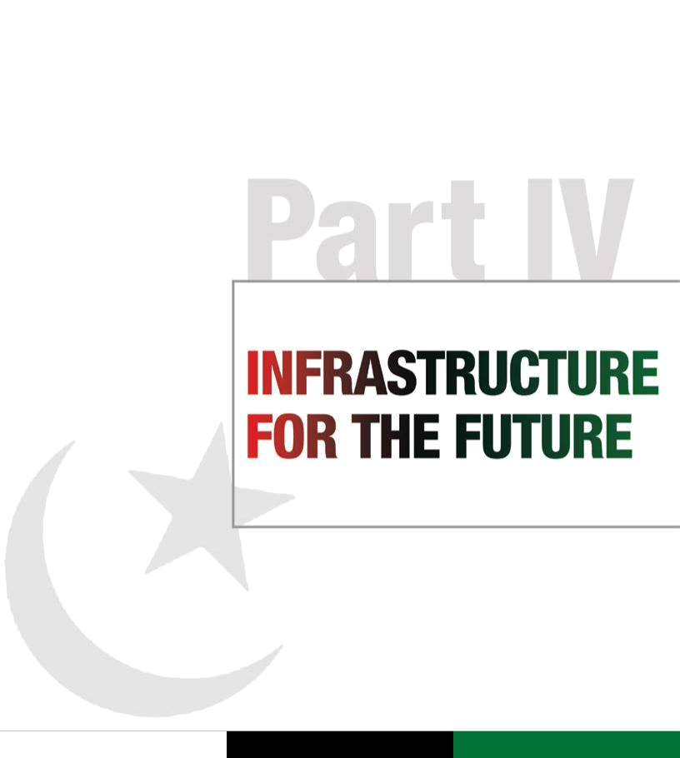

Pakistan People’s Party Parliamentarians

Part IV |  | Manifesto
Infrastructure for the future |  | 2013

Manifesto
2013

“As chief executive of one of the nine largest populated countries in the world, I and the Government are faced with the awesome task of providing for homes, schools, hospitals, sewerage, drainage, food, gas, electricity, employment and infrastructure.”
Shaheed Mohtarma Benazir Bhutto, Cairo, Egypt, 1994

Planning ahead for living in a knowledge-based global society means introducing an information technology (IT) policy that easily and economically interfaces with every sector involved in developing social and economic capital for the future. It is also the only way forward to safeguard the people’s entitlements in health, social security, agriculture and citizenship records, leveraging land and digital money to unlock underused potential in a country rich with untapped resources.

Pakistan’s rich cultural and religious diversity is a source of national pride and must be promoted. The Party promises to achieve this by encouraging diversity and promoting the arts. We pledge to set up art councils in every district. Our government will protect indigenous languages and cultures, and set up language boards to promote research. We will support and preserve public spaces like parks, public squares, museums and art galleries, and establish a national endowment fund for the arts.

 |  |  | Executive summary
 |  |  | We believe that the future of this country lies in
 |  |  | harnessing modern technology for growth and
 |  |  | social justice while conserving our heritage and
 |  |  | the environment. The development of sustainable,
 |  |  | well-maintained infrastructure is a prerequisite for
 |  |  | unleashing Pakistan’s growth potential.
 |  |  | Our Party has historically advanced power
 |  |  | generation in the country. Other parties, when in
 |  |  | government, have stalled this policy and, in doing
 |  |  | so, interrupted multiple projects. As a consequence,
 |  |  | the current government inherited crippling power
 |  |  | shortages and a daunting circular debt.
 |  |  | Despite these challenges, our government added
 |  |  | 3,700 MW of power to the national grid during
 |  |  | its tenure. Long-gestation projects in which the
 |  |  | government has invested are soon to come
 |  |  | online. To take Pakistan into a future where all its
 |  |  | schoolchildren can read by uninterrupted light and
 |  |  | to ensure that industry can work full cycles, we will
 |  |  | rebuild the national grid and its sources of power to
 |  |  | provide reliable and affordable electricity.
 |  |  | The Party is committed to developing mining and
 |  |  | providing adequate infrastructure. We will create
 |  |  | an infrastructure fund with our neighbours in the
 |  |  | region. In addition, we plan to develop wind and
 |  |  | solar solutions throughout the country. Creating
 |  |  | biogas power solutions using animal waste
 |  |  | will also be a priority. To meet the ever-growing
 |  |  | demand for energy, we plan to build run-of-the-
 |  |  | river hydropower plants. At the same time, we
 |  |  | will increase the supply of gas by encouraging new
 |  |  | exploration and importing liquefied natural gas. We
 |  |  | will work to reduce power tariffs by increasing the
 |  |  | use of a mix of hydroelectricity and coal.
 |  |  | The Party will prioritize large-scale infrastructure
46 |  |  | programmes to modernize and expand roads,
 |  |  | bridges, canals and dams, promoting public–private

partnerships in all sectors as the driving force behind accelerated progress. We have laid down a new grid of motorways connecting Islamabad to Peshawar, Faisalabad to Multan, Gwadar to Ratodero and further knitting the provinces in one transport chain.

Urban planning that meets the needs of Pakistan’s changing demographics is critical for modern cities that cater to the safety, municipal and environmental requirements of urban spaces. Through reforms in existing laws, we will work
to ensure that urban areas are revitalized and redeveloped to meet the challenge of housing a burgeoning population.

The Party will address the issue of land scarcity and the proliferation of katchi abadis. In urban areas, the government will increase land supply through high-density mixed-use developments. A certification process will be introduced for property dealers.
We will also address sanitation issues by diverting sewage to treatment plants in large parks so that recycled water can be used for horticulture purposes.

The Party recognizes that protection from the effects of climate change and natural disasters is essential to the survival and well-being of large swathes of the population. The last 10 years have clearly signalled a strong need for disaster risk mitigation and management policies. These too will be mainstreamed as part of planning for water and environmental security for the future.

We will develop large storage sites along rivers and small dams on hill torrents. To address water shortage issues, we seek to line earthen watercourses and channels, and to conserve water by drip irrigation. In addition, we will create water reservoirs to harness rainfall and flood water. For the survival and sustenance of the Indus delta, we will ensure that the required environmental flows are maintained below Kotri. Our goal is to provide clean drinking water to every citizen of Pakistan.

The Party has already been in the vanguard of building the infrastructure for an IT-based future through investment in NADRA and its software linkages with the BISP and other programmes. We will continue to move ahead with innovative and indigenous cellular and Internet technology solutions to meet multiple challenges by formalizing a data-based e-state outreach initiative.

During our next term we will develop software parks and promote the construction of new educational facilities. We will build a cellular and IT base to document and enhance basic entitlements to social security instruments like the BISP card. We will enhance financial inclusion by digitalizing cash and leveraging collateral through properly recorded land titles. We are currently working to enhance ties with other countries in the region though joint ventures to promote software exports. We will develop e-business in both Urdu and English, thereby including low-income groups in this revenue-building opportunity.

The Party actively seeks to promote accountability and meritocracy, and the introduction of biometric attendance measurement is a step in this direction. To reduce government expenditure, we will promote video conferencing and a paperless environment in the public sector.

Pakistan has tremendous potential in terms of natural resources, with significant reserves of natural gas, minerals and precious stones. Our government will develop mechanisms for their extraction, but with transparency and responsibility, thus ensuring the protection of these resources for future generations.

In compliance with our environment-friendly policies, we will preserve national parks and sanctuaries, while new reserves will be developed. We will curb the trafficking of endangered species
and strengthen efforts to increase environmental awareness.

Pakistan’s tourism industry has been badly hit by external and internal conflict. Our democratic partners have launched various tourism initiatives for the Swat valley, an area that used to be known as the Switzerland of Asia. We will continue to support all such endeavours and will focus on revitalizing the tourist industry in militancy-affected areas through incentives for hoteliers, tour operators and commerce.

Our Party is actively working to improve and modernize sports. To this end, we will amend the Sports (Development and Control) Ordinance 1962. We will support the Pakistan Sports Board as the supreme regulatory body to monitor the activities of national sports federations, and ensure the proper utilization of annual and special grants provided by the Board.

Living up to our commitments

Faced with crippling infrastructure deficits and virtually no investment in energy, our government has had to lay the foundations for long-gestation projects while meeting immediate demand.

To keep the price of electricity down, the government has spent 1,200 billion rupees in the last four years, while at the same time adding an urgently needed 3,700 MW to the national grid. In order to increase the power supply we have set the stage for moving forward on the Diamer-Bhasha Dam which is expected to produce more power than the Tarbela and Mangla dams combined. We completed significant repairs to three units of the Tarbela

Dam and initiated the fourth Tarbela Extension Project. The rich potential of wind power has not been neglected, and 11 wind power projects have been commissioned, of which one has already started power generation. The Private Power and Infrastructure Board (PPIB) has initiated work on 39

multiple-fuel projects with a cumulative capacity of ₄₇ 1,011 MW. These projects will become operational

Pakistan People’s Party Parliamentarians

Pakistan People’s Party Parliamentarians

Manifesto
2013

Manifesto
2013

in the near future, to power Pakistan into a new era of growth and energy security. At the same time, we have expedited work on the Neelum-Jhelum Hydropower Project, and forged ahead with the Jinnah Hydropower Project and the Chashma Satpara Dam.

We also began work on the rehabilitation of the Sukkur Barrage which was under severe stress following decades of silting and structural deterioration. To overcome growing and acute water shortages, we upgraded the existing power system so that pumps and irrigation systems remained functional, and completed work on the Mirani Dam. We also started work on the Gomal Zam hydropower dam in South Waziristan, which will increase water storage by 6 per cent, benefitting over 30,000 households.

To exploit the region’s energy sources, we have signed agreements with regional partners such as India, Iran, Tajikistan and Turkmenistan. We were able to add 3,700 megawatts to the national grid.

Focusing on the development of infrastructure for the future, during the last four years the government spent 2,200 billion rupees on development projects with more than 200 projects completed. These include Chashma Nuclear Power 2, the Mangla Dam Raising Project, the Islamabad–Peshawar Motorway and the Islamabad–Muzaffarabad Expressway.

To connect modern Pakistan’s villages and towns to its megacities, we have completed 46 road development projects with a combined span of 2,985 kilometres at a cost of 245 billion rupees.

To overcome the trauma of unprecedented natural disasters and protect the people from future calamities, we created the National Disaster Management Authority (NDMA) through an Act of Parliament. This enabled us to effectively manage the devastating monsoon floods of 2011 and conduct the largest relief operation in our history, providing relief in both human and financial terms to the tune of 10 billion rupees. Given the recurring and dangerous cycle of natural disasters in the recent past, we also initiated the process of providing disaster risk insurance for breadwinners, as well as insurance schemes to ensure food and crop security.

We focused in our current term on laying the foundation for a robust science and technology

- sector. We established the National Defence University, and passed laws to allow for the

establishment of the Institute of Space Technology and the NFC Institute of Engineering and Technology. We prepared the National Science, Technology
and Innovation Policy, and provided vocational and technical training to 132,487 young people through programmes sponsored by the National Vocational and Technical Training Commission (NAVTTC). The National University of Sciences and Technology (NUST), now recognized as one of the top 400 universities in the world, shifted to a new campus, offering new courses and establishing new centres of excellence.

Our Party takes pride in the vibrant enthusiasm of Pakistan’s sports culture. We have promoted sports development in communities and strengthened local sports associations. We will invest in state-of-the-art sporting facilities to encourage youth participation in the international arena.

The way forward

Sustainable and renewable energy

Our Party has historically advanced power generation in the country. Our power policy of
1994 successfully attracted private investment in the sector and decreased power outages. Other political parties and regimes stalled this policy and, with it, various projects, resulting in extreme power shortages. As a result, our government inherited circular debt and the country was forced to endure severe load-shedding. Our government began its tenure in 2008 with only a few energy projects in the pipelines. To address the anticipated rise in demand for electricity, we immediately invested in sustainable and renewable energy projects. From 2008 to date, the government has added 3,700 MW of electricity to the national grid and worked on creating additional sources of supply to meet the growth in demand. We intend to generate 12,000 MW of additional power by mobilizing new investment to the tune of 36 billion US dollars through independent power producers (IPPs). We have rehabilitated existing public-sector power plants and begun work on the conversion of these plants to run on coal in place of furnace oil. We have enabled provincial governments to set up power plants in the private sector, while

at the national level we have created the Pakistan-China Energy Working Group (PCEWG) under which various regional companies have begun to partner with their Pakistani counterparts for energy production.

Pakistan People’s Party Parliamentarians

The cornerstone of our energy policy will be to provide reliable and affordable electricity to the people by taking the following steps:

- Encourage foreign investment by establishing policies, procedures, and tax and pricing regimes with respect to petroleum exploration and production, and provide an impetus by modifying current contracting terms.

- Collect wind and solar energy data throughout the country and prioritize green energy in
all provinces in coordination with provincial governments.

- Provide incentives to the private sector for building run-of-the-river hydropower plants on 70 identified hydropower sites, and begin construction on storage dams, especially small dams, for which there is also national consensus.

- Introduce an energy conservation bill which will focus on energy efficiency.

- Staff NEPRA and OGRA with professionals selected through a transparent process. Regulatory decision making will be made transparent to share information and increase public confidence.

- Reduce power tariffs by increasing the use of hydroelectricity and coal in the fuel mix, phasing out furnace oil and diesel, and checking revenue losses in distribution companies. Circular debt is to be eliminated with vigilant governance.

- Increase the supply of gas by encouraging exploration in new areas, ensuring that local communities share in the benefits, tapping tight-gas and low-BTU gas resources, and promoting the import of LNG. Schemes for transnational pipelines will be encouraged.

- Bring transmission losses down to 15 per cent.

Information and communications, science and technology

Our government enacted policies that have resulted in substantial gains in the Internet and cellular technology sector. We have consistently worked to improve the quality of these vital platforms with plans to issue 3G and 4G licences, and to make broadband Internet services available throughout the country, while striving to ensure both convenience and security. As of 2012, Pakistan has the 15th-largest population of Internet users in the world, at just under 30 million people. We remain committed to improving this sector and making ICT increasingly available to the people. We will:

- Continue developing software parks and promoting the building of educational facilities, thereby opening up new opportunities.

- Establish vocational training facilities, sustain an investor-friendly environment to provide growth in the sector, and encourage research and innovation.

- Set up 250 ICT centres in smaller cities.

- Further enhance regional ties in the field of
IT through joint ventures, investment and the exchange of expertise. We can boost mutual trade in the IT sector by a potent 5 billion US dollars through such efforts.

- Develop financial, educational, e-business and other services in both Urdu and English, thereby eliminating the exclusion of low-income groups from this employment opportunity.

- Bridge the ‘digital divide’ by promoting mass literacy through public–private partnerships.

- Further enhance the nationwide disaster pre-warning and post-disaster communications systems that have already been developed during our current tenure.

- Improve access to justice through the automation of procedures and the computerization of court and police records.

- Promote accountability and meritocracy through biometric attendance and analytics-based performance evaluation.

- Cut governance expenses through video conferencing, secure distant sharing facilities and ‘paperless’ workplaces.

Urban planning

The next two decades will bring momentous changes in Pakistan’s demographics. By 2030, more than half of the country’s population will be living in cities and semi-urban clusters. In view of the 18th Amendment, urban development will largely be undertaken by local and city governments. Efforts will therefore be made to strengthen the administrative and financial autonomy of local governments in

the ongoing restructuring process. The Party is committed to making further progress towards achieving a developed and industrialized Pakistan. We will:

- Improve the business environment and promote the urban economy through the expansion of markets in the inner cities and the promotion of

cluster development. | 49

Pakistan People’s Party Parliamentarians

Manifesto
2013

Manifesto
2013

- Revamp existing building regulations and ensure compliance with design standards to meet the challenges of the 21st century.

- Address issues of land scarcity, high land prices and grants of land, which can be wasteful due to flaws in land use regulations and planning standards. The inability of cities to meet land and housing demands has led to large-scale encroachment on public and private lands and the proliferation of katchi abadis.

- Expand urban land supply through high density, mixed use renewal projects in inner city areas, and promote new high-density housing and development projects.

- Adopt best practices to ensure compliance with urban safety requirements including building codes and standards, building licences, and emergency procedures.

- Amend zoning and building regulations to match local market trends to allow for high-density, high-rise and mixed land use developments.

- Introduce a certification process for property dealers in the formal sector. Certification will require a minimum knowledge of property law, property transfer procedures and the dynamics of property markets.

- Encourage provincial governments to initiate the processes required to implement the federal government’s sanitation, water and environment policies, which have a direct bearing on the provision, maintenance and operation of infrastructure.

- Address sanitation issues by giving priority to gravity flow systems, diverting sewage to treatment plants in large parks so that waste water can be used for horticulture. Explore the option of solar pumping for sewage disposal to reduce energy costs, and shift all recycling activity in large towns to landfill sites. The informal sector will transfer recyclable waste to landfill sites or relocate their activities to landfill sites.

- Recognizing that the urban cultural space has greatly shrunk for all citizens, devise strategies to create public spaces open to people from all walks of life by promoting high-density and convivial living.

- Promote social, cultural and entertainment venues such as art galleries, theatres, cinemas, exhibition halls, fair and festival grounds, parks and playing fields, public meeting places, city halls, tea and coffee houses, and libraries.
- • Support road construction, street paving and

the construction of covered drainage systems to protect road surfaces.

- Coordinate land use planning, transport planning and traffic management, and improve public bus services.

- Consider proposals to float municipal bonds for raising funds to finance transportation systems, and give priority to transportation projects and investment.

- Conduct a thorough assessment of environmental degradation in urban areas that has placed the natural environment under tremendous stress.

- Enact policies to make buildings energy efficient, require the use of cleaner fuel in transport, and promote compact urban design.

- Ensure responsive, efficient and accountable urban governance. Security of life and property, including security from accidents (fire, disasters, building collapse, terrorism), has deteriorated due to a breakdown in law and order. Various interest groups and mafias, and sectarian and ethnic groups have emerged in urban areas, fragmenting society, causing conflict, and encouraging violence and disturbances. Citizens must be educated about the importance of these reforms so that there is full ownership of these measures.

- Engage the private and not-for-profit sectors in urban planning and renewal schemes.

Water security and flood management

Pakistan is increasingly becoming a water-stressed state. With climate change taking a toll on regeneration capacity, we must implement strong systems through which water-related issues are efficiently managed. Equity will and must be a prime consideration in water distribution. In the next five years we pledge to:

- Develop large storage sites on rivers and build small dams on hill torrents.

- Embark upon major schemes to line watercourses and channels to prevent seepage losses, and revamp and rehabilitate aging barrage and canal systems.

- Conserve water by drip and sprinkle water application systems, and devise technologies to harvest rainwater in arid zones.

- Revamp and rehabilitate existing drainage infrastructure, and build drainage systems in the remaining areas.

Pakistan People’s Party Parliamentarians

- Ensure that the required environmental flows below Kotri are maintained for the survival and sustenance of the Indus delta.

- Update the rain forecasting system of the

Pakistan Meteorological Department (PMD) for more effective flood management and strengthen the existing flood protection infrastructure.

- Reactivate old abandoned natural river courses to help prevent flooding from rainfall, and excavate new drains to quickly drain rainwater independently or in conjunction with new drainage systems.

- Provide clean drinking water to every citizen and sanitation to all habitations where a water supply system is already in place.

Protecting natural resources, wildlife and the environment

Pakistan has tremendous potential in terms of natural resources, including natural gas, minerals and precious stones. Our government will develop mechanisms for their extraction, but with responsibility so as to ensure their protection for future generations. In our next term, we will:

- Develop national parks, sanctuaries and reserves, and promote ecotourism.

- Take action to conserve biodiversity, and especially to curb deforestation.

- Develop more effective measures to protect the country from the effects of climate change, including to protect mangroves and coastal areas.

- Curb the trafficking of endangered species, and devise special programmes to ensure that Pakistan’s rich wildlife is protected. Ecotourism initiatives will be used to generate much-needed investment in expanding wildlife sanctuaries.

- Strengthen federal and provincial institutions engaged in sustainable development activities, and bolster efforts to increase environmental awareness.

- Use the green economy framework to achieve sustainable development.

- Ensure that the principle of sustainability is built into all future plans for development. Sustainable development requires a holistic, equitable and far-sighted approach to decision making at all

levels. It emphasizes not just strong economic performance but intra-generational and inter-generational equity. It rests on an integrated and balanced consideration of social, economic and environmental goals and objectives in both public and private decision making.

Enlarging cultural space

Pakistan is home to the ancient Indus Valley civilization, a heritage that every Pakistani is proud to call their own. The Indus civilization, Gandhara culture, and our pre-Mughal and Mughal heritage testify to the historical and cultural value of the region.

Pakistan’s rich cultural and religious diversity is a source of national pride and must be promoted. We must recognize the heterogeneous, multicultural, multilingual and pluralistic nature of Pakistani society and culture. The Party promises to achieve this by encouraging diversity and promoting the arts. We will:

• Set up arts councils in every district with the help

of the provinces to promote the arts at the local level. Through public–private partnerships, we will set up training institutions and community centres in large urban areas and smaller cities.

• Promote Pakistan’s national, provincial and

regional languages by encouraging provinces to include regional and indigenous languages in the curriculum. We will set up language boards to promote research and translation. A centre for national and local languages will be established to promote research and preserve linguistic diversity.

• Establish language learning institutions for

indigenous languages.

• Protect indigenous languages and cultures,

especially those that are threatened with extinction, including Baltit, Brahvi, Kalash, Shina and other languages of northern Pakistan.

• Strengthen national cultural institutions such

as the Pakistan National Council of Arts, the National Book Council and Lok Virsa through increased budgetary allocations and reforms in the institutions’ systems.

• Promote and protect public spaces including

museums, parks, public squares, art galleries,
cultural complexes, cinema halls and theatres |  | 51
across cities and in the rural areas.
 | Pakistan People’s Party Parliamentarians

Manifesto
2013

Manifesto
2013

- Encourage and incentivize the development of new public spaces and cultural complexes with cinemas and theatres.

- Establish a national endowment fund for the arts to promote and fund cultural activities, especially theatre, dance, music and film.

- Regulate zoning by-laws, making it mandatory for developers to provide cultural facilities, such as auditoriums, cultural centres and other public spaces, in return for the use of urban land.

- Promote reading as a hobby in schools and through behaviour change campaigns.

- Facilitate and organize literary festivals and book fairs across the country, and encourage Pakistan’s leading literary figures to spearhead a campaign to promote reading.

Tourism and travel

Pakistan’s tourism industry has been badly hit as a result of external and internal conflict. The Swat valley, once known as the Switzerland of Asia, was considered a tourist haven, but its image has suffered greatly due to the rise of militancy and the fallout from the military operation to flush out extremist elements. During our current tenure, our democratic partners have launched tourism weeks to promote the Swat valley as a tourist destination. We will support all such endeavours and focus on revitalizing the tourism industry by providing incentives to hoteliers, tour operators and shops in militancy-affected tourist sites. We will provide the best possible security to tourists visiting areas that are recovering from the effects of extremism. We will make efforts to revive tourism by promoting travel in areas that are largely unaffected by militancy, and promote ecotourism in protected parks and sanctuaries.

Protecting heritage and culture

In our current tenure, we have helped secure efforts to preserve our heritage and historical buildings. Through a public–private partnership, Madr-e-Millat Fatima Jinnah’s property, Mohatta Palace, was rescued from ruin and converted into a museum complex where entry is free of charge, providing citizens a chance to view art and cultural exhibits. We have also worked towards revitalizing and conserving the Frere Hall Museum and gardens as a public

- space for citizens in the heart of the city. In our next term, we will:

- Protect and conserve heritage sites through public–private partnerships.

- Ensure heritage properties are zoned and given landmark status that is fully implemented.

- Preserve heritage sites such as Harappa,

Mehargarh, Moenjodaro and Taxila with institutional support and international cooperation.

- Protect and conserve religious sites and monuments.

- Institute mechanisms to promote artists and artisans through economic support, and provide them with opportunities to pass on their skills and traditional crafts. We will set up artisans’ cooperatives through public–private partnerships.

- Organize and provide support to national arts festivals and exhibitions, including music and theatre, thereby providing artists from across the breadth of Pakistan a platform to promote their work. We will encourage the youth of Pakistan to play a larger role in this field.

- Promote the image of Pakistan’s rich heritage through cultural exchanges with the support of our diplomatic missions across the world.

Sports and community development

While our cricket and hockey teams are amongst the world’s finest, we have yet to realize the full potential of our sporting talent. We must promote sports as essential for the character development of our youth. We will:

- Promote sports for the development of communities.

- Strengthen local sports associations and help organize annual sporting events at the district and city level.

- Invest in state-of-the-art sporting facilities and grounds to encourage youth participation in sporting activities.

- Encourage the participation of women in all sporting events held domestically and internationally.

Pakistan People’s Party Parliamentarians

53
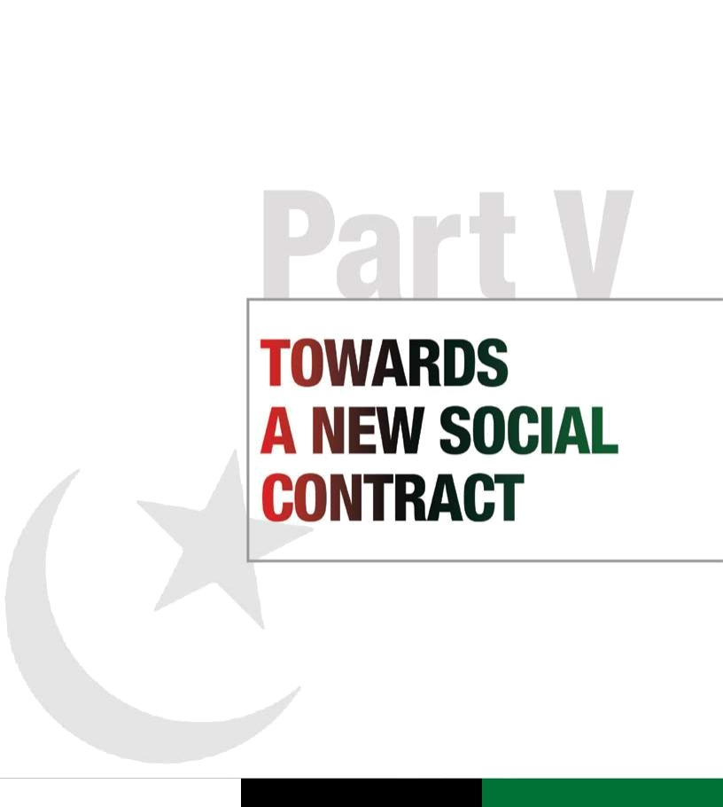

Pakistan People’s Party Parliamentarians

Part V |  | Manifesto
Towards a new social contract |  | 2013

Manifesto
2013

“Democracy is our politics. Without democracy Pakistan would not have been formed.”

Shaheed Zulfikar Ali Bhutto, Khairpur Mirs, Pakistan, 1968

Party has always felt the pain of the insecure and the marginalized, and the President’s public apology to the people of this neglected province was followed by fundamental fiscal, constitutional and affirmative-

the provinces to levy taxes on services while maintaining strong ties between the Federation and the provinces.

Executive summary

The Pakistan People’s Party Parliamentarians has always been the nation’s standard-bearer of democracy. During our first government, we laid the foundations for sustainable democracy in the nation by giving Pakistan the 1973 Constitution, notable for being the country’s first consensus Constitution. Now in its fourth term, the Party has delivered

on many of the promises made in that historic document. In doing so, the Party has refashioned the state’s social contract with the people by not only making government accountable but also fundamentally transferring the locus of power to the federating units of the state.

Four important Constitutional Amendments have been passed during our fourth term. The 18th, 19th, 20th and 21st Amendments have strengthened the federation by devolving powers to the provinces, allowing for the creation of a transition government, creating the framework and mechanism for fair and free elections, and standardizing judicial appointments. The Council of Common Interests (CCI), which strengthens inter-provincial coordination, has been revived and the country rid of dictatorship. The President has voluntarily handed down his powers to Parliament, which has been empowered as the sovereign voice of the people.

Our Party has always been the strongest advocate of federalism. This gave us the political will and the capacity to bring about the unanimous passage of the historic 18th Amendment with the help of democratic forces. This Amendment restores the rights of the provinces, giving them autonomy and fiscal power, and has laid the foundation for a new social contract with the people of Pakistan. In its next term, our Party will devolve power to the grassroots, forging public consensus on the framework of local governments across the breadth of the country. During our current term, were are proud to have implemented major parts of the historic Charter of Democracy (2006) by undoing the damage to the Constitution, restoring and appointing the senior judiciary through a parliamentary committee,

- reducing the voting age to 18, and setting up an independent Election Commission.

Through Constitutional amendments, the Party has also expanded the scope of fundamental rights for all citizens. The 18th Amendment affirms three new rights: the right to due process and a fair trial, the right to information, and the right to education.

After a gap of 13 years, our government was able to forge consensus for the 7th National Finance Commission (NFC) Award, according to which nearly 70 per cent of the federation’s resources are transferred to the provinces. This will in effect provide more financial resources and greater autonomy to the provinces over key subjects such as health, education, municipal services, and law and order.

Public accountability lies at the heart of democratic and just governance. As the only mainstream federal party of Pakistan, and as the country’s first elected government to have completed its full constitutional term, ours has been the most accountable government in the country’s history. We established a Cabinet committee on the prevention of corruption, and its recommendations for sweeping reform have been approved.

In the spirit of building an architecture of institutions that will sustain the democratic transition, we have created through multi-party consensus a strong and independent Election Commission of Pakistan. The Party will work to ensure that the Commission is strengthened and empowered to prepare a level playing field for free and fair elections.

The Party initiated the first tranche of meaningful reform in the Federally Administered Tribal Areas (FATA). In our next term we will continue to mainstream this impoverished and neglected area into the fabric of the country. We will do the same for Gilgit-Baltistan, and move to simultaneously enhance infrastructure and entitlements for Azad Jammu and Kashmir, which has been hit by consecutive natural disasters.

We will invite all political forces to address the grievances of the people of Balochistan, a province that undergoes frequent trauma as it faces a surge of violence from regional instability. Our

action reparations to the people, including for the use of natural resources. We will bring to bear both political will and resources beyond the Aghaz-e-Haqooq-e-Balochistan (AHB) package to build strategies for peace and interfaith harmony in this vulnerable province.

The Party supports the creation of a new province in southern Punjab to address the deprivation in this area and to ensure the people are represented at the federal and provincial levels.

As the Party that restored the senior judiciary and respectfully accepted the judgements of the Supreme Court even in removing its unanimously elected Prime Minister, we uphold the Constitution in supporting an independent judiciary free of political prejudice and committed to institutional integrity. We will continue to implement judicial reforms to ensure all citizens have access to the basic right to justice.

In its current five-year term, the Party has focused its energies and resources on holding the nation together through Shaheed Mohtarma Benazir Bhutto’s policy of reconciliation, both at home and abroad.

We reaffirm our commitment to the Charter of Democracy and to pursue those provisions which have yet to be implemented. More than 80 per cent of the Charter, signed in May 2006, has already been implemented.

Living up to our commitments

Honouring its heritage of federalism and fulfilling its commitment to the Charter of Democracy, the Party and other democratic forces created history by unanimously passing the 18th Amendment. Enacted in 2010, this Amendment reforms and revitalizes the democratic pact between the federation and the provinces. It strengthens the Federation by consolidating provincial autonomy. The Amendment provides for the devolution of federal ministries, re-establishes the Prime Minister as the country’s Chief Executive and has expanded the scope of the fundamental rights of citizens. It allows federal resources to be redistributed according to the National Finance Commission Award, and empowers

The 18th Amendment has expanded the scope of the fundamental rights of citizens, affirming three new rights: the right to fair trial and due process, the right to information, and the right to education. The salient features of the Amendment are as follows:

- Implements structural reforms that affect all pillars of the state: legislature, executive and judiciary.

- Expands the scope of constitutionally guaranteed fundamental rights.

- Redefines political and fiscal relations as well as the legislative jurisdiction of the federal and provincial governments.

- Introduces an innovative concept of institutional power through Parliament, the provincial assemblies, and federal forums such as the Council of Common Interests (CCI) and the National Economic Council (NEC).

The 18th Amendment revised or repealed many articles of the Constitution. The Sixth and Seventh Schedules, which required Presidential approval for the amendment of certain laws and stipulated more stringent requirements for the amendment of others, respectively, have been omitted. The Fourth Schedule, which outlined the legislative jurisdiction of the federal and provincial governments, was substantially revised to devolve greater powers to provincial governments.

The 18th Amendment marks a return to the true spirit of parliamentary democracy. Key powers stand transferred to Parliament, which is now supreme. The Amendment brings about the following major changes:

- At the federal level, the Prime Minister is the Chief Executive and will be responsible, along with the Cabinet, to both the National Assembly and the Senate (Article 91(6)). Earlier, this requirement applied only to the National Assembly (NA).

- At the provincial level, executive authority is exercised in the name of the Governor by the

provincial government, consisting of the chief
minister and provincial ministers (Article 129). | 55

Pakistan People’s Party Parliamentarians

Pakistan People’s Party Parliamentarians

Manifesto
2013

Manifesto
2013

- After the 2013 elections, the size of the federal and provincial cabinets is not to exceed 11 per cent of the total membership of Parliament and respective provincial assemblies (Article 92 and 130).

- The NA and the provincial assemblies must meet on the 21st day following the day on which a general election to the assembly is held, but the President and provincial governors may summon the NA or the respective provincial assembly sooner than that date.

- The concept of run-off elections has been introduced in the case of the Prime Minister and the provincial chief ministers. The restriction on the number of terms in office has been lifted.

- The discretionary powers of the President to dissolve the NA under the notorious Article 58(2) (b), and similar powers of provincial governors vis-à-vis the provincial assembly under Article 112(2)(b), have been omitted.

- The legislative consent of the provincial assembly is required in case of the imposition of emergency rule in the province concerned.

- The President cannot promulgate an Ordinance while the Senate or the NA is in session. An Ordinance may be promulgated only once, and a one-time extension can be accorded by a resolution of the NA or the Senate (Article 89). Similarly for the provinces, Article 128 has been amended.

- The number of Senate working days has been increased from 90 to 100, and the number of days to make recommendations on a Money Bill from 7 to 14.

- For religious minorities, four seats, one from each province, have been added to the Senate, raising its strength to 104 (Article 59(f)).

- Parliamentary committees on the appointment of judges and the Election Commission are functional.

- The formation of a parliamentary committee for the appointment of a caretaker PM, and similar provincial committees for the appointment of a caretaker CM in a province, is conditional upon agreement between the Leader of the House and the Leader of the Opposition in the respective assembly.

- The President’s discretion to refer a question to a referendum has been removed and now rests with the PM. A joint session of Parliament will
- frame the question(s) to be put to a referendum.

- The President retains the right to be informed on all matters of internal and foreign policy and on legislative proposals.

- A time limit has been imposed for the President to act on the advice of the PM.

The 18th Amendment bolsters provincial autonomy in a number of ways. It empowers provinces to levy sales tax on services. Provinces will now exercise joint control with the federal government over 18 subjects including sea ports, all regulatory authorities and national planning as well as national economic coordination, the supervision and management

of public debt, census, certain natural resources and other matters specified in Part II of the Federal Legislative List.

The 18th Amendment also lays the framework for the distribution of federal revenues through the National Finance Commission (NFC) Award. The share of the provinces is protected and cannot be reduced below the percentage decided in the previous NFC Award. The distribution of resources is to be carried out on the basis of multiple criteria (population, poverty, ‘backwardness’, revenue collection and generation, and inverse population density).

The role of the Council of Common Interests (CCI) has been expanded. The CCI is to become a powerful constitutional body, comprising representatives of the federal and provincial governments, for the formulation and regulation of policies related to key matters listed in Part II of the Federal Legislative List. The Council will exercise supervision and control over related institutions. The CCI will also become an effective dispute resolution, economic planning and developmental forum, with a rationale of joint responsibility. It is mandated to meet once every quarter.

Consultation with provincial governments is mandatory prior to making a decision to construct hydroelectric power stations (Article 157). The provinces now have the power to raise domestic or international loans within the limits prescribed by the National Economic Council (NEC) (Article 167(4)). Further, there is joint and equal ownership of natural resources such as oil and gas (Article 172(3)) between the Federation and the province where the natural resource is located. Previously, the Federation was the sole owner. Thus a major demand of the provinces for ownership of resources and a voice in policy formulation has been met.

Pakistan People’s Party Parliamentarians

The National Economic Council (NEC) has been reformed with an advisory role to review the overall economic situation of the country and to advise the federal and provincial governments in economic planning.

During our current term in office, the Party has also taken important steps to bring the Federally Administered Tribal Areas (FATA) into the political mainstream. The Political Parties Act 1962 was extended to FATA, and much-needed reform introduced into the outdated Frontier Crimes Regulation (FCR) 1901. Similarly, in a historic act of commitment to the people of the region previously known as the Northern Areas, Gilgit-Baltistan was given self-rule. It now has its own Legislative Assembly, chief minister and governor. The province of Khyber Pakhtunkhwa was given its indigenous identity.

In recent years, Balochistan has suffered one trauma after another. Following President Asif Ali Zardari’s public apology to the people of this province for the wrongs done to them, the government launched the first phase of a reconciliation package of rights and entitlements. This includes the devolution of power from the federation, as well as the introduction of the Aghaz-e-Haqooq-e-Balochistan (AHB) package which calls for affirmative action in employment and development quotas, among other commitments for reform to secure the lives of Balochistan’s people. The AHB package also provides for the release of prisoners not involved in terrorist acts.

Our Party has ensured that Balochistan is the biggest beneficiary of the current NFC award. Compared

to the previous NFC Award, the province’s share in the divisible pool of finances has been more than doubled. Under the AHB package, the payment of arrears worth 120 billion rupees in the shape of a Gas Development Surcharge has begun. Similarly, 4 billion rupees has been transferred to the Water and Power Development Authority to subsidize farmers in Balochistan.

Recognizing the needs of the province, our government also doubled the Baloch beneficiaries of the Benazir Income Support Programme (BISP) to 750,000, while Balochistan’s share in the NFC Award was increased from 43 billion rupees to 93 billion. In addition, all contractual employees from Balochistan recruited in the federal government have been regularized from 2012, and 11,500 new jobs financed

by the federal government have been created for
the youth of the province. Our government has also
extended for another 20 years provincial quotas in
federal government jobs.
The Prime Minister’s programme of free schooling
for students of high merit has been significantly
expanded, benefitting twice as many students from
Balochistan, and an endowment fund has been
created to sustain the initiative.
Our Party in its fourth tenure has been the most
accountable government in the history of Pakistan,
submitting without hesitation to all judicial and other
instruments of accountability. We established a
Cabinet committee on the prevention of corruption,
which presented 12 recommendations for sweeping
reform. These recommendations, all of which
have been approved, include documentation of
the economy, automation of revenue records and
documentation within public institutions.
We have also worked to strengthen the democratic
process. Conscious of the need to provide a level
playing field, we transformed the ground rules for
holding elections by strengthening the Election
Commission of Pakistan (ECP) through the 18th
and 20th Amendments to the Constitution. The
Chief Election Commissioner’s tenure has been
increased from three to five years. The appointment
is to be made through consultations between the
Prime Minister and the Leader of the Opposition in
the National Assembly, and after the approval of a
parliamentary committee comprising 12 members,
half from the treasury benches and half from the
opposition. The ECP is now a permanent body
with four members appointed through a similar
mechanism.
We have removed uncertainties regarding the
elections; they must be held within 60 days of
the completion of the term of the assemblies, or
within 90 days in cases where the assemblies are
dissolved.
The way forward
Devolving power to local government
Governance cannot be effective unless it is
responsive to the people, and local government is | 57
essential for responding quickly and efficiently to | 57
Pakistan People’s Party Parliamentarians

Manifesto
2013

Manifesto
2013

the immediate and basic needs of the population. The 18th Amendment stipulates: “Each Province shall, by law, establish a local government system and devolve political, administrative and financial responsibility and authority to the elected representatives of the local government” (Article 140A). The Election Commission of Pakistan will oversee local government elections.

Reconciliation, coordination and cooperation

We promise to mentor and materialize structural reforms in the architecture of governance. We are optimistic that these changes will usher in an era of best practices in the provision of services, with a better quality of life for the people of Pakistan. While reconciliation and federalism remain the key drivers of our efforts, we pledge to make this journey even more meaningful. To this end, our Party will:

• Promote a culture of inter-provincial coordination

and cooperation to facilitate the provinces in reforming their governance and sharing best practices with each other.

• Further strengthen the doctrine of ‘institutional

power’ by enhancing the capacity of forums of federal–provincial interaction and shared responsibility such as the Council of Common Interests (CCI) and the National Economic Council (NEC).

• Promote a culture of negotiated conflict resolution in the case of inter- and intra-provincial disputes.

• Review the efficacy of the 7th NFC Award formula for resource distribution, which takes into account a number of new indicators, to further democratize resource distribution in the next NFC Award (2014–15).

• Encourage provincial governments to adopt similar formulas for equitable resource distribution among the districts.

As one of the largest megacities of the world and the country’s port, Karachi will receive a special grant in the NFC Award from the federal divisible pool.

New provinces

58 | Our Party has formed a parliamentary commission
58 | on the creation of a new province in southern Punjab,

to be named Bahawalpur-Junoobi Punjab. We envision a new provincial unit to promote national harmony and inclusive democracy, keeping in view the historical deprivation that this region has faced. Similarly, FATA is to be mainstreamed as a provincial entity. Our Party believes that for all practical purposes power may be distributed, and the creation of new provinces is a step in this direction. We will, upon assuming power, set into motion a mechanism to chart new provinces as deemed necessary by the representatives of the people.

Bahawalpur-Junoobi Punjab

The people of South Punjab have long been demanding recognition of their identity and the redressal of neglect and underdevelopment of the region. Our Party is committed to create a new province in South Punjab, in accordance with the wishes of its people. For the first time, the Party established a separate South Punjab chapter with its own president, general secretary and all other provincial office-bearers. Following the 2008 elections, the Party nominated Yousuf Raza Gillani from South Punjab and got him elected as Prime Minister. When Mr Gillani was disqualified, the Party included another MNA from South Punjab, Makhdoom Shahabuddin, in the list of its nominees for the office of PM.

Consequent upon the unanimous resolutions passed by the National Assembly and the Provincial Assembly of Punjab in May 2012, calling for the creation of a separate province in South Punjab, the President addressed a communication to the Speaker asking her to set up a commission for the purpose. The commission unanimously proposed carving out a separate province of Bahawalpur-Junoobi Punjab. It also proposed a Constitutional Amendment Bill to give effect to its proposal.
Our government piloted the 24th Constitutional Amendment Bill in the Senate, which was passed with a two-thirds majority.

With this landmark achievement, the process of honouring the wishes of the people of South Punjab for a separate province of their own has acquired irreversible momentum. The Party pledges to pursue the mission and take all other constitutional measures necessary to make the province of Bahawalpur-Junoobi Punjab a reality.

Pakistan People’s Party Parliamentarians

Accountability at all levels

Our government in its fourth tenure has been the most accountable government in the history of Pakistan. It has submitted, without hesitation, to all judicial and other instruments of accountability, including a fiercely independent media. Even at the risk of losing elected office, the Party has preferred to sacrifice its unanimously elected Prime Minister rather than be seen as a spoiler in democratic institution building.

In our current term, we have carried Shaheed Mohtarma Benazir Bhutto’s vision forward, ensuring that no political prisoners were taken during our tenure. No one has faced political persecution like the PPPP leadership itself, which has spent years in jail and in exile, with Party workers enduring hardship and torture. No revenge has been extracted for years of political persecution, or for the loss of life, office, monies, dignity and peace of mind.

In its next term the Party will introduce further governance and transparency reforms in the areas of taxation and public management including civil services, government procurements and decentralization. It will introduce a culture of accountability in the delivery of public services by setting metrics for performance, and it will strengthen the Ombudsman’s office.

Judicial reform

Pakistan has witnessed two extreme trends in judicial tradition: one where the judiciary has colluded with anti-democratic forces and the other more recent trend of judicial activism which some have seen

as an attempt to appropriate executive power. While our Party has fought for the independence of the judiciary, it is also cognizant of the principle of separation of powers as the basis of good democratic governance. Taking forward this vision, we pledge that we will:

- Undertake law reforms and frame new legislation, particularly for access to speedy and inexpensive justice.

- Update jail manuals and modernize prisons, with special attention to juvenile and women prisoners.

- Strengthen prosecution services through training and capacity building for lawyers.

- Pursue further reforms to make elections more transparent.

- Formulate laws to expedite and increase access to justice by introducing mobile courts and evening courts, and by establishing formal mechanisms for alternate dispute resolution (ADR) through the local government system. Free legal aid will be institutionalized.

- Revisit the review and writ jurisdictions of the courts to ensure that norms of justice are being upheld.

- Strengthen civil courts with a time limit on adjudication, and strengthen sessions courts.

- To inject greater transparency into the process, review laws pertaining to the appointment of judges and identify ways to make the judiciary more inclusive, with special measures to ensure the representation of women and minorities in the higher judiciary.

- Computerize the records of registrar’s offices and the lower judiciary to improve efficiency and record keeping.

- Improve the quality of education and training for lawyers and paralegal staff, with particular focus on the professional development of young lawyers.

- Introduce laws on ethical practice and sensitize the legal fraternity on issues of gender, minorities and democratic norms.

A strong judiciary is an independent and accountable institution; it should work within constitutional limits and in harmony with parliamentary mechanisms.

In accordance with the Charter of Democracy, and to strengthen the Federation, a constitutional court will be established with equal representation from all federating units and the inclusion of other areas administered by the state.

Civil service reform

In the last five years, our government has provided credible and competent leadership to the Federal Public Service Commission, which has ensured merit-based induction at the entry level.

We have significantly increased salaries in all tiers of | 59
the civil service. This has raised the real wage of civil | 59

Pakistan People’s Party Parliamentarians

Manifesto
2013

Manifesto
2013

servants and bridged the gap between public- and private-sector salaries. As a result, the disincentive to join the civil service and the incentive for corruption have been weakened. This process needs to be taken further to monetize all benefits so that the actual income of civil servants is rationalized and transparent. In our next tenure, we will:

- Devise mechanisms to ensure merit-based appointments are made in the provincial public service commissions.

- Establish a parliamentary commission with representation from all parties to recommend a range of civil service reforms. The commission will recommend policies to ensure security of tenure in the civil service to protect against illegal and politically motivated transfers and postings based on patronage.

- Take into account suggestions from stakeholders, including retired civil servants, academics and members of civil society, who will have equal status as members of the parliamentary commission.

- Establish a new system of accountability based on outcomes. Existing accountability methods through the audit change report (ACR) do not measure performance in terms of guidelines followed or implementation outcomes achieved. The procedure and hierarchy of the process of accountability will also be rationalized and made transparent.

- Put in place credible sanctioning mechanisms based on the new system of accountability. The existing system of penalization through transfers or rendering a civil servant non-operational (the ‘officer on special duty’, or OSD, culture) will be discontinued.

- Restructure mid-career training and refresher courses for civil servants to meet the requirements of dynamic changes in the economy, and to take into account new areas that require focus (most importantly counterterrorism) and the world of diplomacy.

FATA reforms: a work in progress

During its current tenure the Party, in consultation

- with all stakeholders and political parties, introduced reforms to the outdated Frontier Crimes Regulation

(FCR) 1901. We also extended the Political Parties Order 2002 to the tribal areas, encouraging the residents of FATA to organize themselves politically.

Moving beyond the introduction of political parties in FATA, we will do our best to gradually assimilate the area and its citizens into the mainstream of the country, going forward in the future with the creation of a new provincial entity, based on the needs of the people. We will work to extend to FATA laws applicable in the rest of the country, starting with legislation to protect natural resources, wildlife and the environment. The Party feels strongly that the constitutional clause defining FATA separately from the rest of the country’s provinces should be jettisoned to remove FATA’s special status. We will also move to enhance two seats reserved for women candidates from FATA.

Gilgit-Baltistan: self rule and forward

The Party has provided autonomy and self-governance to Gilgit-Baltistan (GB), formerly administered by the Northern Areas regional administration at the federal level. We granted self-rule to the area by creating an elected Gilgit-Baltistan Legislative Assembly. Today GB has de facto province-like status and powers, with its own chief minister and governor. In our next term we will work to consolidate these measures. We will also support the development of infrastructure and mining, ensuring that the benefits are shared equitably with local communities. Promoting income generation activities will be a priority, with focus on fruit and agriculture processing while exploring new ways to boost the local economy.

Azad Jammu and Kashmir: rebuilding lives

Over the last several years, the people of Azad Jammu and Kashmir have endured consecutive natural disasters that have destroyed homes and livelihoods, and severely damaged infrastructure. Our government mobilized all its resources to bring emergency relief to the area, and we have not lost sight of the need to rebuild lives, restore infrastructure and revitalize the local economy. In our next term, we will continue with post-earthquake reconstruction. At the same time we will work

to enhance entitlements for the people of Azad Jammu and Kashmir, and improve and streamline governance.

Pakistan People’s Party Parliamentarians

61
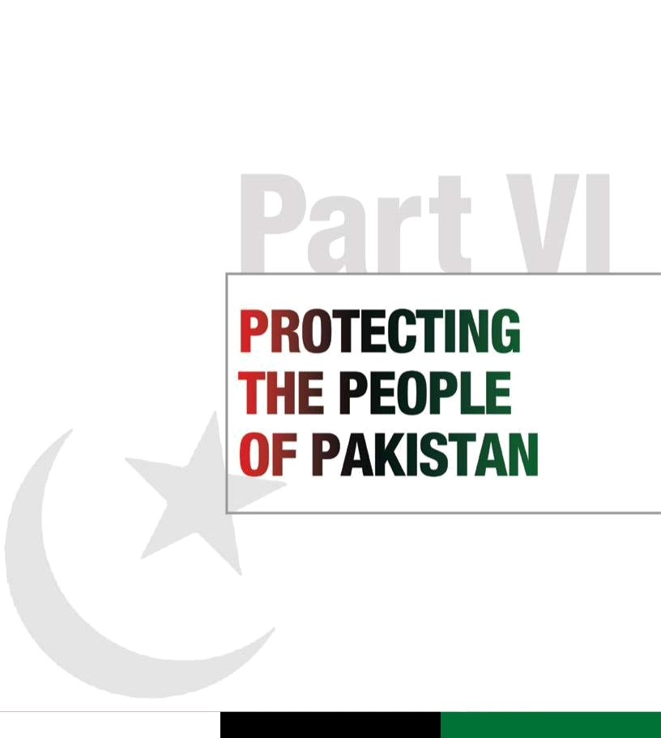

Pakistan People’s Party Parliamentarians

Part VI |  | Manifesto
Protecting the people of Pakistan |  | 2013

Manifesto
2013

“The Pakistan People’s Party Parliamentarians and my colleagues in opposition believe that this is a war on Pakistan, this is a war on our soil. It is our boys who are dying, our children who are homeless, our daughters who are being shut out of their homes, and we will defend our land.”
President of Pakistan, and Co-Chair Pakistan People’s Party Parliamentarians
Asif Ali Zardari, Karachi, Pakistan, 2008

Pakistan’s national defence relies on our conventional and nuclear capabilities, and is strengthened by a growing confidence-building gradient between the civilian and military leadership.

Our Party has always seen itself as a bulwark against extremism in Pakistan. We have borne immense sacrifices in the fight against terrorism and we remain committed to ensuring our country is safe

operation in the Swat valley to flush militants out of the area.

Our government jammed radio stations that openly broadcast terrorist propaganda and hate speech under the previous regime. As part of a broader effort to reduce the space available to those who promote terrorism, we acted through PEMRA to prohibit media coverage of a number of banned

 |  |  | Executive summary
 |  |  | Since 2001, violence at the hands of extremists
 |  |  | has claimed more than 46,000 Pakistani lives.
 |  |  | The victims have been innocent civilians and
 |  |  | law enforcement personnel. Our leader Shaheed
 |  |  | Mohtarma Benazir Bhutto gave her life defending
 |  |  | Pakistan’s people and its soil from the advance
 |  |  | of terrorism. Extremist elements have attacked all
 |  |  | organs of the state. They have spilt the blood of the
 |  |  | innocent, attacking mosques, shrines and schools
 |  |  | across the country. We have buried far too many
 |  |  | of our own and laid wreaths at more graves than
 |  |  | any other nation in this century. We cannot and
 |  |  | will not let this state of affairs continue. Our future
 |  |  | generations should not have to live in the shadow of
 |  |  | militancy and terror.
 |  |  | Recognizing that our nation is under attack from
 |  |  | militant groups seeking to enforce their writ through
 |  |  | terrorist activities, our Party remains committed to
 |  |  | the cause of protecting Pakistan’s citizens and
 |  |  | reinforcing the writ of the state. To this end we
 |  |  | have sought to take back large swathes of territory
 |  |  | from terrorist control in the tribal areas. We built
 |  |  | unprecedented parliamentary consensus for the
 |  |  | conduct of military operations and successfully
 |  |  | relocated millions of people from troubled areas
 |  |  | which are now returning to peace.
 |  |  | During our next tenure we will bring to bear all
 |  |  | resources in finding solutions that address the
 |  |  | multiple and interlinked issues of governance,
 |  |  | reform, economic challenges and security.
 |  |  | We are dedicated to ensuring that all citizens,
 |  |  | including vulnerable minorities, are able to enjoy
 |  |  | their fundamental rights. We will build political
 |  |  | consensus for a comprehensive strategy to de-
62 |  |  | radicalize society and deny space to terrorists,
 |  |  | and implement a series of coordinated measures to

guarantee that extremism is wiped out once and for all.

Recognizing the scale and urgency of the security imperatives at stake, we will immediately move forward with a multi-phased National Security Plan to secure our borders, cities and villages from both external and home-grown terrorism, and to tackle the rise of militancy in Pakistan.

In our next term, we will seek policy solutions that combine conventional tactics and counter-insurgency measures, to implement the rule of law and bring security to the people. Our policy has focused on framing and strengthening legislation, and our next step will be to ensure its effective enforcement through federal and provincial agencies. We will channel resources, build political consensus and bolster law enforcement capacity for enforcement. We will engage all religious leadership loyal to the state of Pakistan to work with a nationwide communications campaign that condemns the use of terror and reinforces Islam’s message of peace for all communities, sects and religions.

We have led from the front to build a lasting peace with our neighbours, aware of the fact that this is central to peace within our borders. We have done so without compromising on national sovereignty. We democratized external security policy in a series of historic parliamentary initiatives that brought transparency and accountability to the process. Our government not only shut down Shamsi Airbase

for use by foreign countries but also ensured that no such agreements are made without public consent. The use of unmanned aircraft by foreign governments in the tribal areas has been clearly and unambiguously defined as an unacceptable encroachment on Pakistan’s sovereignty.

from the threat of terrorist forces, viewing terrorism as a challenge to our sovereignty. Our policy of dialogue, disarmament and deterrence is based on a peacekeeping model where the rehabilitation of former militants is conditional on their acceptance of the Constitution of Pakistan and the writ of the state.

Living up to our commitments

Despite the seemingly insurmountable nature of the challenge and the sacrifices that this may continue to entail, we are committed to the task of facing up to extremism and terrorism. To further this goal we have taken significant and practical measures to protect the people of Pakistan. Our government developed a comprehensive counterterrorism strategy based on political engagement and economic development, backed by credible military force. At the same time, we unequivocally conveyed to the world the Pakistani people’s anger over drone strikes inside our territory.

Our government introduced public ownership to the war against terrorism in Pakistan by introducing debate on the issue in the National Assembly. We worked to increase the level of trust between the armed forces, elected representatives and the people.

We introduced a policy of dialogue, development and deterrence that has helped to lay the groundwork for a more inclusive and tolerant society. We successfully garnered public support for military operations against terrorists.

Through joint resolutions in Parliament, we created an important consensus to defy all forces aligned behind the terrorist banner. We galvanized public opinion and support, and launched a military-led

organizations. To this end, 64 notices were issued to various media organizations.

To counter the message of hate spread by such organizations, our government launched Radio Swat with the support of the ISPR. We launched public service campaigns on nearly 50 television channels and 30 radio stations, and in 200 national and regional newspapers in our strategic communications offensive against terrorism.

When dialogue and deterrence did not bring about the desired results, our government authorized military action. Since 2008, security forces have launched two dozen major and smaller military operations against militants in FATA and Khyber Pakhtunkhwa, weakening the infrastructure and operational capabilities of the militants, and eliminating some of their key leaders.

Our government developed a new strategy to combat terrorism in urban areas. This included coordination among intelligence agencies, building the capacity of law enforcement agencies, putting curbs on terrorist financing, and taking strong action to designate militants and extremist organizations as terrorists and to ban these outfits and their affiliates.

Military operations conducted during our government successfully regained territory lost to extremist elements. In doing so, over two million people, including women and children, were relocated

to camps elsewhere in the country. This wave of dislocation was the largest in the country’s history. In a coordinated inter-agency response, our government established dozens of camps for internally displaced persons (IDPs) in and around conflict zones in FATA and Khyber Pakhtunkhwa. In October 2010, we constituted and supervised

an inter-agency task force to assist in the return ₆₃ of thousands of IDPs to FATA. In one of the most

Pakistan People’s Party Parliamentarians

Pakistan People’s Party Parliamentarians

Manifesto
2013

Manifesto
2013

extraordinary undertakings in Pakistan’s history, the government and military worked together to return most of these displaced persons to their homes, an effort that was lauded by international development agencies. To meaningfully assist in the recovery of these areas, in 2010 our government exempted the militancy-hit areas of Khyber Pakhtunkhwa from the tax survey for the next 10 years.

In Balochistan, our government put an end to all military operations except for necessary action against terrorism. Following the brutal attacks on the Hazara Shia community in Quetta, our government dismissed the chief minister of the province, and we are ensuring that effective law enforcement measures are implemented.

Our commitment to creating a secure space for Pakistan’s religious minorities is unwavering. We beefed up security at places of worship for all minorities across the country and ensured that enhanced security measures were in place for minorities visiting their holy sites. Our government also remitted the sentences of minorities convicted for minor crimes.

We have tackled the problem of terrorist financing through the legal system. In 2010 our government established three accountability courts, two in Islamabad and one in Multan, for the expeditious disposal of cases. Three special courts, one each in Karachi, Lahore and Peshawar, have been established under the Offences in Respect of Banks (Special Court) Ordinance 1984, which have to date disposed of 561 cases. To control narcotics trafficking, special courts were established under the Drugs Act 1976 in Bahawalpur, Faisalabad, Gujranwala, Karachi, Lahore, Multan, Peshawar, Quetta and Rawalpindi, clearing 3,126 cases so far.

Under the Anti-Terrorism Act 1997, our government shut down terrorist training centres, blocked websites spreading a message of hate and arrested key militants. Our government has introduced the Anti-Terrorism (Second Amendment) Bill to tackle banned militant groups that resurface under a new name. Members of such groups will not be allowed to travel abroad or receive support from any

- financial institution, and will have their arms licences cancelled. The Bill will also bar courts from granting

bail to those accused of offenses under this Act that are punishable with death, imprisonment for life or imprisonment for a term exceeding 10 years. Under our leadership, the Federal Cabinet approved the Fair Trial Bill. This law will allow the security agencies to monitor the telephone calls and other communications of suspected terrorists and the evidence collected through such surveillance will be admissible in a court of law. We will not allow this law to be misused for harassing or exploiting citizens. The Cabinet also approved the National Counter-Terrorism Authority Act 2012.

To address the increasing use of improvised explosive devices (IEDs), especially in the border areas, our government and the military worked together to formulate a comprehensive counter-IED strategy which helped to prevent a large number of potential attacks.

Besides tackling the nexus between terrorist financing and the narcotics trade by beefing up legal and law enforcement mechanisms, we developed a comprehensive Anti-Narcotics Policy. This policy takes a multi-pronged approach, aiming simultaneously to address demand reduction and supply reduction, while improving international coordination.

We introduced a policy of dialogue, deterrence and development by enlisting the support of religious leaders, the ulema, academics and policy practitioners to denounce violence, relying on Islamic teachings to promote harmony, peace and religious tolerance. By encouraging an open dialogue on Islamic teachings, we aim to draw a clear distinction between the peaceful tenets of Islam and the distorted message disseminated by militant groups.

The way forward

Securing Pakistan

Our Party recognizes the seriousness of the terrorist threat our country faces and will continue to condemn and combat all such groups and activities. We will build on our efforts to crack down on any entity that supports and carries out these acts of barbarism.

Pakistan People’s Party Parliamentarians

Whether external or home-grown, terrorism poses a grave challenge to Pakistan. With more than 46,000 lives lost since 2001 and an estimated 78 billion US dollars in losses to the national economy, terrorism has gravely impacted the lives of innocent civilians, targeting Pakistan’s ethnic and religious minorities with attacks in urban centres and rural areas. The martyrdom of Shaheed Mohtarma Benazir Bhutto, the assassinations of Shaheed Salman Taseer, Punjab Governor, and Shaheed Shahbaz Bhatti, Minister for Minority Rights, are instances where the Party lost its best and bravest to acts of terrorism. We recently lost another courageous leader, Senior Minister Bashir Bilour, in the fight against extremism. The targeted killing of minorities, health workers, political activists, teachers, students and children urgently calls for resources to be mobilized to protect the people of Pakistan.

Creating a policy that is responsive to multiple security challenges on the ground is no easy task. The Party is very clear that the implementation of measures to secure Pakistan from both external and internal threats is a top priority, especially in the context of regional transitions that add more refugees and volatility to our border areas. To accomplish this we will:

- Develop a National Security Plan with the overarching goal of providing safety and security to all Pakistani citizens. The Federal Cabinet has already approved the National Counter-Terrorism Authority Act 2012 and this constitutionally mandated body will play a critical role in evolving more effective counterterrorism initiatives. The National Counter-Terrorism Authority will be redesigned and placed under the PM secretariat, which will serve as a control room for all federal agencies. Provinces will be encouraged to set up their own counterterrorism authorities, in coordination with the centre and the security agencies.

- Establish coordination and information-sharing mechanisms involving law enforcement agencies, and local, provincial and federal governments to confront the terrorist threat.

- Utilize strategic communications as a tool to counter fundamentalist and militant rhetoric.

- Devise a comprehensive security strategy to prevent attacks on major urban centres.

- Undertake targeted military operations against all militant and terrorist outfits that challenge the writ of the state.

- Improve intelligence gathering mechanisms by utilizing modern technology and state-of-the-art surveillance.

- Enhance border security measures to prevent the movement of insurgents and militants across the Pak-Afghan border.

- Continue the repatriation of Afghan refugees, in close coordination with the Afghan government and international organizations.

- Accelerate the policy of building a national narrative against religiously motivated violence.

- Launch an active campaign to prevent Pakistan from being used as a base for terrorist activities.

- Dismantle militant groups that create parallel entities within the state in an attempt to impose their writ, attempt to determine foreign policy agendas for the Government of Pakistan, threaten and eliminate innocent civilians, government and security personnel, threaten to destabilize Pakistan and the region, and recruit militants.

- Provide all captured militants with access to legal representation, and ensure the due course of justice and prosecution through a fair trial.

- Develop a comprehensive witness protection programme for those who have provided critical information leading to the arrest and incarceration of militants.

- Establish a programme that provides security and protection to judges and legal personnel involved in the prosecution of members of militant organizations.

- Renew our vow to promote equal rights for all, including the universal right to life. As we move forward with our commitment to protect all minorities, we bear witness to the senseless violence that has been inflicted upon our communities by militant groups.

- Commit all our resources and policy enforcement tools to ensure that political stability is sustainable in the long term.

65

Pakistan People’s Party Parliamentarians

Manifesto
2013

Manifesto
2013

Internal security

Terrorism continues to plague Pakistan, with the loss of economic resources, infrastructure and, most significantly, precious and innocent human lives. Our Party believes that national defence is rooted in the economic health of the country, where gainful employment deters internal conflict and disorder.

Thousands of Pakistanis, especially in the law enforcement agencies, have succumbed to the menace of improvised explosive devices (IEDs). With the assistance of our international partners, we have devised a comprehensive counter-IED strategy. Counterterrorism measures cannot, however, rely solely on clamping down on terrorist groups; a strategy is also needed to curb terrorist recruitment. We will:

- Promote Pakistan’s multi-ethnic, multi-religious and multicultural identity at the state level to counter the extremist mindset actively fostered by such groups.

- Enhance research and intelligence gathering related to key extremist outfits, their operations and their recruitment strategies.

- Regulate all madrassas through a Federal

Madrassa Board to ensure that the curriculum adheres to the national education policy and is not based on a narrow, extremist worldview. We will ensure that the skills and education imparted in these institutions are holistic and marketable.

- Ensure that any institution providing free meals and basic services does not mislead students from underprivileged backgrounds and recruit them for the purposes of militancy.

- Review Pakistan’s education system and implement critical reforms to ensure it meets the challenges of the 21st century.

- Encourage interfaith discussion forums where religious scholars from all faiths take a united stand against extremism and religious intolerance.

- Initiate a process of disarmament, demobilization and reintegration (DDR) for any militant group or individual willing to renounce violence.

- Establish a strategic communications unit in
- each province and at the centre to spread a

peaceful message of Islam, and to embolden progressive voices.

- Take adequate measures to secure areas where religious or ethnic minorities reside in large numbers.

- Make sure that peace talks are only held with militants provided they renounce violence as a means to their ends and recognize all provisions of the Constitution.

- Ensure that the use of force remains the monopoly of the state.

Narcotics control

Besides tackling the nexus between terrorist financing and the narcotics trade by strengthening legal and law enforcement mechanisms, we developed a comprehensive Anti-Narcotics Policy (2010). Our policy takes a multi-pronged approach, aiming simultaneously to address demand reduction and supply reduction, in addition to interventions in the health sector for the rehabilitation of drug addicts and to raise awareness. We also launched a number of development projects in areas where poppy cultivation has traditionally been the primary source of income. These projects have helped local farmers to diversify their crops and created new livelihood opportunities. In our next term, we will:

- Continue to beef up law enforcement and strengthen the legal framework where necessary.

- Improve the performance and capacity of anti-narcotics officers.

- Create more effective public awareness campaigns, expand the use of traditional media and explore the use of new media and social media, especially to reach young people.

- Provide drug treatment and rehabilitation facilities to more communities.

- Expand area development programmes, and develop similar programmes to cover new areas, so that farmers are able to permanently shift away from poppy cultivation.

Law enforcement and police reforms

Pakistan’s police force has been at the forefront of fighting terrorism. From Peshawar to Karachi, our

Pakistan People’s Party Parliamentarians

brave police officers have laid down their lives to protect the homeland and its people. We salute the valour of our officers and will not allow their sacrifices to be in vain. While we will never be able to make up for the losses suffered, we have ensured that the brave widows and families of police and paramilitary officers who have embraced martyrdom are compensated and their children are provided employment opportunities.

Our Party believes that robust internal defence starts with sound law enforcement. Making Pakistan secure will entail a coordinated strategy with all agencies

at the local, provincial and state levels. At the same time, law enforcement agencies and officials will be mandated to follow the law.

During our current term, we have recruited young men and women in large numbers and instituted new training protocols, including specialized commando training. In the next five years, we will make the police more effective, responsive and alert to all threats and train them for community protection. We will:

- Promote a merit-based system, increase transparency and eliminate existing structural challenges within the police force.

- Establish a police college for federal and provincial police officers, to serve as a centre of excellence in developing and enhancing skills, forensic research and policing standards. Best practices in policing can be adapted from our regional allies, especially in counterterrorism activities.

- Create incentives within the existing system for former UN peacekeepers to serve in the national police force, adding personnel as well as valuable expertise from conflict zones.

- Introduce proactive policing methods that are responsive to community needs, and encourage and formalize citizens’ participation in crime prevention and the protection of their own communities.

- Assess the Citizens-Police Liaison Committee

(CPLC) model for extension to other parts of the country, and review the need for a Public Safety Commission.

- Encourage the computerization of police records and the close interaction of the police with institutions such as NADRA to aid crime prevention and detection.

- Ensure that women are inducted in larger numbers to offset gender imbalances in the police force, and make the police more sensitive to community needs, especially in cases related to women and children.

- Transform juvenile detention centres into facilities that are compliant with Pakistan’s domestic laws and international conventions.

External security

Recognizing Pakistan’s strategic geographic location, our Party has been the principal architect of a defence policy that safeguards the country’s territorial integrity and national sovereignty. Quaid-e-Awam Shaheed Zulfikar Ali Bhutto gave Pakistan the vision for minimum credible deterrence and nuclear parity with regional powers. Under Shaheed Mohtarma Benazir Bhutto, Pakistan gained enhanced missile capability, which deterred external aggression and continues to underpin Pakistan’s strategic posture today.

Our government has deployed 151,000 of our brave soldiers on our western borders to protect the country from cross-border infiltration by extremist elements. We have set up over 800 border security posts to check the movement of narcotics, criminals and militants. We have already implemented key measures to stem the flow of ammonium nitrate used in IEDs across the Pakistan–Afghanistan border, thereby cutting off the influx of nearly all explosive materials used in IEDs.

Pakistan’s alliance with the US and relations with
Afghanistan remained critical in our struggle to
ensure peace and stability. We seek to work with
our allies to fight terrorism in the most productive
and cooperative ways possible, and to find
convergence in our anti-terror strategies. We have
refused to compromise on our rights as a nation,
and have introduced transparency and parliamentary
consensus in policy making. | 67

Pakistan People’s Party Parliamentarians

Manifesto
2013

Manifesto
2013

Our Party unambiguously considers all external and unilateral attacks on Pakistani territory to be an attack on this nation’s sovereignty and a clear violation of international law. This includes foreign drone attacks by unmanned aerial vehicles (UAVs) that violate Pakistani airspace to target militant leaders. Such attacks create public resentment and provide fuel for opportunist militant organizations to capitalize on the grievances of citizens. These strikes breed deep-seated resentment and activate potential terrorists, and are counter-productive. Such attacks reverse important public consensus gains made by the current administration in building national ownership of the fight against terrorism. Our Party views the presence of foreign UAVs in Pakistani airspace as an unacceptable intrusion on sovereign territory. In our next term, we will:

- Ensure the protection of our borders from the threat of extremism and violent forces.

- Proactively coordinate with international organizations and the Afghan government to facilitate the repatriation of Afghan refugees and ensure their safe passage.

- Crack down on cross-border infiltration on our western border to prevent further casualties on both sides.

- Work with our international partners and neighbours to disrupt militant networks operating in areas such as Nuristan and Kunar which launch cross-border attacks on Pakistan.

- Continue to impress upon our allies that drone strikes carried out by the US are counter-productive, a clear violation of international law and Pakistan’s sovereignty, and that they undermine the writ of the state.

- Work with our partners and neighbours in securing a peaceful and prosperous South Asia.

Defence
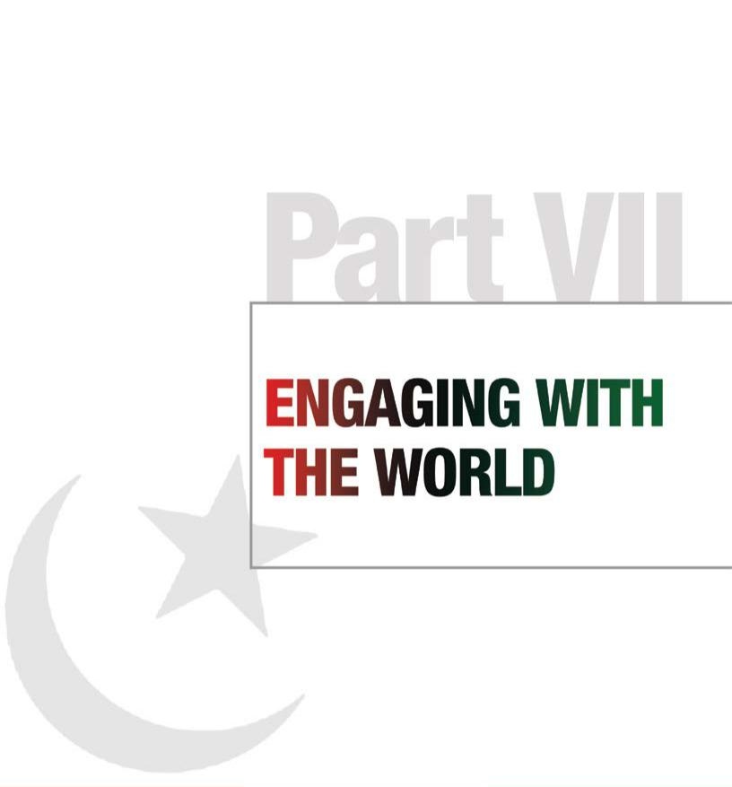

In the last five years, Pakistan’s armed forces have confronted the threat of terrorism with courage and fortitude. As a frontline force in the war against militancy and extremism, Pakistan’s military has suffered high casualties as well as damage to infrastructure, but has remained steadfast in its task of protecting the people and defending the country from external and internal threats. The armed forces also played an active role in disaster rescue and relief operations during the floods of 2010 and 2011.

Despite severe financial constraints, our government provided the necessary resources available for national security in order to ensure that our defence services are able to maintain the minimum level of defence and deterrence. To express our gratitude and to provide much needed motivation to our men and women in uniform, we have doubled the salaries of members of the armed forces.

As we seek a fresh mandate, we promise the people of Pakistan that we will:

- Articulate a strong, well-defined national security strategy that protects Pakistani citizens from both internal and external security challenges.

- Ensure that our armed forces maintain the highest professional standards so that they earn the love and respect of the nation.

- Encourage closer working relationships between defence and parliamentary institutions for cooperation as well as oversight.

- Make military budgets accountable to

Parliament, and institutionalize better oversight of defence expenditure.

68

Pakistan People’s Party Parliamentarians

69

Pakistan People’s Party Parliamentarians

Part VII |  | Manifesto
Engaging with the world |  | 2013

Manifesto
2013

“I dream of a Pakistan, of an Asia, of a world, where we can commit our social resources to the development of human life, and not to its destruction.”

Shaheed Mohtarma Benazir Bhutto, Cairo, 1994

and the HR Council, the two most widely sought memberships in the UN system. Our government ensured that Pakistan retained its position in all such global forums as one of the top troop-contributing countries for UN peacekeeping operations. Pakistan also continued to contribute actively in steering key UN led norm-setting processes dealing with new and emerging challenges in the security and development

the region. Despite unprecedented security and development challenges posed by volatility in the neighbourhood, and successive and unprecedented natural disasters over the last five years, we remained focused on moving forward with building real constituencies for reform across the board to further our commitment to peace.

Executive summary

Our Party has been unwavering in its commitment to build a progressive, democratic, peaceful, egalitarian Pakistan. From Shaheed Zulfikar

Ali Bhutto’s era to Shaheed Mohtarma Benazir Bhutto’s stewardship, our Party has been the first to safeguard the nation’s sovereignty and national independence. Today, under the leadership of Party Co-chair President Asif Ali Zardari, we have been actively seeking to build a strong, secure, stable, peaceful and prosperous state. There has been a constant focus on socio-economic advancement as a strategic priority, and a clear commitment to regional and global peace, security and prosperity.

We believe strongly in a Pakistan at peace with itself and with its neighbours. Based on this vision, during the last five years we have initiated a transformational shift in the country’s foreign policy through an unprecedented process of inclusive policy reform and sustained statesmanship.

Our Party led a historic consensus-building process in Parliament for a foreign policy based on public consent and transparency. This empowered the government to lead a comprehensive review of Pakistan’s foreign policy both regionally and globally, bringing fresh impetus as well as traction to our broader goals of peace, cooperation and trade as the cornerstone of Pakistan’s engagement with the world.

By reframing the policy-making process and bringing clarity, dynamism and depth to evolving strategic agendas, our Party has reshaped Pakistan’s global calculus and profile. Working with all key stakeholders in national security, including public representatives in Parliament as well as the military, we have managed to decisively craft a new role and profile for Pakistan as a responsible and cooperative player, especially in the region. In

- this context, during our current term in office we initiated a robust and enhanced process of global

engagement based on the principles of equality, respect and mutuality of interest and benefit.

The Party has to its credit a long list of credible and outstanding achievements in strengthening existing partnerships and building new relationships in the region and beyond. We have also worked hard to restore Pakistan’s democratic credentials at home and abroad as well as to enhance Pakistan’s rightful place in the comity of nations.

Pakistan’s outreach to the Afghan government, as well as the opposition parties, and its support for a comprehensive reconciliation process led and owned by the Afghans, is an important and historic move. The pursuit of an honest and sincere dialogue for the resolution of all outstanding issues with India, including the core issue of Kashmir, the normalization of trade relations and the easing of travel restrictions, are in line with the Party’s commitment to regional peace. The strategic challenge of reframing a

more enduring, balanced and clearly defined partnership with the US, rooted in mutuality of interest and respect, while securing the largest-ever economic assistance package for Pakistan, is a signal achievement. The deepening and strengthening of Pakistan’s time-tested and abiding friendship with China and our partners and allies in the Muslim world is another. Reaching out to our friends in Europe, East Asia including Japan and Korea, Canada and Australia to explore and reinforce, as appropriate, trade and investment links, remained a priority. We deepened engagement with the EU. This policy resulted, among other things, in the historic securing of WTO-endorsed preferential market access for Pakistani exports to the EU.

We will continue our outreach to the Central Asian Republics, Turkey, Saudi Arabia and other Middle Eastern countries.

During the last five years, our government was vigilant to ensure that Pakistan maintained its prominence and stature as a credible and responsible player in the multilateral arena. As a result, we won elections to the UN Security Council

arenas including terrorism, sustainable development and climate change. We are determined to capitalize on the goodwill, trust and respect earned by Pakistan over the last five years as a result of our government’s external policies rooted in the ideals of peace, outreach and cooperation, bolstered by full democratic ownership and public support.

Our goal will always be the welfare of the people of Pakistan first, and to this end we will deploy all necessary resources to bring the dividends of peace and prosperity to the people by building partnerships across the region and beyond. During our next term, we aim to redouble our efforts to enhance and build Pakistan’s relationship with countries of the region and with our allies and partners around the world.

As the region shifts towards a period of transition, with a drawdown of US military forces and elections in Afghanistan, our government will work with Pakistan’s neighbours and allies to build a strong and stable region. To this end we will redouble our efforts to establish and enable regimes for free trade arrangements, comprehensive economic partnerships, financial and banking systems, trans-regional and intra-regional energy supply and energy security arrangements, and secure transport and freight corridors. In short, we will aggressively pursue paths to make Pakistan an energy and trade hub for the region and beyond.

Globally, we will seek to ensure that Pakistan continues to play its due role in promoting and protecting the principles and ideals enshrined in the UN Charter, and in building coalitions of like-minded countries to deal with the new and emerging challenges humanity confronts today, including terrorism, narcotics proliferation and climate change.

Living up to our commitments

Under our Party’s leadership, Pakistan’s foreign policy has made an important shift by proactively advancing trade, commerce and economic ties in

By working diligently with all key stakeholders in national security, including public representatives in Parliament as well as military forces, we have crafted a new role and profile for Pakistan as a responsible and cooperative player globally and in the region.

To preserve these gains and to protect the country from regional instability, we sought to further advance Shaheed Mohtarma Benazir Bhutto’s project of reconciliation and peace, both at home and abroad. Mutual respect and a consideration for each other’s democratic priorities remained the hallmark of all engagement with international partners.

Anchored in democratic consent, our foreign policy continued its seminal new direction by deepening engagement in the region as the pivot for trade, cooperation, dialogue and public diplomacy. In pursuit of fulfilling Pakistan’s obligation to Article 40 of the Constitution, to “promote international peace and security”, our government paid special attention to stabilizing the region at a time of multiple transitions, building bridges with all neighbours both to the east and the west.

As part of the transformational shift we set in motion in conceiving and executing Pakistan’s foreign policy, we tirelessly worked to proactively advance trade, commerce and economic ties in the region, and sought to replace old templates that hinged strategic ties on narrow definitions of national security.

Normalization of trade relations with India, movement forward on the Iran–Pakistan gas pipeline project, the initiation of a new transit trade agreement

with Afghanistan, the transfer of Gwadar Port management to a Chinese company, and working to realize the CASA 1000 (Central Asia South Asia) power transmission project, are among some of the important achievements of our government over the last five years in integrating trade and commerce in the region.

We believe that consistent diplomatic, economic

and security engagement with all our neighbours ₇₁ is crucial for building confidence and stability in a

Pakistan People’s Party Parliamentarians

Pakistan People’s Party Parliamentarians

Manifesto
2013

Manifesto
2013

region facing multiple challenges. During our current tenure, Pakistan has also built a new architecture of institutionalized engagement with Canada, Russia, the UK and the Commonwealth.

In recognition of Pakistan’s pivotal location with respect to trade routes to Central Asia, the Gulf and the GCC, our government has proactively invested in building commercial, social and cultural ties with the peoples and states of these regions. We redoubled our efforts to further develop and enrich our very special relations with Turkey, particularly by intensifying exchanges at the leadership level.

Our government has also successfully pursued the cementing of strategic partnerships that invest in broad-based roadmaps for enhanced cooperation. We will continue fostering better ties with the states and the people of all these countries in the medium and long term, with an emphasis on greater access to each other’s markets.

As a vital stakeholder in Afghanistan’s stability, with a long and porous border between the two countries, Pakistan under our Party’s fourth government has led a historic building of ties with Kabul. We believe that a stable, peaceful and prosperous Afghanistan is fundamental to Pakistan’s stability, and we will support every Afghan-led initiative that is in pursuit of this ideal.

Pakistan’s proximity to Afghanistan must not become a motive for meddling in Afghanistan’s internal dynamics. We have demonstrated our commitment to non-interference in Afghanistan by supporting only Afghan-led paths to stabilization, reconciliation and peace, without favouring any group, faction or tribe.

During our current tenure, Pakistan signed a historic transit trade agreement with Afghanistan and ensured that there is broad-based engagement at the highest level with all political groups, irrespective of their alignment.

Our government has sought to bring consistency and confidence to the bilateral relationship with India. We seek to ease tensions with India through peaceful and uninterrupted dialogue on outstanding disputes and issues.

During the December 1988 SAARC Summit, Prime Minister Benazir Bhutto’s proposal to transform

- SAARC from a cultural organization into an economic entity was accepted by SAARC member countries.

This goal remains a guiding principle for our government, which has worked hard to redefine a regional economic framework for the countries of South Asia to benefit all its people through economies of scale. A regional economic group has the potential to turn into a global economic powerhouse, attracting investment, creating jobs and eliminating poverty.

In our current tenure, we have followed Shaheed Mohtarma Benazir Bhutto’s vision that a prosperous Pakistan is the key to a prosperous South Asia. Maintaining peaceful ties with our neighbours is imperative if we wish to achieve these goals. Home to one fifth of the global population, South Asia deserves the dividend of opportunities that peace and enhanced commerce can bring.

Pakistan has always considered the People’s Republic of China to be one of our strongest allies and the relationship between our two countries has weathered the test of time. During our current term, we worked to further deepen and strengthen Pakistan’s comprehensive and cooperative partnership with China, the foundation of which was laid by Shaheed Zulfikar Ali Bhutto, and made efforts to take it to new heights by intensifying exchanges at the core leadership level. These efforts led to further intensification of collaboration between the two countries in the trade, economic and defence fields and in the promotion of regional cooperation.

We continued to promote the goals of Islamic solidarity, stability, peace and the common economic development and prosperity of the Islamic Ummah by further deepening and strengthening bilateral ties with our friends and allies in the Muslim world and through the OIC.

We brought a new balance and stability to Pakistan’s relationship with the US based on mutuality of respect and benefit. Most importantly, we moved these relations away from being a ‘one-window operation’ geared only to suit the needs and interests of individuals, to a more institutionalized enterprise designed to serve the best interests of the people of Pakistan.

Our government worked assiduously to achieve this through a deliberate effort aimed at promoting a partnership between two peoples committed to the principles and ideals of democracy, freedom and justice, capable of talking to each other with candour and honesty to advance the twin goals of prosperity

Pakistan People’s Party Parliamentarians

and security for both countries. The US pledge of the largest-ever economic assistance package for Pakistan, the initiation of strategic dialogue covering almost every conceivable issue in bilateral cooperation through Working Groups, and the revival and restoration of momentum in the relationship after a rough and difficult patch in relations, marks the beginning of a new phase and approach.

Our Party supports the right of self-determination for all people.

We support the rights of the Kashmiri people and during our current government we initiated and continued to pursue a dialogue process agenda with India, including on Kashmir. We will not allow lack of progress on one agenda to impede progress on the others.

Without prejudice to UN Security Council Resolutions, we support open and safe borders at the Line of Control to socially unite the Kashmiri people. We note that India and China have a border dispute and yet enjoy tension-free relations.

During the last five years, Pakistan also maintained its prominence and stature as a credible and responsible player in the multilateral arena, winning elections to the UN Security Council and the HR Council, the two most widely sought memberships in the UN system. Pakistan continued to retain its position as the top troop-contributing country for UN peacekeeping operations.

Pakistan also continued to contribute actively in steering key UN-led norm-setting processes dealing with new and emerging challenges in the security and development arena including terrorism, sustainable development and climate change.

The way forward

We will continue our commitment to believing in and advancing the UN purposes and principles; furthering global peace, security and prosperity; promoting multilateral cooperation; protecting the environment, promoting sustainable development, and eliminating hunger and disease; redressing social injustices, empowering women, and promoting tolerance and inter-cultural and interfaith harmony; promoting fundamental freedoms, human rights, the rule of law, justice and democratic polity; supporting disarmament and non-proliferation; and fighting to

eliminate terrorism, drug trafficking and organized crime. We will continue contributing to regional stability and peace, especially in adjoining south, central and west Asia as well as the Indian Ocean region, and promoting regional economic and trade cooperation by establishing and fortifying links in connectivity and infrastructure and setting up the requisite facilitative regimes.

Peace, prosperity and stability

Building on the gains made over the last five years in protecting, promoting and advancing Pakistan’s interests externally and in securing peace, prosperity and stability for the people of Pakistan, in our next term in office we will:

- Continue and accelerate our policy of building a consensus against terrorism and extremism both at home and abroad. Our government will bring fresh resolve and vigour to a renewed campaign to lead the way in disallowing the use of Pakistan’s territory for attacks on any country’s soil, and will commit its resources to advancing peace at home and abroad.

- Build on deterrence and dialogue as a means to dismantle and degrade the power of militant groups who seek to take hostage the foreign policy of the country and impose their writ through force on the tribal areas of Pakistan and elsewhere.

- Build on existing capacities and explore new opportunities to position Pakistan as a hub for commerce, communications and energy connectivity.

Regional cooperation and engagement

Consistent with our belief that continued diplomatic, economic and security engagement with all our neighbours is crucial for building confidence and stability in a region facing multiple challenges, we will persist in spearheading a roadmap and a diplomatic surge for enhanced relations at different levels with Afghanistan, India, Iran and the People’s Republic of China. To this end, we will:

- Move forward with our seminal new direction in foreign policy, anchored in democratic consent,

by deepening engagement in the region as the | 73

Pakistan People’s Party Parliamentarians

pivot for trade, cooperation, dialogue and public diplomacy.

- Continue to aggressively pursue institutional frameworks for regional cooperation at multiple levels, adding value to new scaffolding for constructing an enduring business, investment, development and infrastructural architecture in the region.

- Enhance Pakistan’s strategic partnership with

China and strengthen Pakistan’s traditionally strong ties with the Islamic world. Pakistan has always considered China to be one of our strongest allies. Our relationship has weathered the test of time, and our ties have strengthened and deepened in different spheres of economic, defence and regional cooperation. We will endeavour to enhance our deep friendship with enhanced cooperation in the economic, social and defence sectors while protecting our national interest and sovereignty.

- Continue to reshape the relationship with

Afghanistan based on peace, brotherhood, respect and cooperation. We will not allow Pakistan’s territory to be used for cross-border terrorism against Afghanistan. We have demonstrated our commitment to non-interference in Afghanistan by supporting only Afghan-led paths to stabilization and peace. We firmly adhere to the principle of supporting our neighbour without meddling in Afghanistan’s internal affairs, and we favour no group, faction or tribe.

- Encourage the voluntary and safe resettlement of Afghan refugees from Pakistan, and promote enhanced development, cultural, commercial and people-to-people cooperation between the two countries.

- Maintain full solidarity with and continued moral, political and diplomatic support of the Kashmiri people for realizing their legitimate aspirations.

Strengthening bilateral ties and building new relationships

We will cement our ties with old allies and seek engagement with other nations for trade and
- development. To this end, we will:

Manifesto
2013

- Further strengthen and deepen relations with the US, with emphasis on market access and enhanced trade opportunities for Pakistan’s exports and foreign direct investment in Pakistan.

- Promote Pakistan-EU cooperation, and especially work for a free trade arrangement and the establishment of mutually beneficial collaborative links in the economic, technological, cultural and educational fields.

- Build a new architecture of institutionalized engagement and partnerships for enhanced trade, economic and development cooperation on the lines of those put in place by our government during the last five years with the UK, Russia, Canada and the Commonwealth.

- Continue to proactively invest in building commercial, social and cultural ties with the peoples and states of Central Asia and the GCC, and maintain our historical and friendly ties with Turkey and Iran.

- Accord special focus to mutually beneficial

Asia-wide cooperation, and associate fully in programmes of common and shared development in the SCO, ECO, SAARC, ASEAN and GCC regions.

- Reach out to Japan, South Korea, the ASEAN region, Australia and New Zealand as part of our efforts to bring fresh impetus to our ‘look east’ policy in Asia to build ties based on trade and investment.

- Seek greater cooperation with and participation in all regional and Asian forums, and continue to pursue the goal of promoting an Asian common market that can attract investment, create jobs and build bridges of peace and trade across South Asia.

- Enhance Pakistan’s outreach to African and Latin

American states by building on a base of new shared trade, business, technical and cultural ties.

Pakistan People’s Party Parliamentarians

Manifesto
2013

75

Pakistan People’s Party Parliamentarians

Manifesto
2013

76

Pakistan People’s Party Parliamentarians

